457 chem. Project
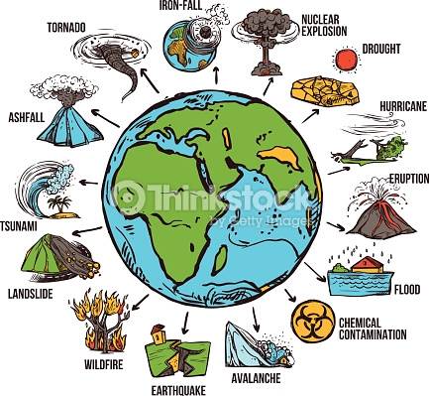
: Project 2
5 marks
Scientific paper on the determination of pollutants in the environment (atmosphere, hydrosphere, geosphere, etc.)
Evaluation will be based upon:
- is The topic related to the course
- extent of understanding of the analytical techniques used
- Presentation skills and clear explanation of the information in the paper.

