TIME SERIES

TIME SERIRES PLOT

ACF

PACF

TRANSFORMATION

DIFFERENCE

PLOTS OF RESEDIUSL

TIME SERIRES PLOT



ACF

PACF



TRANSFORMATION

LAMDA IS -0.5

SO THE TRANSFORMATION IS 1/SQRT (W13.2)

TIME SERIES FOR THE DEFERENCE OF 1/SQRT (W13.2)



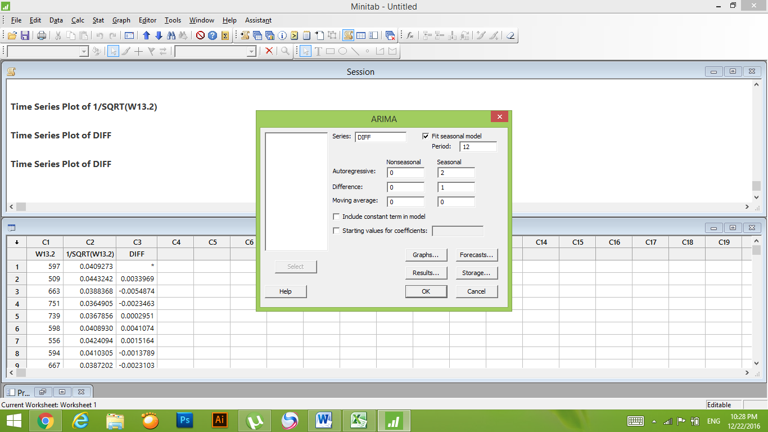FITTING THE MODEL

**ARIMA Model: DIFF**

Estimates at each iteration

Iteration SSE Parameters

0 0.000576799 0.100 0.100

1 0.000506584 -0.050 0.003

2 0.000452894 -0.200 -0.098

3 0.000415736 -0.350 -0.200

4 0.000395642 -0.500 -0.311

5 0.000392762 -0.562 -0.366

6 0.000390404 -0.586 -0.406

7 0.000390305 -0.586 -0.392

8 0.000390303 -0.586 -0.389

9 0.000390302 -0.585 -0.389

10 0.000390302 -0.585 -0.389

Relative change in each estimate less than 0.0010

Final Estimates of Parameters

Type Coef SE Coef T P

SAR 12 -0.5852 0.1190 -4.92 **0.000**

SAR 24 -0.3888 0.1354 -2.87 **0.005**

**P – VALUE < 0.05**

Differencing: 0 regular, 1 seasonal of order 12

Number of observations: Original series 81, after differencing 69

Residuals: SS = 0.000371833 (backforecasts excluded)

MS = 0.000005550 DF = 67

Modified Box-Pierce (Ljung-Box) Chi-Square statistic

Lag 12 24 36 48

Chi-Square 10.6 26.3 40.9 49.8

DF 10 22 34 46

P-Value **0.393 0.238 0.193 0.324**

**P – VALUE > 0.05**

ACF OF RESIDUALS



PACF OF RESIDUALS

RESIDUALS  PLOTS