In some cases, ectotherms attain body temperatures that are actually higher than the temperature of their environment. Marine reptiles have many characteristics for a terrestrial lifestyle that have been adapted to allow a life in the sea. Rather than gills, however, aquatic reptiles possess lungs for breathing.
Marine reptiles are reptiles which have become secondarily adapted for an aquatic or semiaquatic life in a marine environment.
Currently, of the approximately 12,000 extant reptile species and sub-species, only about 100 of are classed as marine reptiles:
Extant marine reptiles include:- marine iguanas, sea snakes, sea turtles and saltwater crocodiles.^{[4]}
Some marine reptiles, such as ichthyosaurs, plesiosaurs, metriorhynchid thalattosuchians, and mosasaurs became so well adapted to a marine lifestyle that they were incapable of venturing onto land and gave birth in the water. Others, such as sea turtles and saltwater crocodiles, return to shore to lay their eggs. Some marine reptiles also occasionally rest and bask on land

Extant varieties[edit]
- Sea turtles: there are seven extant species of sea turtles, which live mostly along the tropical coastlines of Central and South American and the Caribbean, though some do migrate long distances and have been known to travel as far north as Scandinavia. Sea turtles are largely solitary animals, though some do form large, though often loosely connected groups during nesting season. Although only seven turtle species are truly marine, many more dwell in brackish waters.^{[4][5]}
- Sea snakes: the most abundant of the marine reptiles, there are over 60 different species of sea snakes. They inhabit the tropical and subtropical waters of the Indian and Pacific oceans, though very limited reports of sightings suggest they may be extending into the Atlantic ocean. Sea snakes are venomous and their bites have been known to be fatal, though generally they only bite when provoked and often inject only a very small, non-fatal quantity of venom. Sea snakes are distinguished from terrestrial snakes by a vertically flattened tail.^{[4][6]}
- Marine iguana: marine iguanas live only on the Galapagos Islands and are not fully adapted to marine life. Although they feed exclusively on marine plants and spend a good deal of their time in the water, they do nest on land and need to bask in the sun to reach their ideal body temperature; they are thus also subject to terrestrial predators.^{[4][7]}
- Saltwater and American crocodiles: none of the 23 extant species of crocodiles is truly marine; however, the saltwater crocodile (Crocodylus porosus) does display adaptations to saltwater inhabitation and dwells in the brackish waters of Southeast Asia and Australia. Saltwater crocodiles dispose of excess salt in their bodies through specialized salt glands. These animals are the largest species of crocodiles, also making them the largest of the reptiles—they can grow up to six meters in length.^{[4][8]} American crocodiles (Crocodylus acutus) similarly prefer brackish over freshwater habitats.^{[9]}

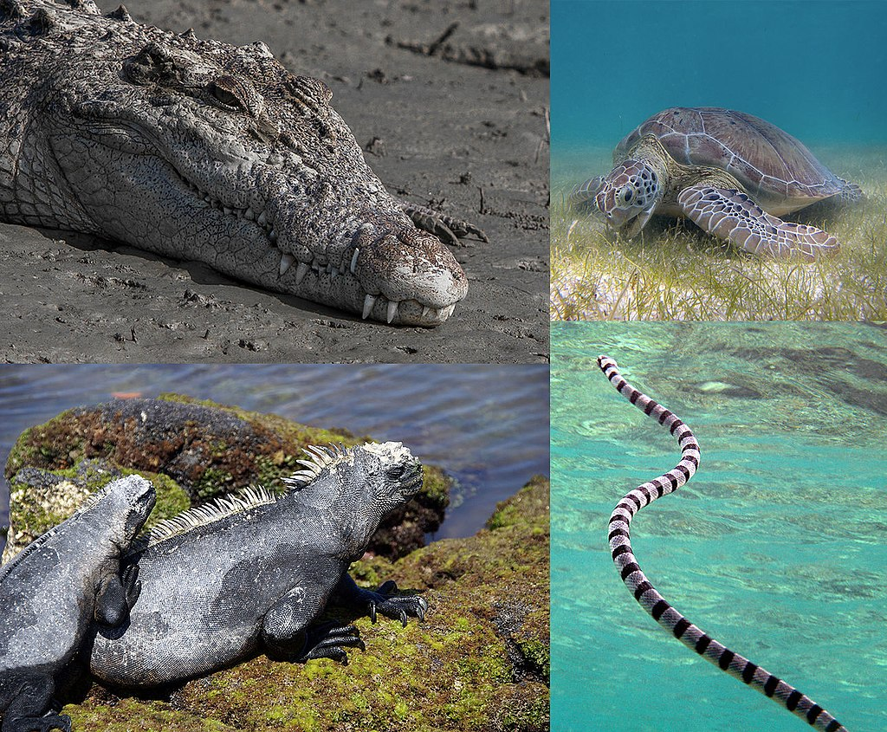
Reptiles that live in the sea. 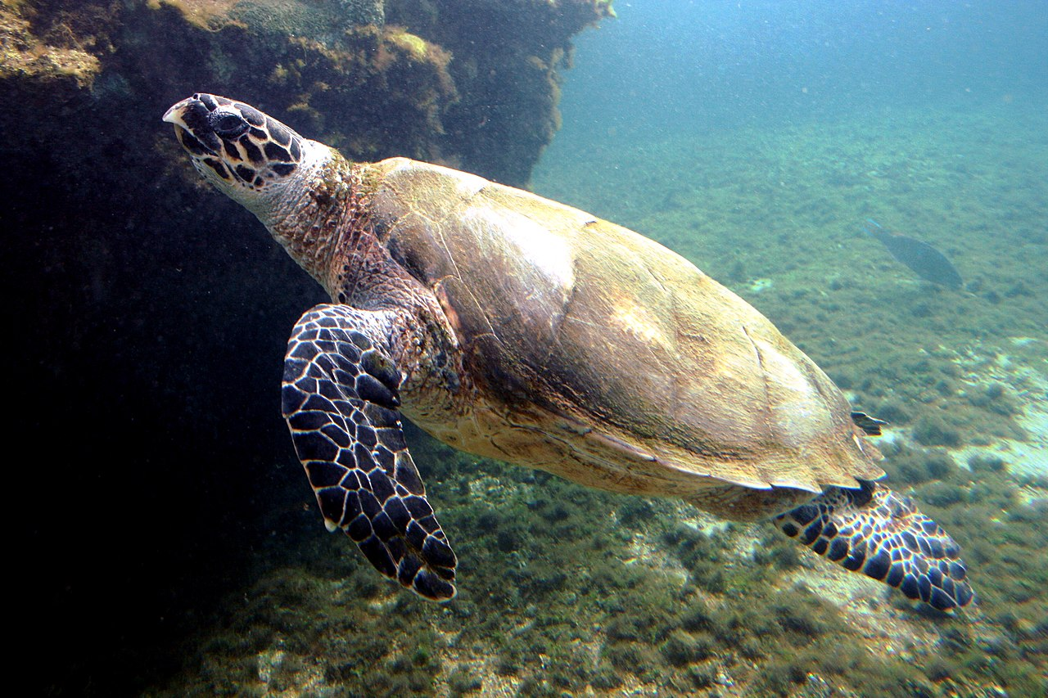
Hawksbill sea turtle (Eretmochelys imbricata) off the coast of Saba
Sea snakes, or coral reef snakes, are a subfamily of venomous elapid snakes, the Hydrophiinae, that inhabit marine environments for most or all of their lives. Most are extensively adapted to a fully aquatic life and are unable to move on land, except for the genus Laticauda, which has limited land movement. They are found in warm coastal waters from the Indian Ocean to the Pacific and are closely related to venomous terrestrial snakes in Australia.
All sea snakes have paddle-like tails and many have laterally compressed bodies that give them an eel-like appearance. Unlike fish, they do not have gills and must surface regularly to breathe. Along with whales, they are among the most completely aquatic of all air-breathing vertebrates.^{[3]} Among this group are species with some of the most potent venoms of all snakes. Some have gentle dispositions and bite only when provoked, but others are much more aggressive. Currently, 17 genera are described as sea snakes, comprising 69 spec
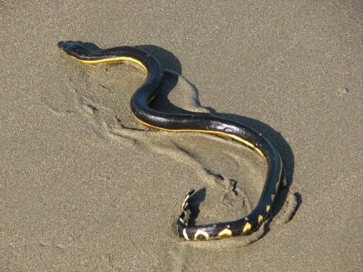 Yellow-bellied sea snake (Pelamis platura) on a beach in Costa Rica
Kingdom: | Animalia
Phylum: | Chordata
Class: | Reptilia
Order: | Squamata
Suborder: | Serpentes
Family: | Elapidae
Subfamily: | Hydrophiinae

The marine iguana (Amblyrhynchus cristatus), also known as the sea iguana, saltwater iguana, or Galápagos marine iguana, is a species of iguana found only on the Galápagos Islands (Ecuador) that has the ability, unique among modern lizards, to forage in the sea, making it a marine reptile. This iguana feeds almost exclusively on algae and large males dive to find this food source, while females and smaller males feed during low tide in the intertidal zone. They mainly live in colonies on rocky shores where they warm after visiting the relatively cold water or intertidal zone, but can also be seen in marshes, mangrove and beaches. Large males defend territories for a short period, but smaller males have other breeding strategies. After mating, the female digs a nest hole in the soil where she lays her eggs, leaving them to hatch on their own a few months later.^{[5]}
Marine iguanas vary in appearance between the different islands and several subspecies are recognized. Although relatively large numbers remain and it is locally abundant,^{[7]} this protected species is considered threatened, primarily from El Niños, introduced predators and chance events like oil spills.^{[1}
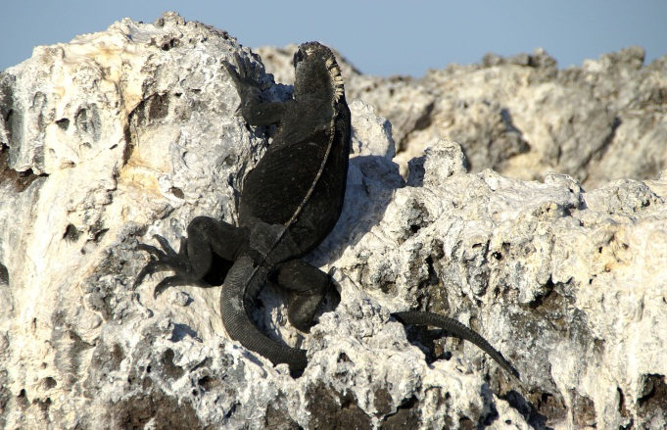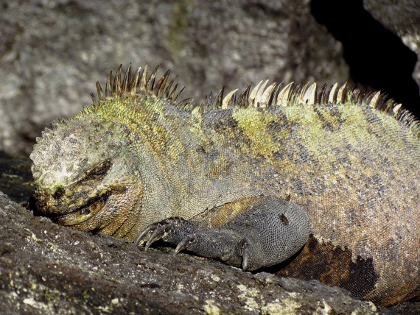
A. c. albemarlensis on Isabela Island A. c. cristatus on Fernandina Island
Sea turtles arose about 100 million years ago from terrestrial or fresh-water turtles (Figure 1) [2]. Currently only 7 species are extant (Table 1) although certain authors list Chelonia mydas agassizi as an eighth valid species (e.g. [3]). Sea turtles are found primarily along tropical coasts (Figure 2). However, some are also well-known for their long journeys across the oceans. Most species nest along the coasts of Central and South America or in the Caribbean, although some species occasionally travel as far north as Scandinavia. Like many other reptiles, most if not all sea turtles seem to use temperature-dependent sex determination (TSD). TSD has been demonstrated for loggerhead (Caretta caretta), green (Chelonia mydas), leatherback (Dermochelys coriacea) and olive ridley (Lepidochelys olivacea) turtles [4]. Since TSD is often sensitive to small changes in temperature, global warming may eventually affect sex ratios in these species and, together with their general vulnerabilities (see below), have a dramatic effect on their reproductive rate and thus long-term survival.

