COLLEGE OF APPLIED STUDIES AND COMMUNITY SERVICE
CT1411
Sheet#7

Q1. Using Graphics capabilities draw the following diagram.
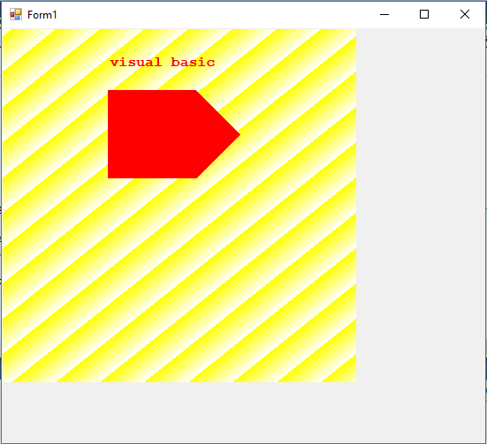
(120,170)
(270,120)
(220,70)
(120,70)
Hint:
- Use linear gradient brush (yellow and white) to fill the background rectangle
- The background rectangle width = 400, Height = 400
- The string starts in point (120, 30), color is red, and style is bold.
- The Polygon color is red.

