King Saud University
College of Applied Studies and Community Service
Programming and Database Diploma
2nd Semester (1434-1435)

(CT1311): Visual Basic Programming 1

Sheet 1

Using Visual Basic:
- Write a project that has this question “what is the visual basic?” then when a user press the button, the program will show this answer “It is one of the visual studio package” and a picture .

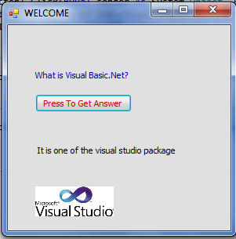
Your program should be seems like Figure 1

Fig.1
******************************************
2. Write a project that allows the user to enter two numbers then calculate math operations (-,*,/,\,mod,^) of the numbers and show the result in msgbox?

Your program should be seems like Figure 2

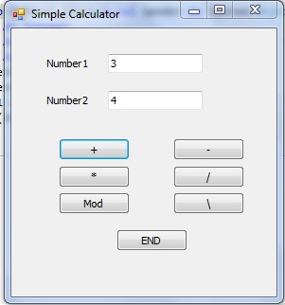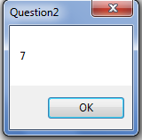
Fig.2

