Example :
Java has one important arithmetical operator you may not be familiar with, %, also known as the modulus or remainder operator. The % operator returns the remainder of two numbers. Generates the remainder when you divide two integer values.
For instance 10 % 3 is 1 because 10 divided by 3 leaves a remainder of 1. You can use % just as you might use any other more common operator like + or -.

5%3 gives 2 5%4 gives 1
5%5 gives 0 5%10 gives 5
Modulus operator is most commonly used with integer operands. If we attempt to use the modulus operator on floating-point values we will garbage
To help you understand more try to run this code:
public static void main(String [] args)
{
System.out.println(10/3);
System.out.println(10.0/3);
System.out.println(10/3.0);

System.out.println(10%3);
System.out.println(10.0%3);
System.out.println(10%3.0);
}

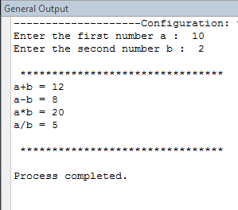
write a JAVA code to DO the following :
- a program that asks the user to enter two numbers and print out the (sum-subtract-multiply-product) of the two numbers.

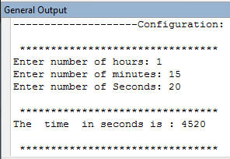
- a program that outputs the time in seconds , after reading the time in hours, minutes and seconds.
Note: Define and use constants in your coding FOR number of seconds in hour and number of seconds in minutes.

- reads three int numbers a,b and c then calculates the following formula
$$4ba^{3}+\frac{3c}{b+a}$$
- reads an integer of 4 digits and print the right most digit and the left most digit of the number.
Note: Use the % operator and the / operator
Here is a similar example Get some inspiration from it and give it a try
