COLLEGE OF APPLIED STUDIES AND COMMUNITY SERVICE
CT1411
Sheet#4

Using Graphics capabilities draw the following diagram.
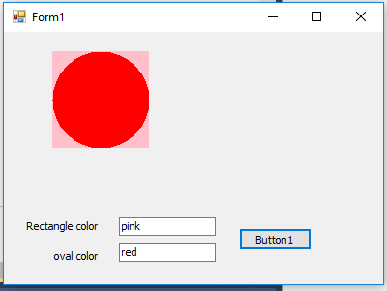
Draw two shapes rectangle and oval with colors specified by the user in text boxes.

