Sheet # 6
Question #2: Write visual basic Programs

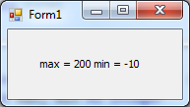
- Write a program that have a one dimensional array with 10 elements and then calculate the maximum array element and the minimum array element (without using the built in functions arrayName.Min and arrayMin.Max) then display the result.
Example:
ArrayName = {20, 10, 5, 17, 18, 19, -10, 200, 12, 10}

- (Grade Analyzer) Write a program that analyses student grades of CT 1311 and CT 1314 courses which are as follows:
Amal  CT 1311 | Ahlam | Enas | Faten | Hend | Jamelah | Khuloud | Lamya | Nadya | Rema
90  CT 1314 | 93 | 61 | 77 | 89 | 72 | 99 | 82 | 68 | 59
100 | 87 | 78 | 69 | 75 | 94 | 81 | 60 | 97 | 40

Your program should classify these map these grades into its corresponding letters (A+,A,B+,B,C+,C,D+,D,F} and stores the result in a two dimensional array. Then print the result as shown below:
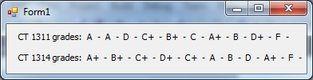

- Write a program that reads 3 sentences consisting of only three words for each one as follows:
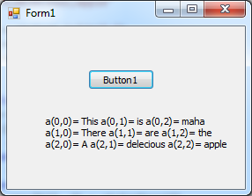
The First sentence is separated by (-) word1-word2-word3
The second separated by (,) word1,word2,word3
And the last one separated by (;) word1;word2;word3
Then store these 3 sentences in a two dimensional (3 by 3) array and display the output as shown above.

