Given the following diagram, Implement all the Classes and write a client code to test your application.
Emlpoyee
+ name
+hourerate
+CalculateEarning()
SalariedEmployee
-workedhoures
+CalculateEarning()
patrEmployee
-number of soled parts
CalculateEarning()

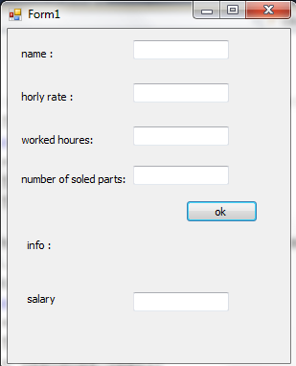
- Class Employee:
CalculateEarning(): return double and its must override method.
- Class Salaried Employee:
CalculateEarning(): return the salary (hourerate*workedhoure)
- Class patrEmployee:
CalculateEarning(): return the horerate* number of soled parts.
- Write appropriate properties for each class.
- The client program should be test the application by :

Create the appropriate object depending on the information he filled and calculate and display the salary.

