MACRO

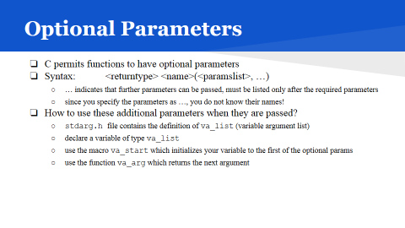

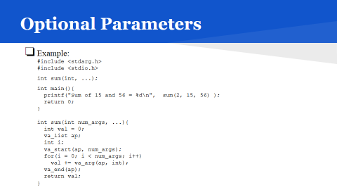

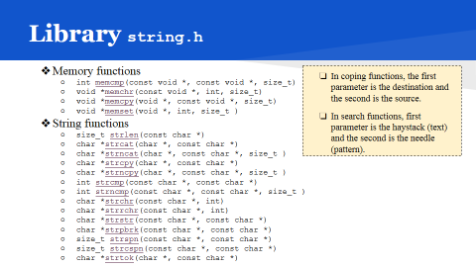

strlen()

Description
The C library function size_t strlen(const char *str) computes the length of the string str up to, but not including the terminating null character.

Declaration
Following is the declaration for strlen() function.
size_t strlen(const char *str)

Parameters
- str -- This is the string whose length is to be found.

Return Value
This function returns the length of string.

Example
The following example shows the usage of strlen() function.
#include <stdio.h>
#include <string.h>

int main ()
{
char str[50];
int len;

strcpy(str, "This is tutorialspoint.com");

len = strlen(str);
printf("Length of |%s| is |%d|\n", str, len);

return(0);
}
Length of |This is tutorialspoint.com| is |26|

strcat()

Description
The C library function char *strcat(char *dest, const char *src) appends the string pointed to by src to the end of the string pointed to by dest.

Declaration
Following is the declaration for strcat() function.
char *strcat(char *dest, const char *src)

Parameters
- dest -- This is pointer to the destination array, which should contain a C string, and should be large enough to contain the concatenated resulting string.
- src -- This is the string to be appended. This should not overlap the destination.

Return Value
This function returns a pointer to the resulting string dest.

Example
The following example shows the usage of strcat() function.
#include <stdio.h>
#include <string.h>

int main ()
{
char src[50], dest[50];

strcpy(src, "This is source");
strcpy(dest, "This is destination");

strcat(dest, src);

printf("Final destination string : |%s|", dest);

return(0);
}
Final destination string : |This is destinationThis is source|

strncat()

Description
The C library function char *strncat(char *dest, const char *src, size_t n)appends the string pointed to by src to the end of the string pointed to by destup to n characters long.

Declaration
Following is the declaration for strncat() function.
char *strncat(char *dest, const char *src, size_t n)

Parameters
- dest -- This is pointer to the destination array, which should contain a C string, and should be large enough to contain the concatenated resulting string which includes the additional null-character.
- src -- This is the string to be appended.
- n -- This is the maximum number of characters to be appended.

Return Value
This function returns a pointer to the resulting string dest.

Example
The following example shows the usage of strncat() function.
#include <stdio.h>
#include <string.h>

int main ()
{
char src[50], dest[50];

strcpy(src, "This is source");
strcpy(dest, "This is destination");

strncat(dest, src, 15);

printf("Final destination string : |%s|", dest);

return(0);
}
Final destination string : |This is destinationThis is source|

Concept strcopy()
Syntax :
Char *strcpy( char *dst, const char* src)
Own Implementation:
char* mystrcpy(char *dst, char*src)
{
While(*dst++ = *stc++);
}
Problems:
- If src length larger than dst buffer overflow.
- If dst overlaps with src

Src = I n d I a ‘\0’
1 2 3 4 5 6
Des = I n d I a ‘\0’ _ _
1 2 3 4 5 6

Src = I n d I a ‘\0’
Des = d I a ‘\0’ _ _
3 4 5 6 7 8

Src = I n d I a ‘\0’
After overlapping..
Whats the case?

Example Link: https://www.tutorialspoint.com/c_standard_library/c_function_memset.htm

C library function - memset()

The C library function void *memset(void *str, int c, size_t n) copies the character c (an unsigned char) to the first n characters of the string pointed to, by the argument str.

Declaration
Following is the declaration for memset() function.
void *memset(void *str, int c, size_t n)

Parameters
- str -- This is a pointer to the block of memory to fill.
- c -- This is the value to be set. The value is passed as an int, but the function fills the block of memory using the unsigned char conversion of this value.
- n -- This is the number of bytes to be set to the value.

#include <stdio.h>
#include <string.h>

int main ()
{
char str[50];

strcpy(str,"This is string.h library function");
puts(str);

memset(str,'$',7);
puts(str);

return(0);
}

Output:
This is string.h library function
$$$$$$$ string.h library function

Memcpy()

The C library function void *memcpy(void *str1, const void *str2, size_t n) copies n characters from memory area str2 to memory area str1.

Declaration
Following is the declaration for memcpy() function.
void *memcpy(void *str1, const void *str2, size_t n)

Parameters
- str1 -- This is pointer to the destination array where the content is to be copied, type-casted to a pointer of type void*.
- str2 -- This is pointer to the source of data to be copied, type-casted to a pointer of type void*.
- n -- This is the number of bytes to be copied.

Return Value
This function returns a pointer to destination, which is str1.

Example
The following example shows the usage of memcpy() function.
#include <stdio.h>
#include <string.h>

int main ()
{
const char src[50] = "http://www.tutorialspoint.com";
char dest[50];

printf("Before memcpy dest = %s\n", dest);
memcpy(dest, src, strlen(src)+1);
printf("After memcpy dest = %s\n", dest);

return(0);
}
Let us compile and run the above program that will produce the following result:
Before memcpy dest =
After memcpy dest = http://www.tutorialspoint.com

https://www.tutorialspoint.com/c_standard_library/c_function_memcpy.htm

memchr()

Description
The C library function void *memchr(const void *str, int c, size_t n)searches for the first occurrence of the character c (an unsigned char) in the first n bytes of the string pointed to, by the argument str.

Declaration
Following is the declaration for memchr() function.
void *memchr(const void *str, int c, size_t n)

Parameters
- str -- This is the pointer to the block of memory where the search is performed.
- c -- This is the value to be passed as an int, but the function performs a byte per byte search using the unsigned char conversion of this value.
- n -- This is the number of bytes to be analyzed.

Return Value
This function returns a pointer to the matching byte or NULL if the character does not occur in the given memory area.

Example
The following example shows the usage of memchr() function.
#include <stdio.h>
#include <string.h>

int main ()
{
const char str[] = "http://www.tutorialspoint.com";
const char ch = '.';
char *ret;

ret = memchr(str, ch, strlen(str));

printf("String after |%c| is - |%s|\n", ch, ret);

return(0);
}
Let us compile and run the above program that will produce the following result:
String after |.| is - |.tutorialspoint.com|

strtok()
The C library function char *strtok(char *str, const char *delim) breaks string str into a series of tokens using the delimiter delim.

Declaration
Following is the declaration for strtok() function.
char *strtok(char *str, const char *delim)

Parameters
- str -- The contents of this string are modified and broken into smaller strings (tokens).
- delim -- This is the C string containing the delimiters. These may vary from one call to another.

Return Value
This function returns a pointer to the last token found in the string. A null pointer is returned if there are no tokens left to retrieve.

Example
The following example shows the usage of strtok() function.
#include <string.h>
#include <stdio.h>

int main()
{
char str[80] = "This is - www.tutorialspoint.com - website";
const char s[2] = "-";
char *token;

/* get the first token */
token = strtok(str, s);

/* walk through other tokens */
while( token != NULL )
{
printf( " %s\n", token );

token = strtok(NULL, s);
}

return(0);
}
Let us compile and run the above program that will produce the following result:
This is
www.tutorialspoint.com
website

<time.h>
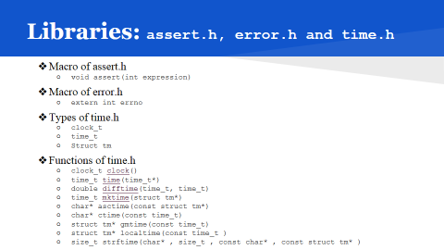

The time.h header defines four variable types, two macro and various functions for manipulating date and time.

Library Variables
Following are the variable types defined in the header time.h:
S.N. | Variable & Description
1 | size_t  This is the unsigned integral type and is the result of the sizeofkeyword.
2 | clock_t  This is a type suitable for storing the processor time.
3 | time_t is  This is a type suitable for storing the calendar time.
4 | struct tm  This is a structure used to hold the time and date.
The tm structure has the following definition:
struct tm {
int tm_sec; /* seconds, range 0 to 59 */
int tm_min; /* minutes, range 0 to 59 */
int tm_hour; /* hours, range 0 to 23 */
int tm_mday; /* day of the month, range 1 to 31 */
int tm_mon; /* month, range 0 to 11 */
int tm_year; /* The number of years since 1900 */
int tm_wday; /* day of the week, range 0 to 6 */
int tm_yday; /* day in the year, range 0 to 365 */
int tm_isdst; /* daylight saving time */
};

Library Macros
Following are the macros defined in the header time.h:
S.N. | Macro & Description
1 | NULL  This macro is the value of a null pointer constant.
2 | CLOCKS_PER_SEC  This macro represents the number of processor clocks per second.

Library Functions
Following are the functions defined in the header time.h:
S.N. | Function & Description
1 | char *asctime(const struct tm *timeptr)  Returns a pointer to a string which represents the day and time of the structure timeptr.
2 | clock_t clock(void)  Returns the processor clock time used since the beginning of an implementation defined era (normally the beginning of the program).
3 | char *ctime(const time_t *timer)  Returns a string representing the localtime based on the argument timer.
4 | double difftime(time_t time1, time_t time2)  Returns the difference of seconds between time1 and time2 (time1-time2).
5 | struct tm *gmtime(const time_t *timer)  The value of timer is broken up into the structure tm and expressed in Coordinated Universal Time (UTC) also known as Greenwich Mean Time (GMT).
6 | struct tm *localtime(const time_t *timer)  The value of timer is broken up into the structure tm and expressed in the local time zone.
7 | time_t mktime(struct tm *timeptr)  Converts the structure pointed to by timeptr into a time_t value according to the local time zone.
8 | size_t strftime(char *str, size_t maxsize, const char *format, const struct tm *timeptr)  Formats the time represented in the structure timeptr according to the formatting rules defined in format and stored into str.
9 | time_t time(time_t *timer)  Calculates the current calender time and encodes it into time_t format.

asctime()

Description
The C library function char *asctime(const struct tm *timeptr) returns a pointer to a string which represents the day and time of the structure struct timeptr.

Declaration
Following is the declaration for asctime() function.
char *asctime(const struct tm *timeptr)

Parameters
The timeptr is a pointer to tm structure that contains a calendar time broken down into its components as shown below:
struct tm {
int tm_sec; /* seconds, range 0 to 59 */
int tm_min; /* minutes, range 0 to 59 */
int tm_hour; /* hours, range 0 to 23 */
int tm_mday; /* day of the month, range 1 to 31 */
int tm_mon; /* month, range 0 to 11 */
int tm_year; /* The number of years since 1900 */
int tm_wday; /* day of the week, range 0 to 6 */
int tm_yday; /* day in the year, range 0 to 365 */
int tm_isdst; /* daylight saving time */
};

Return Value
This function returns a C string containing the date and time information in a human-readable format Www Mmm dd hh:mm:ss yyyy, where Www is the weekday, Mmm the month in letters, dd the day of the month, hh:mm:ss the time, and yyyy the year.

Example
The following example shows the usage of asctime() function.
#include <stdio.h>
#include <string.h>
#include <time.h>

int main()
{
struct tm t;

t.tm_sec = 10;
t.tm_min = 10;
t.tm_hour = 6;
t.tm_mday = 25;
t.tm_mon = 2;
t.tm_year = 89;
t.tm_wday = 6;

puts(asctime(&t));

return(0);
}
Let us compile and run the above program that will produce the following result:
Sat Mar 25 06:10:10 1989

clock()

Description
The C library function clock_t clock(void) returns the number of clock ticks elapsed since the program was launched. To get the number of seconds used by the CPU, you will need to divide by CLOCKS_PER_SEC.
On a 32 bit system where CLOCKS_PER_SEC equals 1000000 this function will return the same value approximately every 72 minutes.

Declaration
Following is the declaration for clock() function.
clock_t clock(void)

Parameters
- NA

Return Value
This function returns the number of clock ticks elapsed since the start of the program. On failure, the function returns a value of -1.

Example
The following example shows the usage of clock() function.
#include <time.h>
#include <stdio.h>

int main()
{
clock_t start_t, end_t, total_t;
int i;

start_t = clock();
printf("Starting of the program, start_t = %ld\n", start_t);

printf("Going to scan a big loop, start_t = %ld\n", start_t);
for(i=0; i< 10000000; i++)
{
}
end_t = clock();
printf("End of the big loop, end_t = %ld\n", end_t);

total_t = (double)(end_t - start_t) / CLOCKS_PER_SEC;
printf("Total time taken by CPU: %f\n", total_t );
printf("Exiting of the program...\n");

return(0);
}
Starting of the program, start_t = 0
Going to scan a big loop, start_t = 0
End of the big loop, end_t = 20000
Total time taken by CPU: 0.000000
Exiting of the program...

difftime()

Description
The C library function double difftime(time_t time1, time_t time2) returns the difference of seconds between time1 and time2 i.e. (time1 - time2). The two times are specified in calendar time, which represents the time elapsed since the Epoch (00:00:00 on January 1, 1970, Coordinated Universal Time (UTC)).

Declaration
Following is the declaration for difftime() function.
double difftime(time_t time1, time_t time2)

Parameters
- time1 -- This is the time_t object for end time.
- time2 -- This is the time_t object for start time.

Return Value
This function returns the difference of two times (time1 - time2) as a double value.

Example
The following example shows the usage of difftime() function.
#include <stdio.h>
#include <time.h>

int main ()
{
time_t start_t, end_t;
double diff_t;

printf("Starting of the program...\n");
time(&start_t);

printf("Sleeping for 5 seconds...\n");
sleep(5);

time(&end_t);
diff_t = difftime(end_t, start_t);

printf("Execution time = %f\n", diff_t);
printf("Exiting of the program...\n");

return(0);
}
Let us compile and run the above program that will produce the following result:
Starting of the program...
Sleeping for 5 seconds...
Execution time = 5.000000
Exiting of the program...

