Business Statistics (QUA 207)

Second Term (2020/2021) (1442H)

Course description
The course basically deals with inferential statistics, which will be the focus of the course. The topics covered in the course include Central limit theorem and sampling distribution; statistical inference involving means, proportions; ANOVA; Chi-Square Tests; and simple regression.

Course objectives
The main objective of this course is to provide basic knowledge about inferential statistics for the purpose of making effective business decisions.
The objectives of the course can be sated as follows:
- Understand the concept of the sampling distribution.
- Understand the importance of the Central Limit Theorem.
- Construct and interpret confidence interval estimates for sample statistics.
- Compute probabilities related to sample statistics.
- Determine the sample size necessary to develop confidence interval estimate for a parameter.
- Learn how to use hypothesis testing to test parameters.
- Compare the parameters of two populations.
- Compare the means of two and more than two populations.
- Learn when to use the chi-square test for contingency tables.
- Learn to use regression analysis and evaluate its assumptions.
- Use software programs (such as SPSS or Microsoft Excel)

Required Materials (More Information on Page: 5)
David M. Levine, Kathryn A. Szabat, David F. Stephan: Business Statistics: A First Course, 7th Global Edition, Pearson.
Textbook ISBN-13: 978-1-292-09593-6
MyLab Statistics: You are required to purchase access to MyLab Statistics, if you fail to do so you will lose up to 20% of total course credit.
Required Chapters: 7, 8, 9, 10, 11, and 12

Study Plan
- In MyLab Statistics, each student will complete an individualized Study Plan that reflects their progress through the course material.
- Each Section/ Chapter of the textbook covered in class is associated with up to 4-6 Objectives, each objective is worth one Mastery Point.
- Each Objective may be practiced by using the Practice button in the Study Plan. You will be graded based on the number of mastery points earned and you can earn mastery points by successfully taking a Quiz Me.
- If you are having trouble with a particular question, while you are in the problem, you may want to click Help Me Solve This, View an Example, or Textbook Pages.
- If you still need help, please post a question on the Discussion Forum for the assigned Chapter. Remember, working study Plan problems is the best preparation for the exams.

Homework Assignment (10%)
- The assignments are drawn from the problems at the end of each textbook chapter and practice problems. You should correctly answer each question prior to the posted due date.
- Homework problems that are attempted and submitted will NOT be accepted.
- Make sure you perform well as possible on the Homework!

Homework Schedule (Male & Female)
Homework | Start |  |  | End (Due Dates)
Ch7 | Thursday | 21/01/2021 | 6:00pm | Saturday | 13/02/2021 | 11:59pm
Ch8 |  | 31/01/2021 |  |  | 20/02/2021
Ch9(1) |  | 18/02/2021 |  |  | 6/03/2021
Ch9(2) |  | 04/03/2021 |  |  | 20/03/2021
Ch10 |  | 18/03/2021 |  |  | 10/04/2021
Ch11 |  | 08/04/2021 |  |  | 24/04/2021
Ch12 |  | 11/04/2021 |  |  | 24/04/2021

Quizzes (10%)
- Quizzes are given based on the timetable below “Quizzes Schedule”. Students are expected to work on quizzes individually.
- These quizzes are provided as an aid for preparing for the midterm and the final exam.
- The quiz will contain 8-15 questions and you will only have 30 minutes to take the quiz.
- The instructor reserves the right to utilize whatever format (true-false, multiple choice, fill in the blank, essay/short answer) or combination of formats he\she deems necessary and in the students’ best interest.
- There is no make-up for missed quizzes, you only have one attempt and your overall quizzes evaluation will be based on the best 4 out of 6 quizzes.
Quizzes Schedule (Male & Female)
Quizzes | Day | Date | Start | End
Ch7 | Sunday | 14/02/2021 | 8:00pm | 10:00pm
Ch8 | Sunday | 21/02/2021 | 8:00pm | 10:00pm
Ch9 | Sunday | 28/02/2021 | 8:00pm | 10:00pm
Ch10 | Sunday | 28/03/2021 | 8:00pm | 10:00pm
Ch11 | Sunday | 11/04/2021 | 8:00pm | 10:00pm
Ch12 | Sunday | 18/04/2021 | 8:00pm | 10:00pm

Exams
- There shall be three examinations given during this course, two midterms and a final examination.
- The 1st midterm is the 8th week–and the 2nd is the 11th week of the term.
- The instructor reserves the right to utilize whatever format (true-false, multiple choice, fill in the blank, essay/short answer) or combination of formats he\she deems necessary and in the students’ best interest.
- There is no make-up for missed Midterm exams and Final exams. Students are expected to take the exams during the week they are given.
- Remember, you only have one attempt and all midterm/final exams are closed book!

Male section
Exam | Day | Date | From | To | Points
First Midterm | Sunday | 07/03/2021 | 12:00pm | 01:30pm | 20%
Second Midterm | Wednesday | 31/03/2021 | 12:00pm | 01:30pm | 20%
Final Exam | Based on University Schedule |  |  |  | 40%

Female section
Exam | Day | Date | From | To | Points
First Midterm | Sunday | 07/03/2021 | 12:00pm | 01:30pm | 20%
Second Midterm | Wednesday | 31/03/2021 | 12:00pm | 01:30pm | 20%
Final Exam | Based on University Schedule |  |  |  | 40%

Evaluation

Assessment Task | Proportion of Assessment
Homework Assignment | 10%
Quizzes | 10%
First Midterm Exam | 20%
Second Midterm Exam | 20%
Final Exam | 40%
Total | 100%

Attendance Policy
- Regular and punctual attendance at all scheduled classes is expected from all students.
- Students may be denied entry to the final exam if they miss more than 25% of classes.

*This syllabus is subject to change by the Quantitative Analysis Department only at any time. Changes, if any, will be announced in class. Students will be held responsible for all changes.

Course outline
- Content of the Course and lectures Plan
Chapters | Contents | Weeks
 |  | Dates | Exams
Ch. 7  Sampling Distributions | 7.1 Sampling Distribution  7.2 Sampling Distribution of the Mean  7.3 Sampling Distribution of the Proportion. | 2 Weeks  (17Jan.-  28Jan.) | Covered by First midterm exam & Final exam
Ch. 8  Confidence Interval Estimation. | 8.1 Confidence Interval for the Mean (Known)  8.2 Confidence Interval for the Mean (Unknown)  - Confidence Interval for the Proportion  8.4 Determining Sample Size | 31 Jan.-11 Feb.)
Ch. 9 Fundamentals of Hypothesis Testing: One-Sample Tests | 9.1 Fundamentals of Hypothesis-Testing Methodology  9.2 t Test of Hypothesis for the mean (Unknown) | 2 Weeks  (14 Feb.-25Feb.)
First Midterm (20 points) 07/03/2021
Ch. 9 Fundamentals of Hypothesis Testing: One-Sample Tests | 9.3 One-Tail Tests  9.4 Z Test of Hypothesis for the Proportion | 1Week  (28 Feb.-4March.) | Covered by Second midterm exam & Final exam
Ch. 10  Two-Sample Tests and One-Way ANOVA | 10.1 Comparing the Means of Two Independent Populations (352 omitted)  10.2 Comparing the Means of Two Related Populations Paired t Test.  10.3 Comparing the Proportions of Two Independent Populations.  10.4 F Test for the Ratio of Two Variances.  10.5 One-Way AN OVA.(381 to 386 omitted) | 4 Weeks  (7 March.-1April.)
Second Midterm (20 points) 31/03/2021
Ch. 11  Chi-Square Tests | 11.1 Chi-Square Test for the Difference Between Two Proportions.  11.2 Chi-Square Test for Differences Among More Than Two Proportions.  11.3 Chi—Square Test of Independence. | 1 Week  (4 April-8April) | Covered by Final exam
Ch. 12  Simple Linear Regression | 12.1 Types of Regression Models.  12.2 Determining the Simple Linear Equation.  12.3 Measures of Variation.  12.7 Inferences About the Slope and Correlation Coefficient..(464 omitted) | 2 Weeks  (11 April.-22 April.)
Final Exam (40 points) Based on University Schedule

Required Materials
- Title: Business Statistics: A First Course, 7th Global Edition, Pearson
- Authors: Levine, Szabat, and Stephan
- Textbook ISBN-13: 978-1-292-09593-6
- Required Chapters: 7, 8, 9, 10, 11, and 12

MyLab Statistics
- In order to be able to work on the Study Plan, Homework, Quiz; the student MUST purchase MyLab Statistics Access Code (which will INCULDE the eTextbook), if you fail to do so you will lose up to 20% of total course credit.
- MyLab Statistics is a platform that is connected to the student’s LMS to enrichen the learning experience. It provides the student with access to the eTextbook, Example, and other multimedia material.

Learning Management System Support (Blackboard Support)
- Webpage: https://daleel.ksu.edu.sa/ar
- Tel#: 00966 11 4677297
- Tel#: 00966 11 4675557
- Email: itsupport@ksu.edu.sa
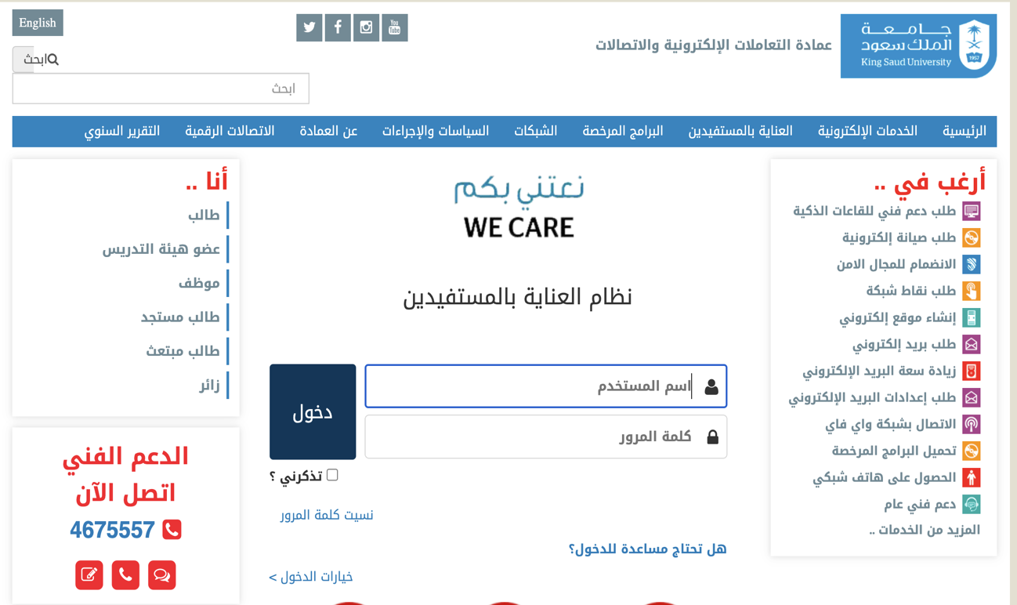

How to purchase the Book\ eBook\ MyLab Statistics Code
- Student Fund Market webpage direct link: https://salla.sa/student_fund/my-lab-statistics-a-first-course-global-7th-edition/p2130282455
- Student Fund Market webpage: https://salla.sa/student_fund
- Student Fund Support Tel#: +966540428743

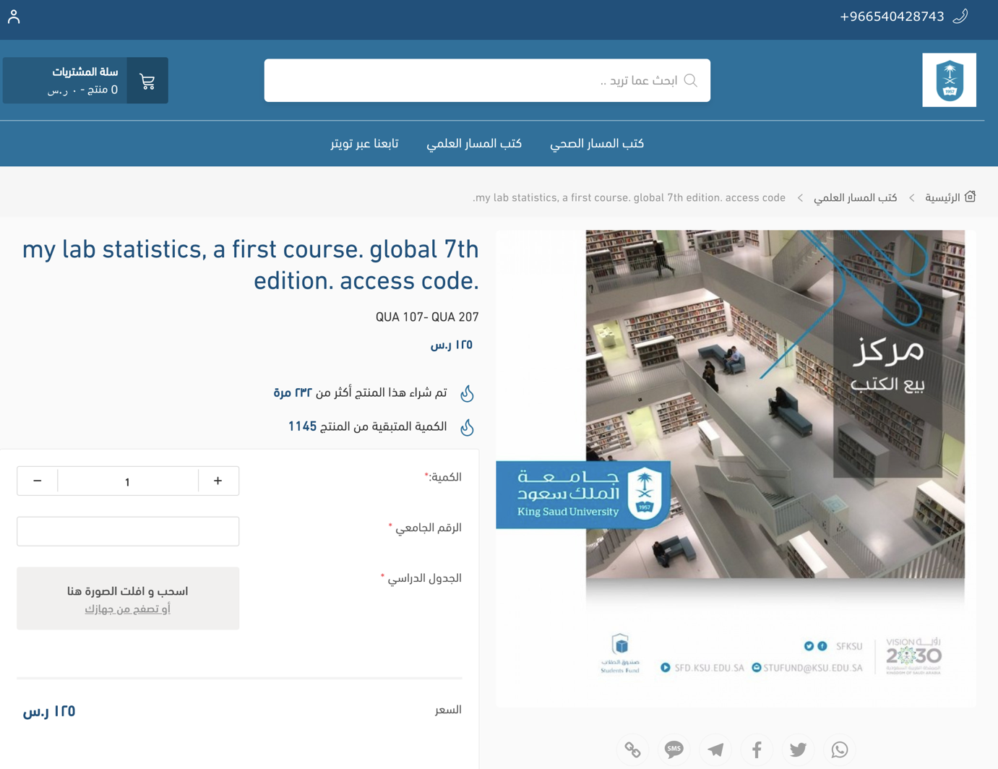

Activate your MyLab Statistics Code
In order to activate Code, You have to connect through your LMS.KSU.EDU.SA page and Select your section QUA_207, following these steps:
Step 1:
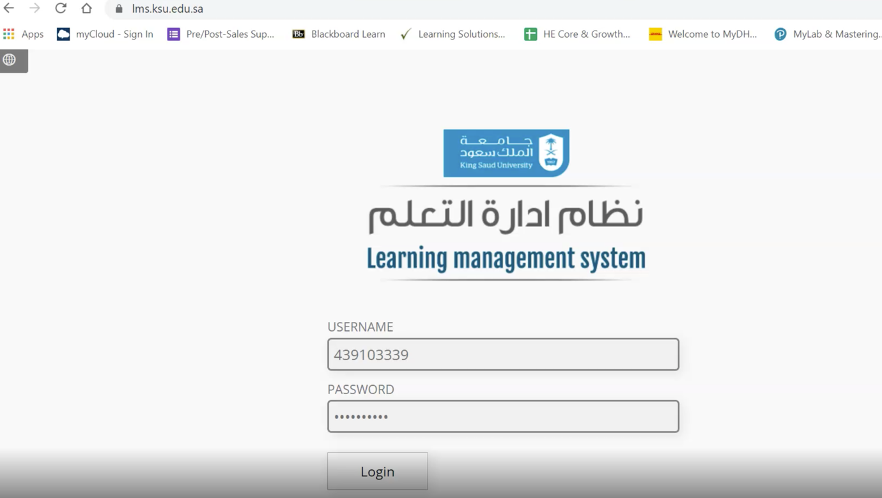
Step 2:
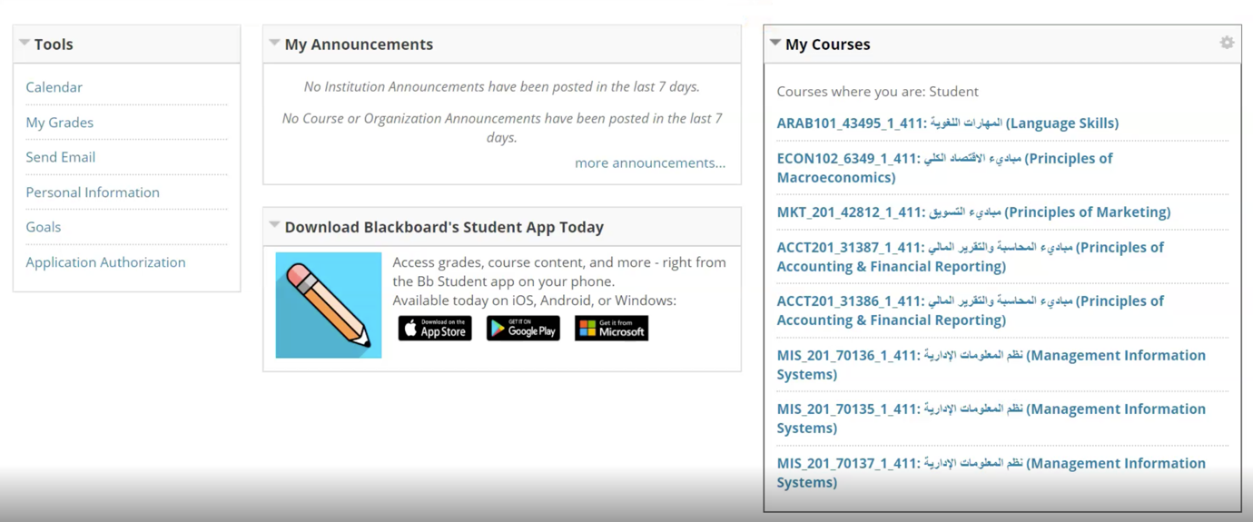
ابحث عن مادة
QUA_207

Step 3:
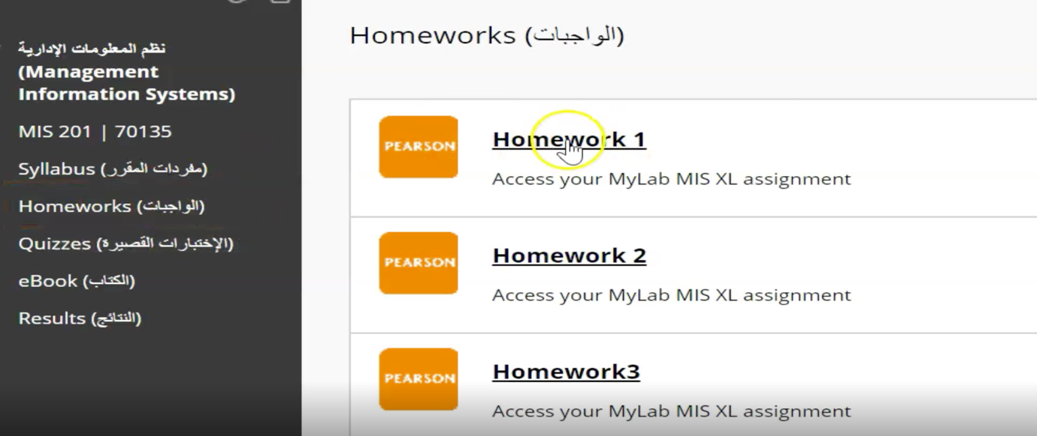
Step 4:
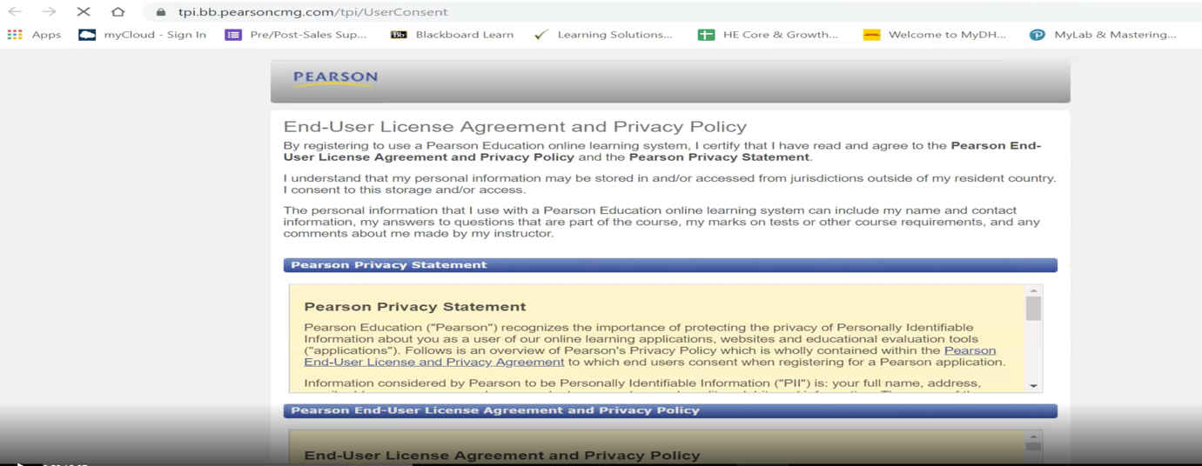
Step 5:
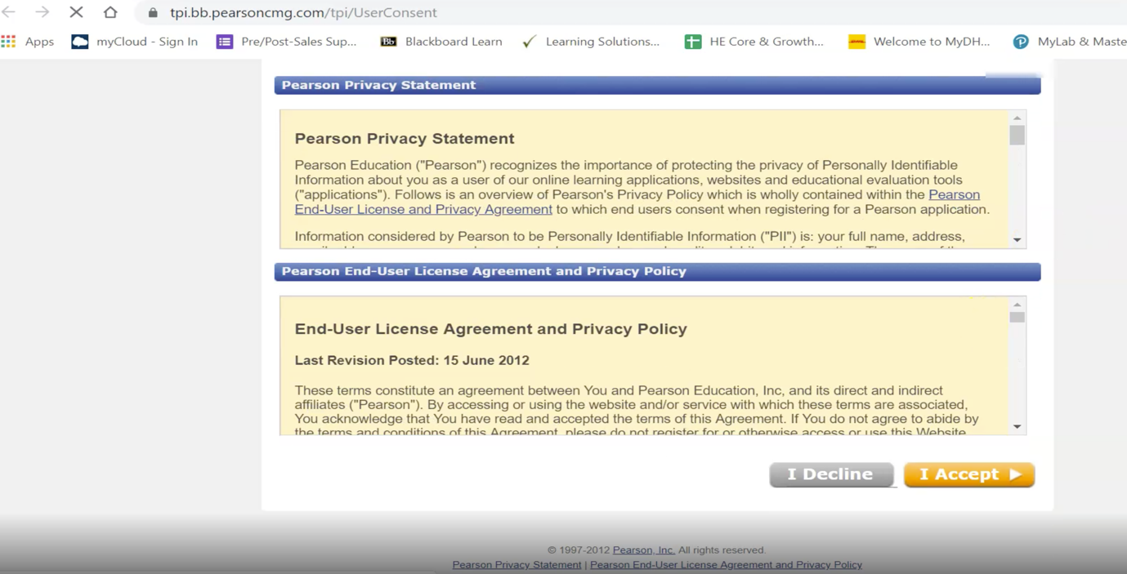
Step 6:
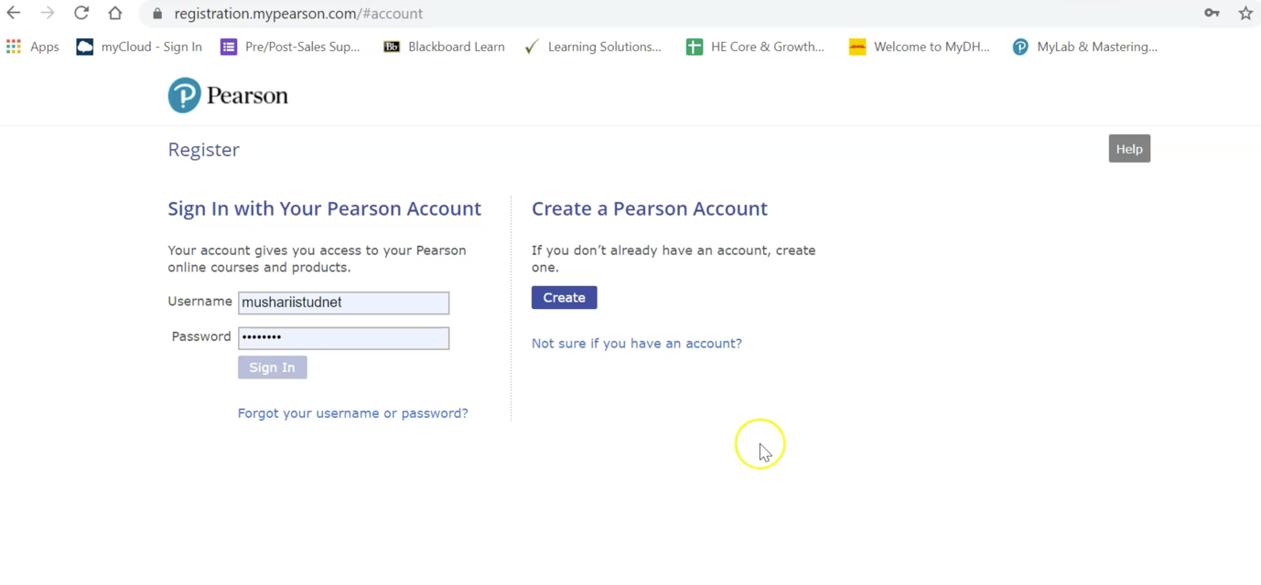
Step 7:
- Use your KSU Student Email.
- Any other Emails will NOT be accepted; such as: Gmail, Yahoo, … etc.
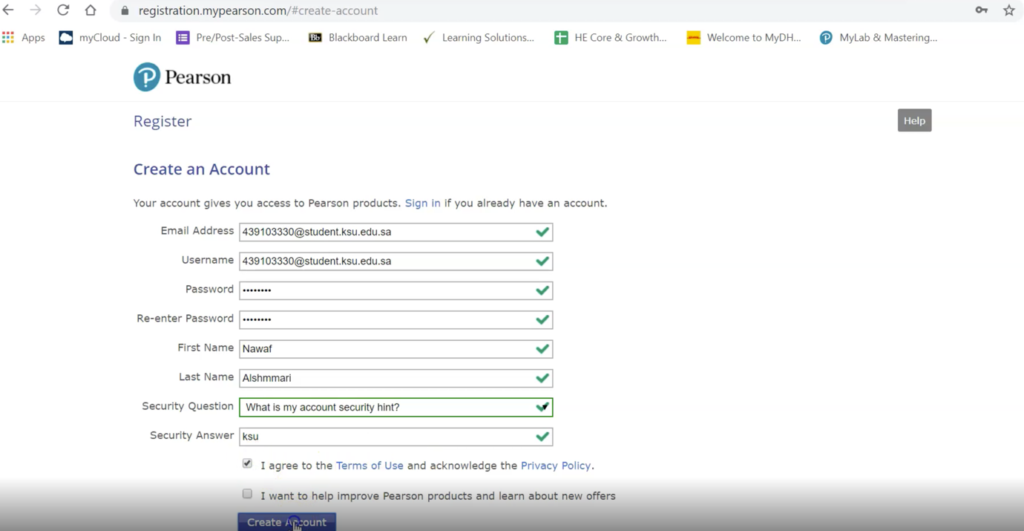
KSU EMAIL ONLY

Step 8:
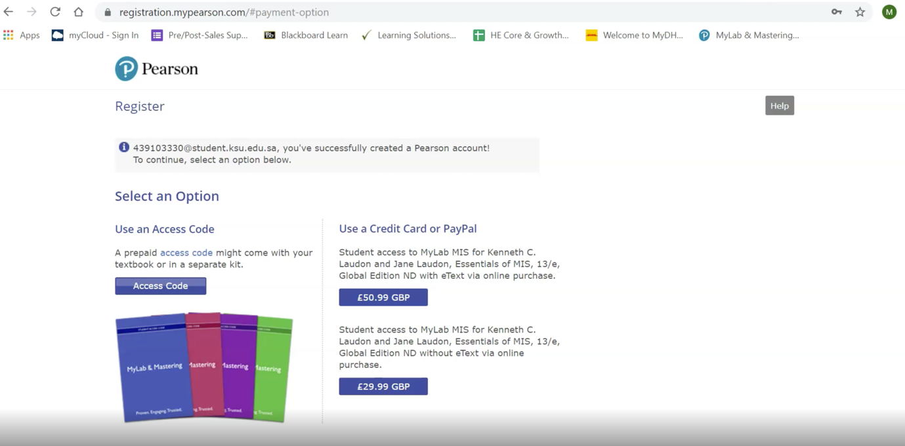

Step 9:
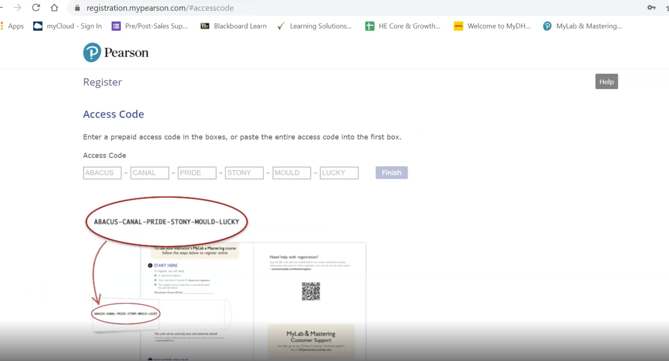
ادخل الكود الخاص بك هنا

Step 10:
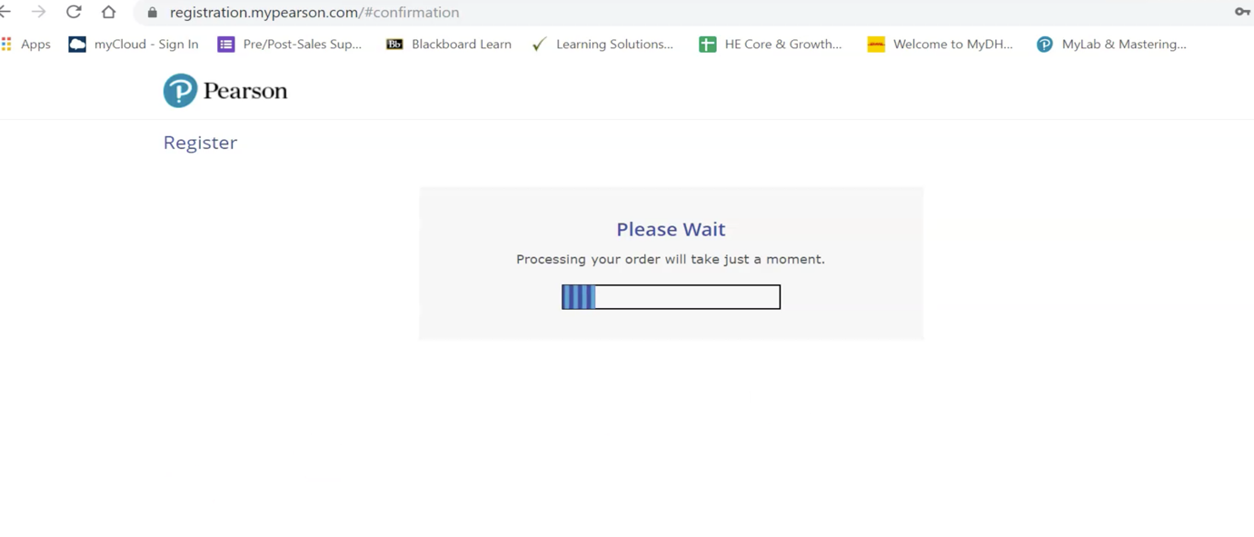
Step 11:
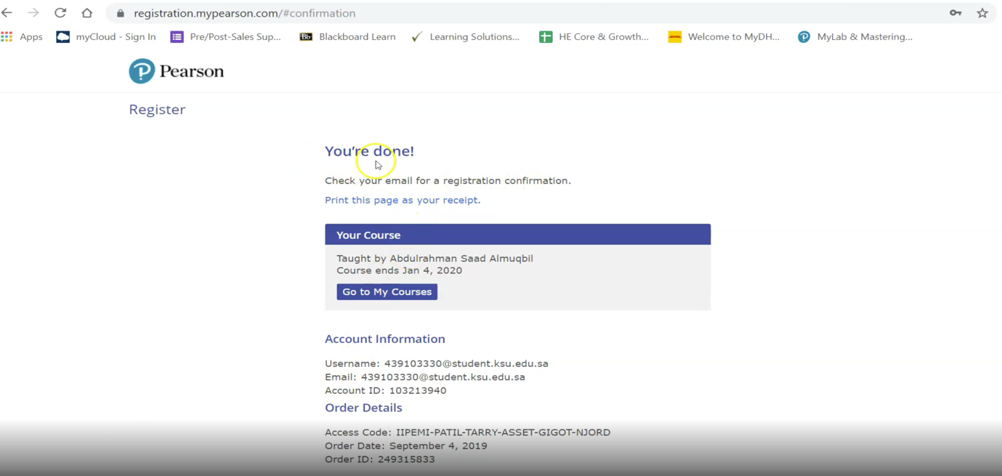
Step 12:
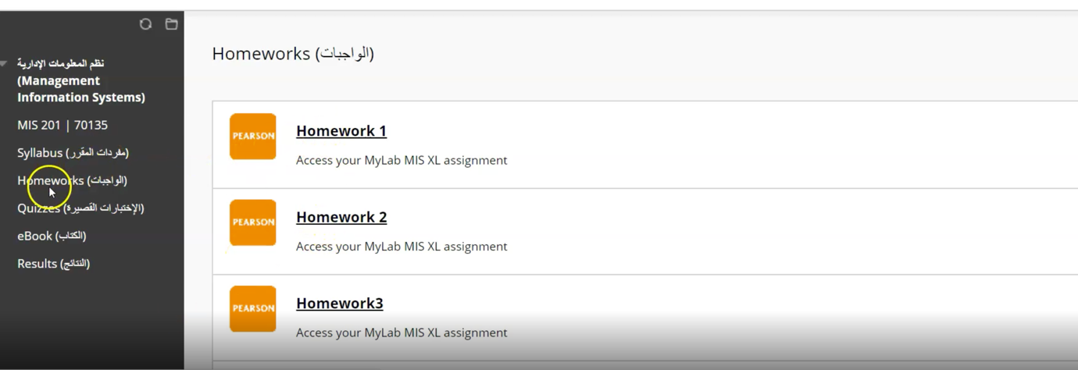

Step 13:
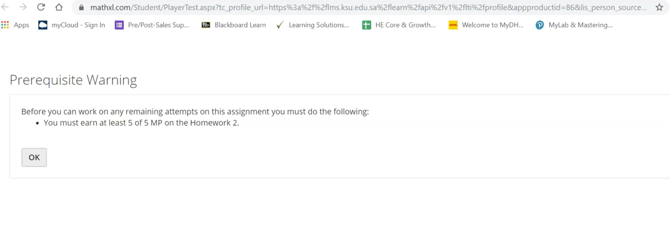
Practice Exercises Information

