King Saud University  College of Applied Studies and Community Service  Natural Science and Engineering Program | 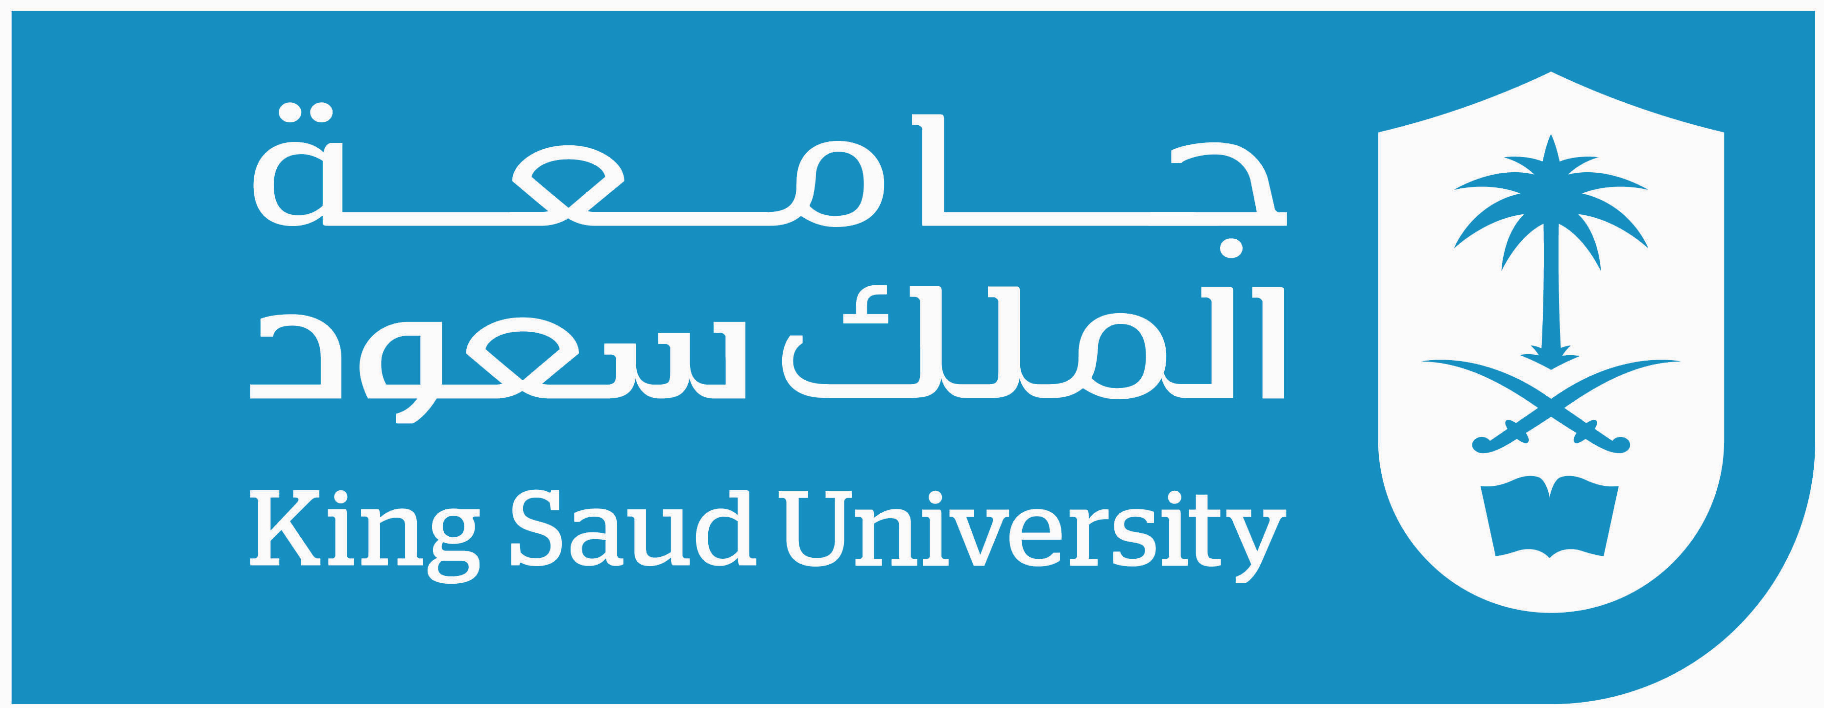

Communications Lab (1)
1302CT
1st Semester 1438/1439

Instructor: Nour Alhariqi
Email: nalhareqi@ksu.edu.sa noor.ksu@gmail.com
Office Hours: SUN: 12- 1 and by appointments
Credit Hours: 3 hours (1 Lecture + 4 labs)
Co-requisites: Communication Systems - CT1301
Course objectives:
The aim of this lab is to introduce the basics of electric communications that is used in our daily life in practical way. It gives theoretical and practical background in the following:
- Introducing electric communications in general
- Introducing Analog and Digital modulations
- Practicing with three types of Analog modulation generation and a complete transmission and reception process for one of them.
- Practicing with three types of Digital modulation generation and a complete transmission and reception process for two of them.
Grading Policy:
First Mid 20% Date: MON Nov 6 Week 8
Second Mid 20% Date: MON Dec18 Week 14
Evaluations 10% Homework 10% Final Exam 40%

Reference:
Lecture notes Lab worksheets
Class Rules:
- Please print lecture notes and lab worksheets.
- Attendance is very important.
- If you are late you may attend but you will be considered absent.
- If you miss one of the major exams you will be not excused unless the instructor accepts your formal medical report and it will cover both Mids

