King Saud University
Department of Computer Science
CSC227:Operating Systems

Tutorial No. 6

Exercise 1

Below is a table of four CPU-bound processes P1, P2, P3, and P4 and their associated arrival times and CPU burst times.

- Draw Gantt charts illustrating the execution of these processes using SRTF scheduling.
- What is the average turnaround time
- What is the average waiting time

Process | Arrival | Burst Time
P1 | 0 | 8
P2 | 1 | 4
P3 | 2 | 9
P4 | 3 | 5

Gantt chart:
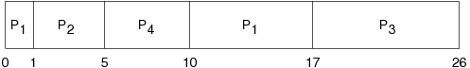
Process | Arrival | Burst Time | Start | Wait | Finish | TA
1 | 0 | 8 | 0 | 9 | 17 | 17
2 | 1 | 4 | 1 | 0 | 5 | 4
3 | 2 | 9 | 17 | 15 | 26 | 24
4 | 3 | 5 | 5 | 2 | 10 | 7

Average waiting time: (9+0+15+2)/4 = 6.5
Average turnaround time: (17+4+24+7)/4 = 13

Exercise 2

Below is a table of four CPU-bound processes P1, P2, P3, and P4 and their associated arrival times and CPU burst times.

Process | Arrival | Burst Time
P1 | 0 | 7
P2 | 2 | 4
P3 | 4 | 1
P4 | 5 | 4

- Draw Gantt charts illustrating the execution of these processes using SRTF scheduling.
- What is the average turnaround time
- What is the average waiting time

- Gantt chart:
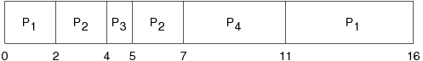
Process | Arrival | Burst Time | Start | Wait | Finish | TA
1 | 0 | 7 | 0 | 9 | 16 | 16
2 | 2 | 4 | 2 | 1 | 7 | 5
3 | 4 | 1 | 4 | 0 | 5 | 1
4 | 5 | 4 | 7 | 2 | 11 | 6

- Average waiting time: (9+1+0+2)/4 = 3
- Average turnaround time: (16+5+1+6)/4 = 7

Exercise 3

Below is a table of five CPU-bound processes P1, P2, P3, P4, and P5 and their associated arrival times and CPU burst times.

Process | Arrival | Burst Time
P1 | 0 | 10
P2 | 0 | 29
P3 | 0 | 3
P4 | 0 | 7
P5 | 0 | 12

- Draw Gantt charts illustrating the execution of these processes using RR (quantum=10) scheduling.
- What is the average turnaround time
- What is the average waiting time

- Gantt chart:
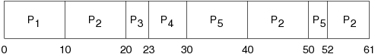
Process | Arrival | Burst Time | Start | Wait | Finish | TA
1 | 0 | 10 | 0 | 0 | 10 | 10
2 | 0 | 29 | 10 | 32 | 61 | 61
3 | 0 | 3 | 20 | 20 | 23 | 23
4 | 0 | 7 | 23 | 23 | 30 | 30
5 | 0 | 12 | 30 | 40 | 52 | 52

- Average waiting time: (0+32+20+23+40)/5 = 23
- Average turnaround time: (10+39+42+49+61)/5 = 35.2

