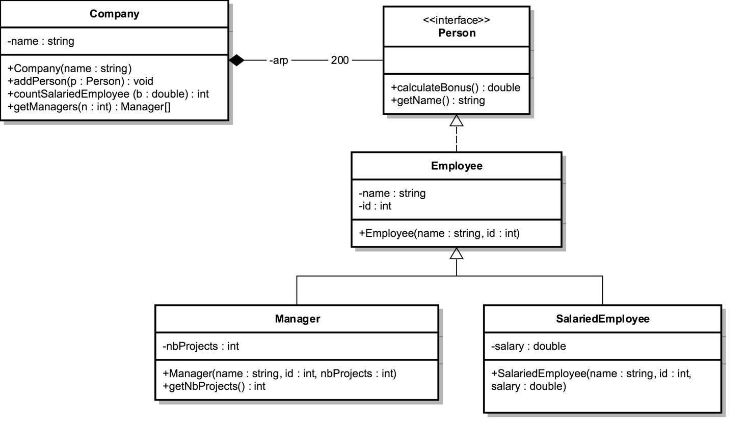

Interface Person:
- METHODS:
- calculateBonus (): calculated as:
- for Manager : Bonus = nbProjects * 10,000
- for SalariedEmployee: Bonus = salary * 2

- getName (): returns the name of the Employee.

Employee class
- METHODS:
- Employee (name: String, id : int): constructor.

Manager class
- METHODS:
- Manager (name: String, id : int, nbProjects : int): constructor.
- getNbProjects(): getter for attribute nbProjects.

SalariedEmployee class
- METHODS:
- SalariedEmployee (name: String, id : int): constructor.

Company class
- METHODS:
- Company(name: String): constructor.
- addPerson(p: Person): add a person to the Company.
- countSalariedEmployee (b : double): count the number of SalariedEmployee in the Company with Bonus grater or equal to b.
- getManagers(n : int): this method will return an array containing all the Manager with number of papers greater than n.

QUESTION: Translate into Java code all the classes

