- Where possible, write equivalents for the following equations using Java statements:
$3a+4yx-6$ $\frac{3a}{b+4}$ $\frac{a+b+c}{3}$

- Find errors in the following program
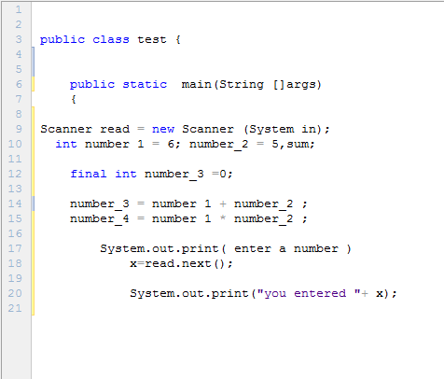

- Writ a program that asks the user to enter his name and date of birth then display his name along with his age.

