Write a fragment of code using (if) or (if ... else) statements to do the following:

- tests the value of the char variable response and performs the following actions:
- If response is ‘y’, the message “Your request is being processed” is printed.
- If response is ‘n’, the message “Thank you anyway for your consideration” is printed.
- For any other value of response, the message “Invalid entry; please try again” is printed

- Change the value of the variable x if it is negative to positive value

- asks the user to enter 2 numbers then displays a menu on the screen as shown below:
A. Print sum
B. Print average
C. Print sum and average
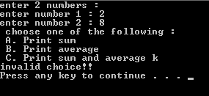
The program reads the user’s option and then display the result. Your code should recognize the invalid characters and display "invalid choice!!" message. 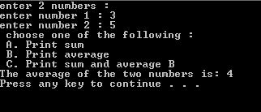

Write a java program that ask the user to enter his last 4 water bills .
The program should find and output their average monthly water bill.
- If the average bill exceeds $75, the output should include a message indicating that too much water is being used.
- If the average bill is at least $25 but no more than $75, the output should indicate that a typical amount of water is being used.
- if the average bill is less than $25, the output should contain a message praising the user for conserving water.

Use the sample output below as a model for your output.
Sample Run 1:
Please input your water bill 1:
300
Please input your water bill 2:
200
Please input your water bill 3:
225
Please input your water bill 4:
275
Your average monthly bill is $83.33. You are using excessive amounts of water
Sample Run 2:
Please input your water bill 1:
100
Please input your water bill 2:
150
Please input your water bill 3:
75
Please input your water bill 4:
125
Your average monthly bill is $37.50. You are using a typical amount of water

- If inputChar is a variable of type char, use the switch statement below to answer questions:
switch (inputChar) {
case 'A':
case 'a':
cout<<inputChar<<endl;
case 'Z':
case 'z':
cout<<inputChar<<endl;
break;
default:
cout<<inputChar<<“ is not found”<<endl;
break;
}
- What is the output when inputChar is 'A'?
- What is the output when inputChar is 'B'?

Write a fragment of code using (if) or (if ... else) statements to do the following:

test whether an integer variable score contains a valid test score. Valid test scores are in the range from 0 to 100.

- change an integer value stored in x as follows:
  - If x is even, divide x by 2.
  - If x is odd, multiply x by 3 and subtract 1.
Write a java program that prompts the user to enter 2 numbers. Then the program checks if num1 is equal to twice the value of num2 or not?

