- Ask the user to enter number then print from zero to that number
Enter number :3
0 - 1 -2 – 3
Enter number : 7
0-1-2-3-4-5-6-7
- Ask the user to enter number then print a square with the same width
Enter number : 4
****
****
****
****
- ask the user to enter his birth year and print his age
If the user enters an invalid year, print an error message (year range from 1940 to 2016) And ask him if he want to do it again or to stop
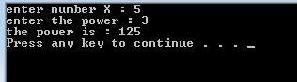
- calculate x raised to the y power. (i.e. $x^{y}$ ) both numbers are entered from the user

- Find and correct the errors in the following segments:
int z ;  z=input.nextInt();  while ( z >= 0 )  sum += z; | int c, p;  while(c<=5)  p *=c;  ++c;
for (x = 100,x >=1;x++);  System.out.print( x); | the following code should output odd integers from 999 to 1:  for (x=999;x>=1;x-=1)  System.out.print( x);

