Tutorial 8
GC 312
Problem 1:

Apply the timestamp ordering algorithm to these schedules and determine whether the algorithm will allow the execution of the schedules.

S1: r2(Z); r2(Y); w2(Y); r3(Y); r3(Z); r1(X); w1(X); w3(Y); w3(Z); r2(X); r1(Y); w1(Y); w2(X);
S2: r3(Y); r3(Z); r1(X); w1(X); w3(Y); w3(Z); r2(Z); r1(Y); w1(Y); r2(Y); w2(Y); r2(X); w2(X);

Problem 2:
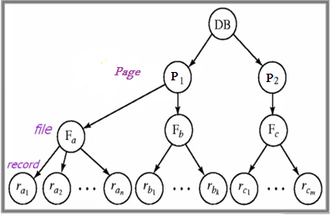

Apply the Multiple Granularity protocol to the following transaction:
- Suppose that transaction T18 reads record ra2 in file Fa.
- Suppose that transaction T19 modifies record ra9 in file Fa.
- Suppose that transaction T20 reads all the records in file Fa.
- Suppose that transaction T21 reads the entire database.

