- Present the relational schema mapped from the Library model shown in below.
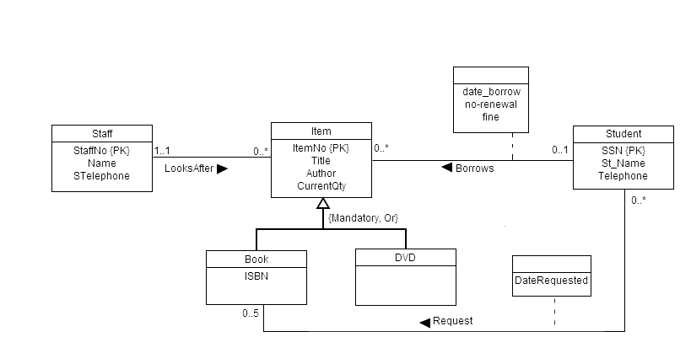

Q2: Derive relation schema for the following conceptual data models:
A)
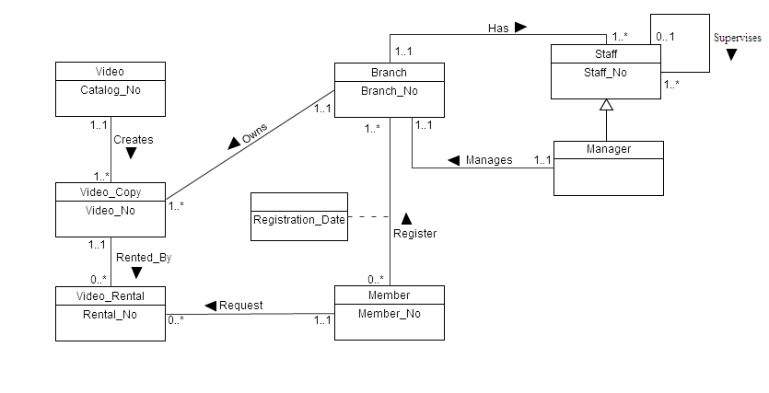

B)
