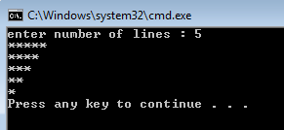
Write a C++ program to do the following :

- prompts the user to enter the number of lines to draw a triangle of stars upside down

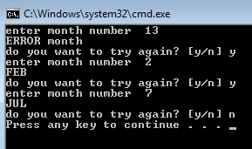
- ask the user to enter an integer from 1-12 and displays equivalent month . If the user enters an invalid number, print an error message. And ask him if he want to do it again or to stop

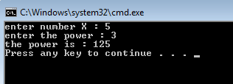
- calculate x raised to the y power. (i.e. $x^{y}$ ) both numbers are entered from the user

- Trace the following programs
#include <iostream>
using namespace std;
void main ()
{
int counter=1,var, result =0;
while (counter<= 5)
{
var= counter*2;
cout<<var<<endl;
result+=var;
++ counter;
}
cout<<"the final result is " <<result<<endl;
}

#include <iostream>
using namespace std;

void main ()
{ int x=-2;
while (x<=5)
{ if (x%2 ==0)
cout << x<<"is even"<<endl;
else
cout << x<<"is odd"<<endl;

++ x; }}
- Find and correct the errors in the following segments:
  - cin>>z;
while ( z >= 0 )
sum += z;

  - int c, p;
while(c<=5)
p *=c;
++c;

  - for (x = 100,x >=1;x++);
cout << x;

  - the following code should output odd integers from 999 to 1:
for (x=999;x>=1;x-=1)
cout << x;

  - The following code should print the values 1 to 10.
n = 1;
while ( n < 10 )
cout << ++n << endl;

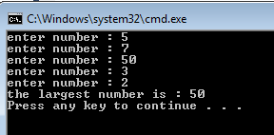
- Ask the user to enter 5 numbers then print the largest

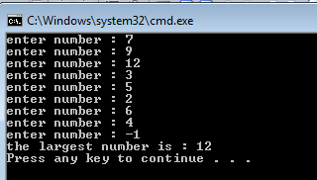
- Chang the previous program to determain the large number for unknown set of numbers .

