Tutorial 7
GC 312

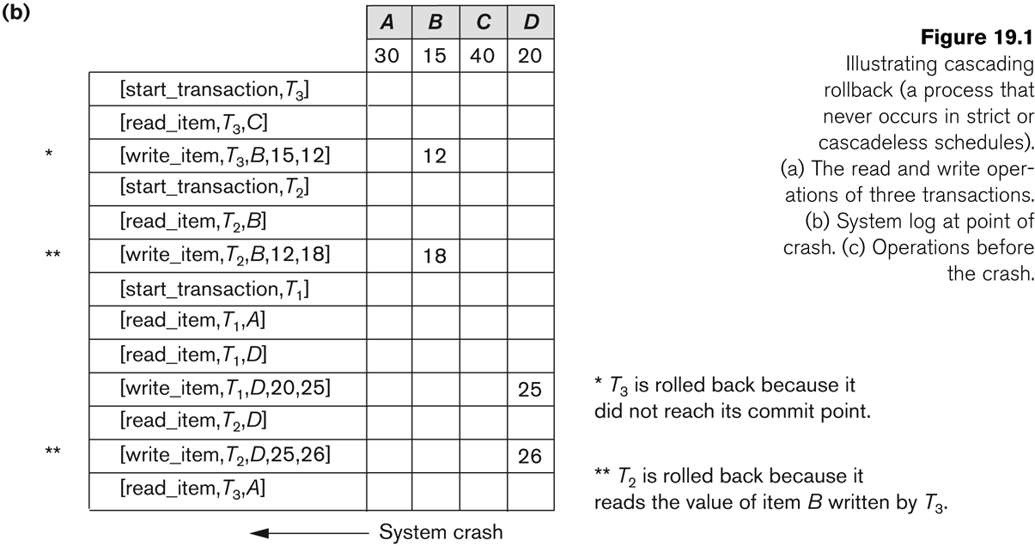
Problem 1:
Suppose that the system crashes before the [read_item,T3,A] entry is written to the log in above Figure; will that make any difference in the recovery process?

Problem 2:
Suppose that the system crashes before the [write_item,T2,D,25,26] entry is written to the log in above Figure; will that make any difference in the recovery process?.

Problem 3:
Choose the correct answer for each of the following multiple-choice questions:
- Incremental logging with deferred updates implies that the recovery system must necessarily
a. store the old value of the updated item in the log.
b. store the new value of the updated item in the log.
e. store both the old and new value of the updated item in the log.
d. store only the Begin Transaction and Commit Transaction records in the log.

- In case of transaction failure under a deferred update incremental logging scheme,which of the following will be needed:
a. an undo operation.
b. a redo operation.
e. an undo and redo operation.
d. none of the above.

- For incremental logging with immediate updates, a log record for a transaction would contain:
a. a transaction name, data item name, old value of item, new value of item.
b. a transaction name, data item name, old value of item.
e. a transaction name, data item name, new value of item.
d. a transaction name and a data item name.

- When using a log based recovery scheme, it might improve performance as well as providing a recovery mechanism by
a. writing the log records to disk when each transaction commits.
b. writing the appropriate log records to disk during the transaction's execution.
c. waiting to write the log records until multiple transactions commit and writing them as a batch.
d. never writing the log records to disk.

- There is a possibility of a cascading rollback when
a. a transaction writes items that have been written only by a committed transaction.
b. a transaction writes an item that is previously written by an uncommitted transaction.
c. a transaction reads an item that is previously written by an uncommitted transaction.
d. both (b) and (c).

- To cope with media (disk) failures, it is necessary
a. for the DBMS to only execute transactions in a single user environment.
b. to keep a redundant copy of the database.
c. to never abort a transaction.
d. all of the above.

- If the shadowing approach is used for flushing a data item back to disk, then
a. the item is written to disk only after the transaction commits.
b. the item is written to a different location on disk.
c. the item is written to disk before the transaction commits.
d. the item is written to the same disk location from which it was read.

