KING SAUD UNIVERSITY
College of Applied and Community Services
CT 1411
Second Semester 1437-1438

Visual Programming Assignment

- Description
Develop a simple windows form application as in the following two steps:
  - Step1:
    - Create a local Sql-Server database file in visual studio project (the details of the database illustrated in the figure below)
    - Create tables, columns, primary keys and foreign keys
    - Populate the tables with data and save them
  - Step2:
    - Implement the following functionality ( add button for each function and read the information from the user):
      - Insert data in the data base.
      - Update data in the data base.
      - Delete data from the data base.
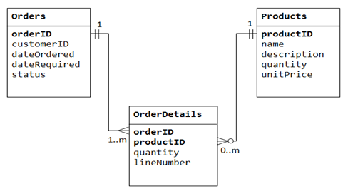

- Team
You should work as teams with 3 girls. You should work together and know the whole code.

- Code
Write meaningful variables and code segments. Use comment to explain everything written.

- Project Folder
Your project folder should be handled in a flash drive containing your project solution and your names.
Any source that you get use should be referenced, or else will be considered as cheating.

- Copying
Copying from the internet is considered cheating. I don't mind learning from any source, but you have to mention your source.

- Create Database in VB
Learn about Creating a New SQL Server Database. Look at this useful link https://msdn.microsoft.com/en-us/library/ms233763(v=vs.100).aspx

- Deadline
You should submit the assignment in 23/04/2017.

