Lesson II: Inserting Equation in Excel

Calculating a Molar Mass
We will use Excel as a basic calculator to find the molar mass of a compound.

Entering Text and Data in the Worksheet
Cells may contain text, numbers, or formulas
- Click on cell A1, and type Molar Mass of Sulfuric Acid H₂SO₄ followed by the Enter key [↵].
(This is the spreadsheet title. Notice after entering the title that the active cell is now A2.)
- In cell A2 type AM H [↵] as a label to indicate the atomic mass of hydrogen.
- In A3 type AM S[↵].
- In A4 type AM O[↵].
- In cell A6, type Sulfuric Acid[↵].
- In cell B2 to the right of the label AM H, enter the atomic mass of hydrogen, 1.00794.
- in cell B3, enter the atomic mass of sulfur, 32.066, and in cell B4, enter the atomic mass of oxygen, 15.9994.

Notice: As you type, the data that you enter appears in the formula bar. If you make a mistake, just click the mouse in the formula bar, and make necessary corrections.

Because the title of the spreadsheet should be easily distinguished from the body, it is appropriate to format the title in boldface font. This can be done by selecting cell A1. In the formula bar select the entire title by dragging the mouse over the words Molar Mass of Sulfuric Acid. When the title has been selected, click the Bold button in the Font group on the Home tab. This action will make the title appear in boldface font.

Entering an Equation
In cell B6 we will enter the formula that we want Excel to use to calculate the molar mass of sulfuric acid. Type into cell B6, the following:
=2*B2+B3+4*B4[↵]
The expression just typed is called a formula. In Excel, formulas begin with an equal sign [=] followed by the desired numerical expression. This formula will calculate the molar mass of H₂SO₄ by summing twice the atomic mass of hydrogen (cell B2), the atomic mass of sulfur (cell B3), and four times the atomic mass of oxygen (cell B4). The result should be as shown in Figure 2-1.

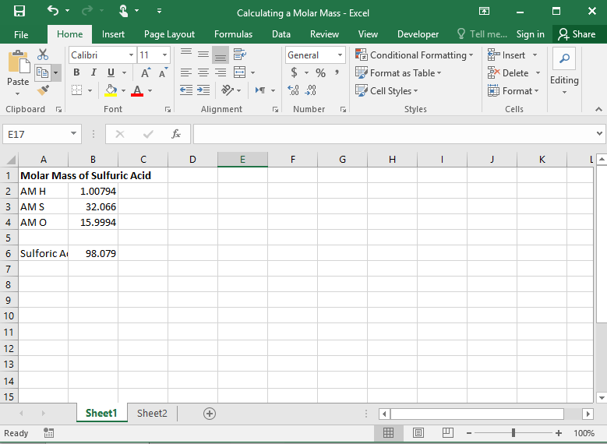
Figure 2-1 Excel spreadsheet to calculate the molar mass of sulfuric acid.

Changing the Width of a Column
Notice that the labels that you typed into column A are wider than the column. You can change the width of the column by placing the mouse pointer on the boundary between column A and column B in the column head and dragging the boundary to the right so that all of the text shows in the column.
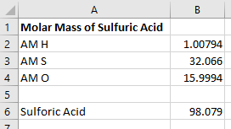

Note in Figure 2-1, that Excel has expressed the molar mass of sulfuric acid to five digits past the decimal point. But the molar mass should be expressed to only three digits beyond the decimal point since the atomic mass of sulfur is only known to this number of digits. Hence, a more appropriate result would be 98.079 for the molar mass of H₂SO₄.

To change the number of displayed digits, click on cell B6. From the Cells group, select the Format command and Format Cells... from the pull down menu. The Format Cells window shown below then appears on the screen.
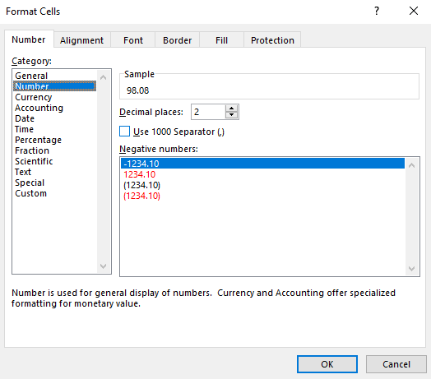

Select the Number tab and then Number from the list. In the Decimal places box select or type 3. Click the OK button. Cell B6 should now contain 98.079. Note that the effect of change the number of decimal places can be previewed in the Sample box in the Format Cells window. You can also increase or decrease the number of decimal places by clicking the Increase or Decrease Decimal button in the Number group on the Home ribbon.

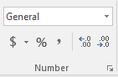

Documenting the Worksheet
Since the spreadsheet does not display the equations entered or indicate which cells contained data, it is important to document all cells that contain an equations or data. There are several different documentation schemes, but we shall introduce a method that is quite easy to implement. Make cell A9 the active cell and type Documentation[↵]. Make the font for this cell boldface. In cell A10, type
Cells B2:B4=user entries[↵]
The colon between B2 and B4 specifies a range. Thus, B2:B4 means the range of cells B2 through B4.
In cell A11, type
Cell B6=2*B2+B3+4*B4[↵]
The spreadsheet should now appear as shown in Figure 2-2. This documentation indicates the data entered by the user and shows the formula entered in cell B6 to calculate the molar mass of sulfuric acid. In many cases, it is apparent which cells contain user entered data. Hence, often the documentation section will contain only formulas.
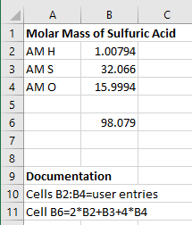
Figure 2-2. Final spreadsheet for calculating the molar mass of sulfuric acid including a documentation section. Note that the Excel ribbon and formula bar are omitted for clarity in this figure.

If desired, you can save your file to the hard disk by clicking on the File (Office in Excel 2016) button and choosing Save As. You can save as an Excel Workbook and various other formats including a format compatible with Excel 97-2003. Choose Excel Workbook and enter a location and a file name such as molarmass. Excel will automatically append the file extension .xlsx to the file name so that it will appear as molarmass.xlsx. Choosing to save in a format compatible with Excel 97-2003 appends the file extension .xls to the file.

An Example From Gravimetric Analysis:
- Click on cell A1 and type Gravimetric Determination of Chloride followed by the Enter key [↵].
- In cell A2, type Samples [↵]
- In cell A3, type Mass of bottle plus sample, g [↵]
- In cell A4, type Mass of bottle without the sample, g [↵]
- In cell A5, type Mass of sample, g [↵].
- In cell A6, hit [↵.
- In cell A7, type Crucible masses, with AgCl, g [↵]
- In cell A8, type Crucible masses, empty, g [↵]
- In cell A9, type Mass of AgCl, g [↵]
- In cell A10, hit [↵]
- In cell A11, type %Chloride [↵]

When you have finished entering the text, the worksheet should appear as shown in Figure 2-3

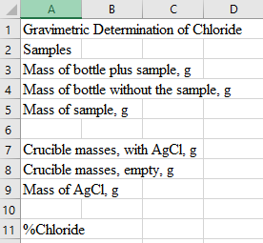
Figure 2-3 The appearance of the worksheet after entering the labels.

- change the width of the column by placing the mouse pointer on the boundary between column A and column B in the column head and drag the boundary to the right so that all of the text shows in the column.
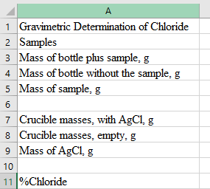

Entering Numbers into the Spreadsheet.
- Click on cell B2 and type
1[↵]
27.6115[↵]
27.2185[↵]
At this point, we wish to calculate the difference between the data in cells B3 and B4, so we type
=b3-b4[↵]
Notice that the difference between the contents of cell B3 and cell B4 is displayed in cell B5.

- Click on cell C2 and type
2[↵]
27.2185[↵]
26.8105[↵]

- Click on cell D2 and type
3[↵]
26.8105[↵]
26.4517[↵]
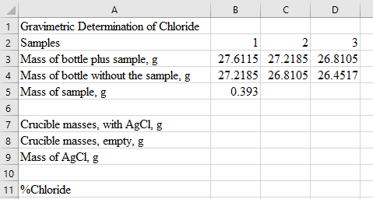
Figure 2-4 Sample data entry.

Duplicate a formula in cells adjacent to an existing formula
- Click on cell B5, click on the fill handle, and drag to the right to fill cells C5 and D5. When you let up on the mouse button, the spreadsheet should appear like Figure 2-5. Now click on cell B5, and view the formula in the formula bar. Compare the formula to those in cells C5 and D5.
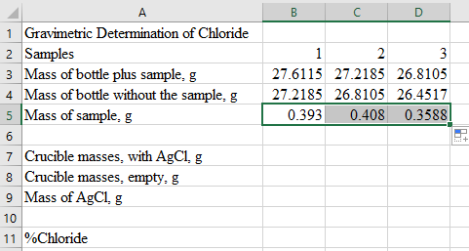
Figure 2-5 Duplicating a formula in cells adjacent to an existing formula
Now we want to perform the same operations on the data in rows 7, 8, and 9 shown in Figure 2-6, so enter the remaining data into the spreadsheet now.
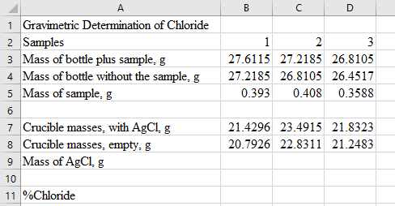
Figure 2-6 Entering the data into the spreadsheet in preparation for calculating the mass of dry silver chloride in the crucibles.

- Now click on cell B9, and type the following formula:
=b7-b8[↵]
- Again click on cell B9 and drag through columns C and D to copy the formula to cells C9 and D9. The mass of silver chloride should now be calculated for all three crucibles.

Making Complex Calculations with Excel
The equation for finding the % chloride in each of the samples is
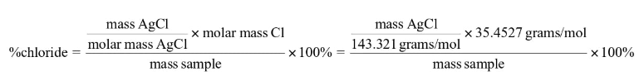

- Click on cell B11 and type
=B9*35.4527*100/143.321/B5[↵]
Once you have typed the formula, click on cell B11, and drag on the fill handle to copy the formula into cells C11 and D11. The %chloride for samples 2 and 3 should now appear in the spreadsheet as shown in Figure 2-7.
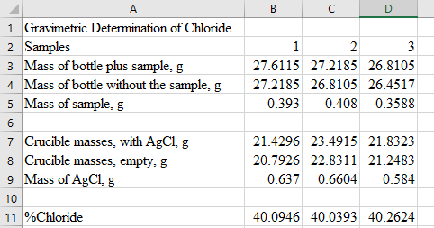
Figure 2-7 Completing the calculation of percent chloride.

- click on the File button and choose Save As and Excel Workbook. Enter a file name grav_chloride, and save the spreadsheet for retrieval and editing later.

