Visual Programming Project

Project Description:
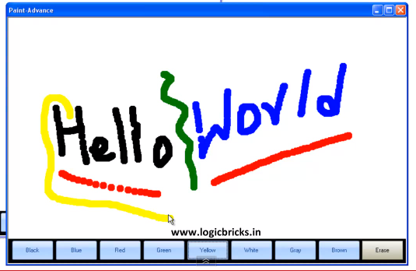
You are required to develop a simple paint application, as the figures below show.

Or for more points use this interface:
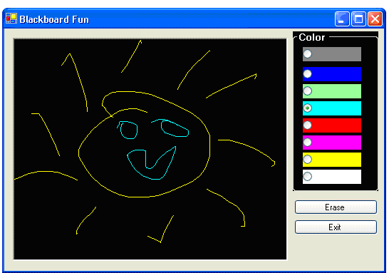

Team
Divide your self into a team of 5 girls. You should distribute the work evenly between you. Each girl should know the whole code.

Code
Write meaningful variables and code segments. Use comments to explain everything written.

Project Folder
Your project folder should be handled in a flash drive. Containing your project solution and your report.
In the report explain what you did in the development by explaining each function and its purpose and also describe main variables. Any source that you get use should be referenced in your report, or else will be considered as cheating.

Copying
Copying from the Internet is considered cheating. I don’t mind learning from any source, but you have to mention your source in your report.

Control Events in VB
Learn about PictureBox and MouseEvents
I found this link useful, check it out
http://www.youtube.com/watch?v=2IzkrO-boUE

Deadline
I should have received all projects by 19 Dec.

