Population composition (2)

Citizenship: Legal nationality
    - May be acquired by birth or naturalization
    - Almost all people born in some countries are automatically citizens, or at least have that option; this is not so in some other countries

Language: Types of Language Data:
- Language spoken at home in early childhood (mother tongue)
- Language currently spoken, or most often spoken in present home (usual language)
- Ability to speak various languages (designated languages); Indicates linguistic skills of population, both native and foreign born

Religion:
- If race or country of origin is also known, religion can be used to make further distinctions among ethnic groups
- Useful personal characteristic because it is associated with a variety of differences in attitudes and behavior

Marital Status:
Categories of marital Status:
•Single (never married)
•Married
•Married but separated
•Widowed and not remarried
•Divorced and not remarried
Note: Ever married = married + widowed + divorced + separated

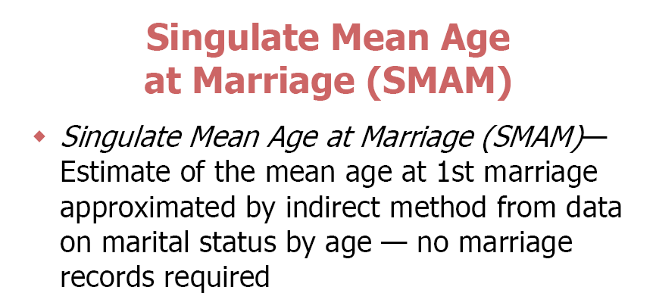
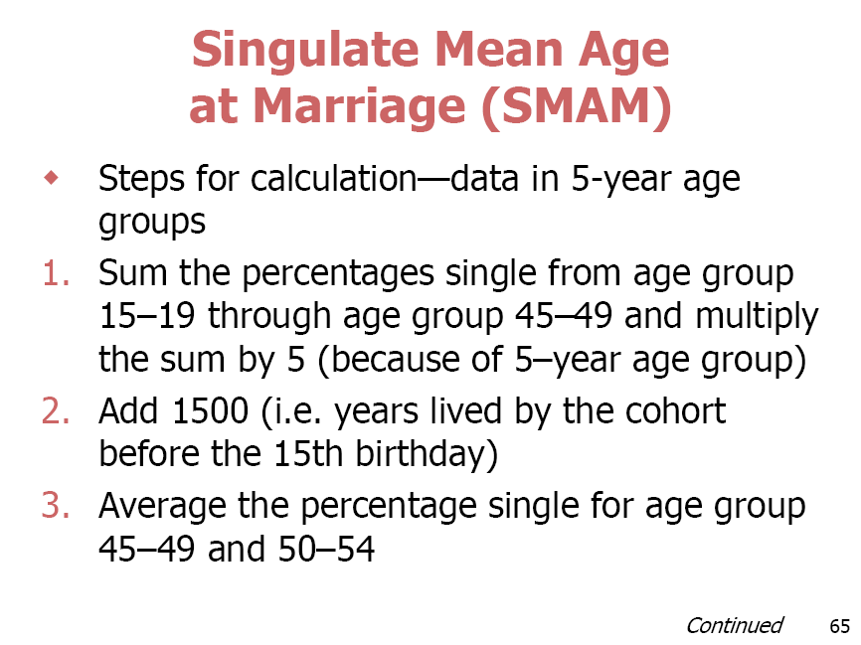

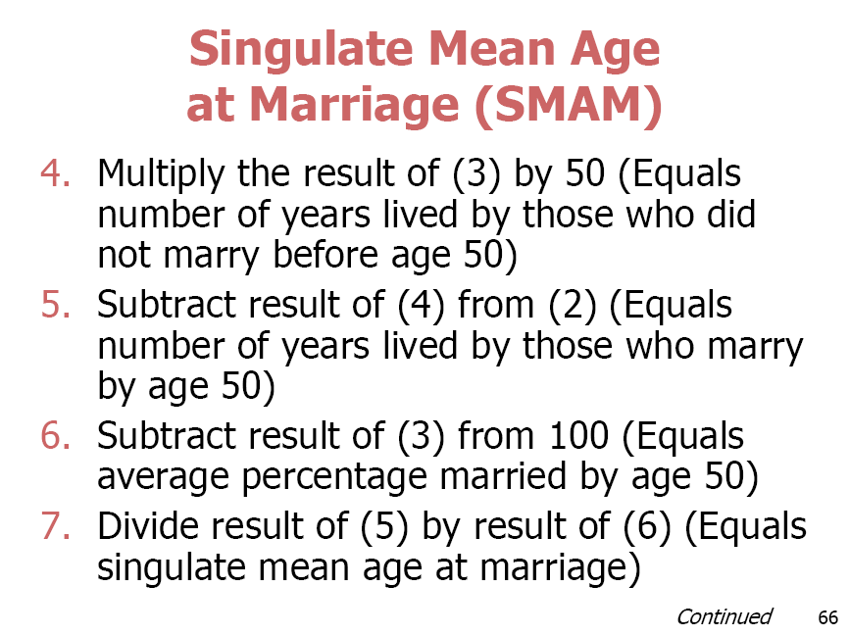

Example:
Estimate the singulate female mean age at marriage in a population has the following female single proportions at age groups from 15-54 years :
Age group Proportion of single females
15- 5%
20- 6%
25- 6%
30- 6.5%
35- 7%
40- 4%
45- 4.5%
50-54 3.5%

Answer:
1- Sum the percentages single from age group 15-19 through age group 45-49 and multiply the sum by 5
Sum percentages single= 5+6+6+6.5+7+4+4.5= 39
39*5= 195

2- Add to result of (1) 1500
159+1500= 1695

3- Average the percentages single at age groups 45-49 and 50-54
= sum of both percentages/2= 4.5+3.5/2=8/2=4

4- multiply the result of (3) by 50
4*50=200

5- Subtract result (4) from (2)
1695-200= 1495

6- Subtract result (3) from 100
100-4= 96

7- devide result (5)/ result (6)
1495/96= 15.5 years

So, the singulate mean age at marriage in that population is 15.5 years

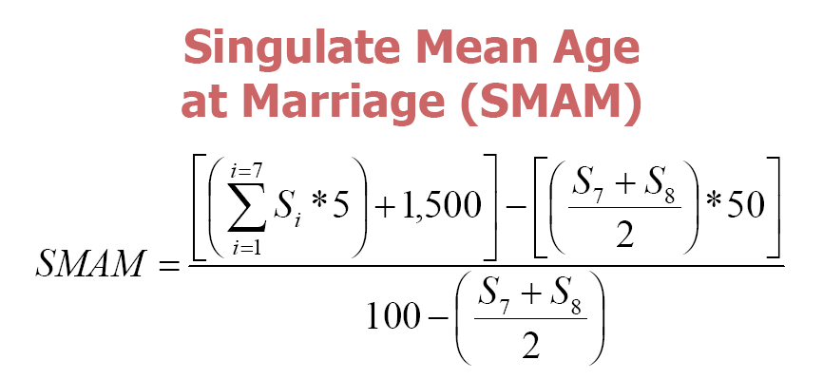

Work shop
Complete:
1- Ever married = ……………….. + ……………….. + …………………. + ……………….
2- Types of Language Data are:
1-………………………………………………………………………
2-……………………………………………………………………….
3-………………………………………………………………………
3- The value of data of religion is that…………………………………………………..
4- Estimate the singulate mean age at marriage of females in a population has the following female single proportions at age groups from 15-54 years :
Age group Proportion of single females
15- 90%
20- 75%
25- 70%
30- 50%
35- 48%
40- 30%
45- 20%
50-54 10%

