Assignment
Physiology BOT271
First semester 2019/2020
Name: ..............................................................

University ID: ..............................................................

Section no.: 59825

- Complete the appropriate cell structure name on the following plant cell:
(Golgi apparatus – Nucleus – Vacuole – cell wall – cytoplasm – Mitochondrion – Rough ER – Smooth ER – chloroplast – plasma membrane – Nucleolus – Vesicle – Ribosomes)

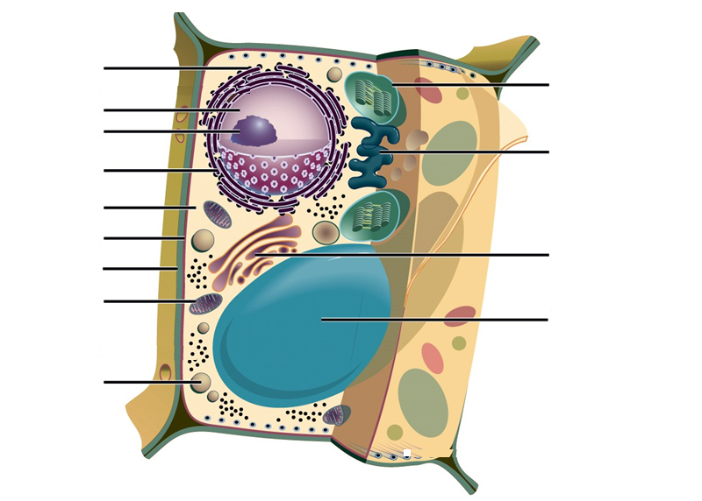

- Plants control the hydration of their cells through three steps – mention the steps according to the illustration

A)
B)
C)
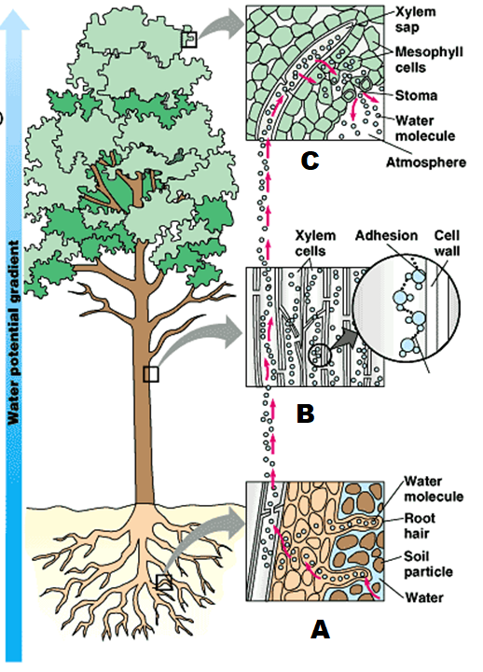

- Choose the right answer:

- You’ve already seen the structure of xylem and phloem. How is a redwood tree able to move water from the soil to leaves 100m above the soil? Choose the appropriate theory.

- Root pressure
- cohesion tension
- vapor movement
- capillary action

- Osmotic potential (Ψ_{π}) – the diffusion of liquid water molecules from a ------------- across a -------------------- membrane into a -----------------.

- selectively permeable
- (less water, more solute)
- permeable
- (more water, less solute)

- Pressure --------------- water potential.

- Decreases
- Increases
- Stabilizes
- Doesn’t affect

- Transpiration (or evapo-transpiration) is the transport of water and minerals from roots to leaves. It involves

- Absorption at the roots.
- cohesion tension in the xylem vessels.
- Evaporation at the leaf.
- All the mentioned above.

- Which of the following is a colloidal system?

- mud
- gasoline
- blood
- a mixture of sugar and water

- From the epidermis to the endodermis there are several pathways in which water can flow from them

- Osmotic pathway
- Symplast pathway
- Diffusion pathway
- All the mentioned above

- In a C4 plant, ------------------ structure enter in the photosynthesis process.

- Bundle sheath
- Epidermis
- Phloem
- Guard cells

- Mineral nutrients acquired by plants through

- Artificial: called foliar application.
- Associations with mycorrhizal fungi.
- Uptake by the roots.
- All the mentioned above.

- From which direction will the water flow through the membrane according to the following illustration.
(no water flow – left to right – right to left)
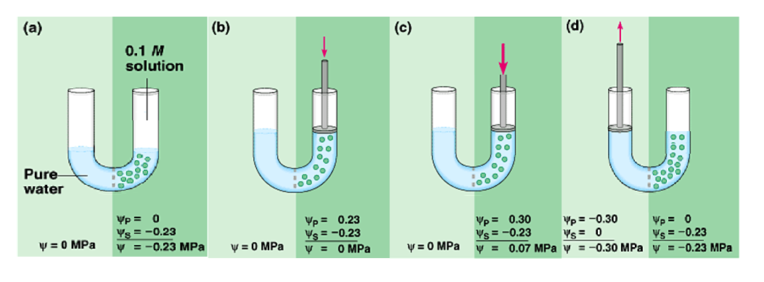

- Read the sentence carefully and determine whether it is true or false:

- Cell Wall in plants contains chitin.

- Rough Endoplasmic Reticulum doesn’t contain ribosomes attached to surface and responsible for proteins manufacture.

- Photosynthesis takes place in the chloroplast and makes cellular food – glucose.

- The combined effects of solute concentration and physical pressure (cell wall) can be measured as Water Potential.

- Sink in sugar transport where the sugar starts its journey (either where it is produced or stored).

- Phloem tissues are dead at maturity.

- Passive transport is used to load sucrose into phloem tubes against a diffusion gradient.

- pH affects the growth of plant roots and soil microbes.

- Plants require nine macronutrients and at least eight micronutrients.

- Light dependent reaction of photosynthesis takes place in the chloroplast stroma.

- An essential nutrient is a chemical element that is required for a plant to grow from a seed and complete the life cycle.

- Exocytosis is a process of taking material into the cell by means of infoldings, or pockets, of the cell membrane (usually putting them into a vacuole).

- NADPH is the energy coin in the cell.

- Passive Transport - requires cell energy, examples: Diffusion, Facilitated diffusion and Osmosis.

- C3 plants are at a disadvantage in hot, dry climates

- Match column A with B

A | B
Suspension | scattering of light by particles in a colloid or suspension, which causes a beam of light to become visible
Colloid | the colloidal dispersion of one liquid in another
Tyndall effect | the chaotic movement of colloidal particles, caused by collision with particles of the solvent in which they are dispersed
Brownian motion | a mixture whose particles are intermediate in size between those of a suspension and a solute solution
Emulsion | a mixture from which some of the particles settle out slowly upon standing

- Observe the diagram then answer:

- This diagram shows that photosynthesis is an ________________ reaction because __________________________.

Carbon for making carbon compounds (such as sugar) comes from ______________.

Oxygen, hydrogen, and minerals are needed also. Oxygen and hydrogen come from __________. Minerals comes from ____________.

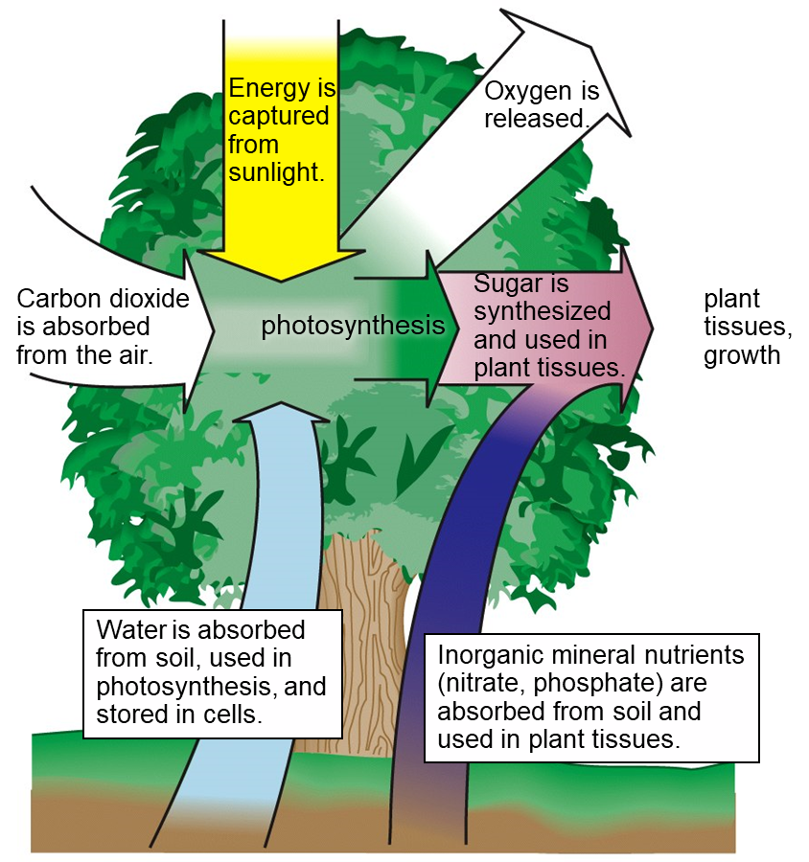

- According to the following relationship between the concentration of nutrient in tissue and plant growth
A – zone.

B – zone.

C – zone.

(toxic – deficiency – adequate)
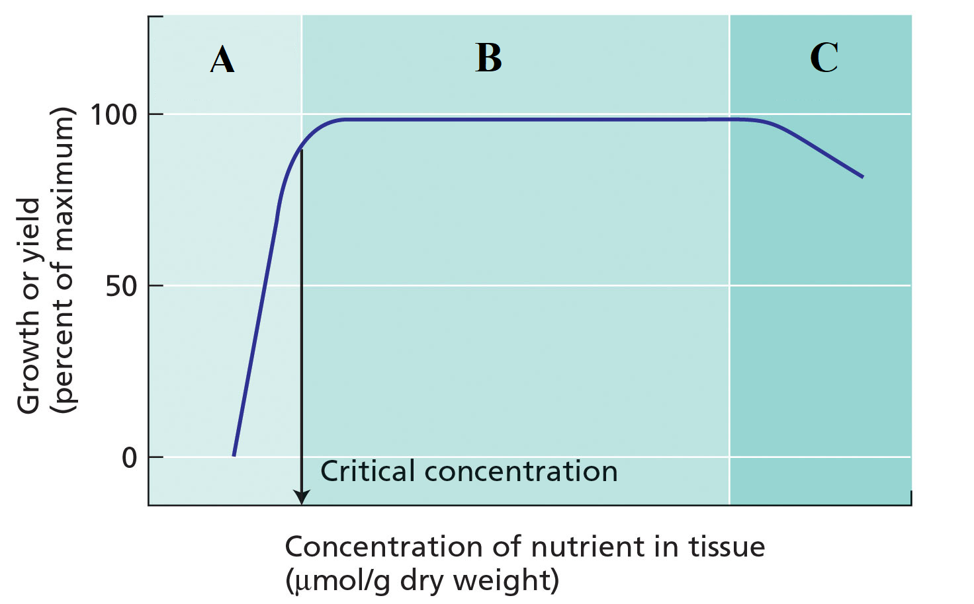

- Light energy is “captured” by ___________, which is embedded in the thylakoid membranes
____ and _______ are used to move energy from one part of the chloroplast to another.
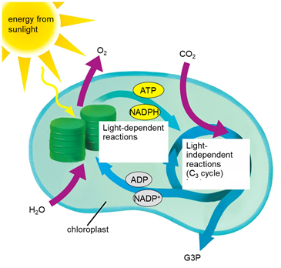

- Respiration steps occurs in

(A) ---------------------------------- ,
(B) ---------------------------------- ,
(C) ---------------------------------- .

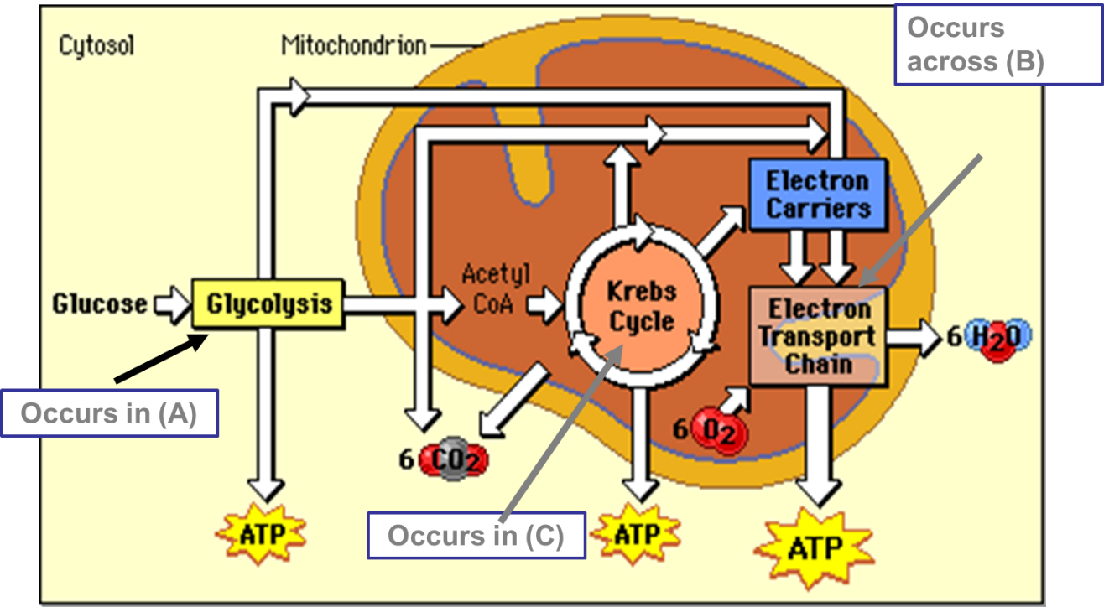

- From which direction will the water flow through the membrane according to the following illustration.
(Hypotonic solution, water moves into the cell – Isotonic solution, water moves in both directions – Hypertonic solution, water moves out of the cell)

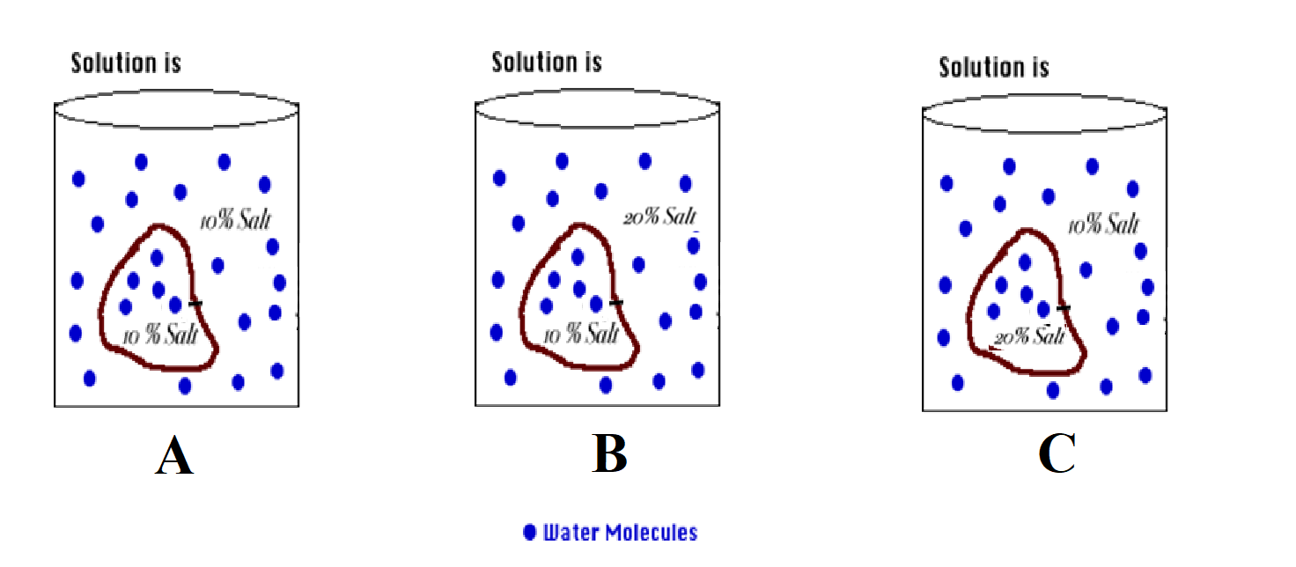

- Explain why a mixture of sand and water can be separated by filtration, but a mixture of salt and water cannot?

- Solute Potential Ψ_{S} of any solution at atmospheric pressure is always negative – why?

- What is the equation for the chemical reaction of photosynthesis and respiration?

- What are the two types of reactions in photosynthesis and where are they occur?

