Web Application Development
MARAM ALDAKHEEL, AMARAM@KSU.EDU.SA

- A basic introduction to the Internet and WWW including HTML, URL and HTTP.
- Developing web applications with static and dynamic web content.
- Formatting web pages with tables, images, frames and CSS (Cascading Style sheets).
- Introduction to client side scripting such as JavaScript.
- Dynamic web content generation and introduction to server side scripting such as PHP, and ASP
.NET.
- Database connectivity to web applications.
- Fundamentals of Web 2.0 – the modern web applications.
- Basics of other relevant concepts and technologies such as XHTML, XML, Ajax, Web servers,
- Effective report writing and communication.

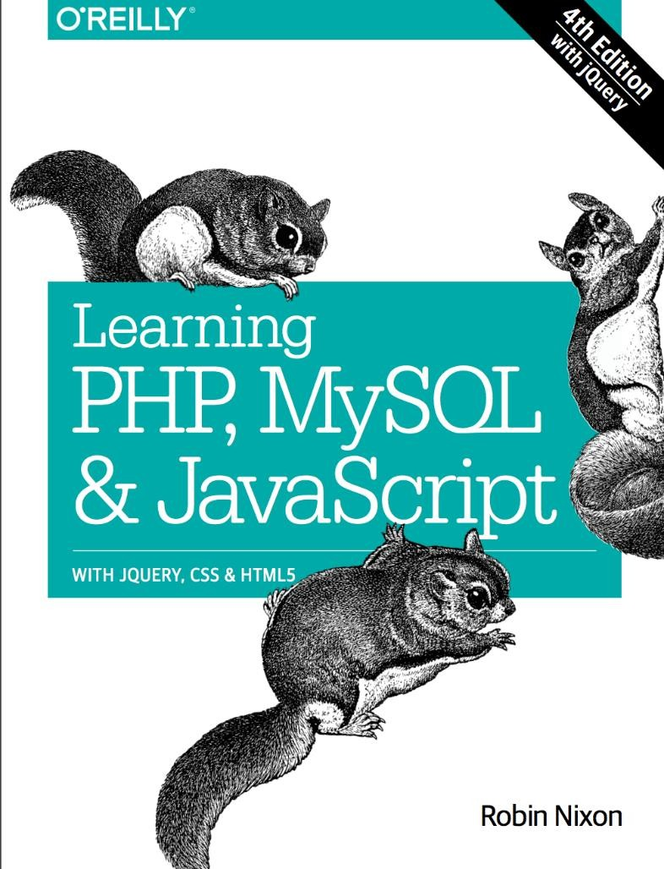

Internet & World Wide Web How to Program (5th edition) Learning PHP, MySQL & JavaScript (4th edition)

Developing Web Applications
  - By Ralph Moseley, Wiley-VCH Verlag GmbH & Co. KGaA, 2007
Web Application Architecture: Principles, Protocols and Practices. (2nd edition)
    - by Leon Shklar and Rich Rosen, John Wiley& Son Ltd. 2009.
Ajax, Rich Internet Applications, and Web Development for Programmers
    - By Paul J. Deitel, Harvey M. Deitel, Jan 2008
Web Technologies: A Computer Science Perspective
    - By Jeffrey C. Jackson, ISBN: 0-13—185603-0
Various Web Resources

- 20% Quizzes
- 10% lab
- 30% Midterm exam
- 40% Final exam

- Be aware of plagiarism – don’t copy and hand in others work and claim credit
- Any plagiarism case will automatically receive “F” grade
- Reports and project documents will not be returned to students
- Regular attendance in the class is highly recommended- otherwise you miss the clue for exams

- No phone/ chatting during class time, any violation the student will be asked to leave the class.
- No talking or disturbing class mates.
- After 15 minutes of the class starting, you may enter. However, you will be marked absent!
- Contact using your KSU email address.

- Absence of 25% or more → not be allowed to enter the final exam.
- Medical excuses → not accepted for deducting the number of absence days.
- A medical excuse may only be used in the case that a student misses an exam.

