بســـــم الله الرحمن الرحـــــيم
College of Science
Dep. Statistics & Operations Research
OR 441 – Modeling and Simulation
Dr. Khalid Al-Nowibet

Final Exam
1440-1441 (Dec. 2019) 1st Semester

 | Student Number | KEY SOLUTION | Name

 | Q. #1 | Q. #2 | Q. #3 | Q. #4 | Q. #5 | Q. #6 | Total
Score

Instructions
- Show your university ID
- Exam period is 3 hours.
- Exam consists of 6 questions; each question should not take more than 30 min on average.
- The answer of each question is on the same page, use the back of the pages if you need more space.
- Answer all questions and Show all your work in the answer
- Turn off your cell phones
- Do not use your cell phone for calculations

Question #1 :
Answer the following with True or False (write your answer in the square before the sentence)
FALSE | - The LCG (X_{n} = ( aX _{n-1} + c) mod(m)) it is always possible to have values for: X₀ , a, c and m to generate more than m pseu-dorandom numbers.
TRUE | - Generating random numbers from the empirical input modeling of individual data gives the exact values that appeared in the sample.
FALE | - To determine the number of runs in simulation with confidence 95% we must determine the accuracy of simulation by choosing Z_{α/2}. BY CHOOSING E
TRUE | - We can determine the number of runs by deciding the expected half width of the confidence interval.
FALSE | - DTAT TABLES in Excel are used to generate random numbers from Normal distribution
FALSE | - Generating random numbers from the empirical input modeling of grouped data gives the only values that appeared in the sample.
TRUE | - The sequence of random numbers generated from a given seed is called a random number a Stream.
TRUE | - In using Acceptance/Rejection method requires at least two U(0,1) random number to give one random follows the function f(x).
FALSE | - The function VLOOKUP in Excel always used to generate numbers from Gamma.
TRUE | - In Excel the Erlang distribution has inverse function using Gamma.
FALSE | - In using Acceptance/Rejection method we must always choose the majorizing g(x) function to be constant.
TRUE | - In simulation of ATM system, the percentage that there are three customers using the ATM is computed by the time average
TRUE | - We use DATA TABLE in Excel to store the measures of simulation for large number of runs.
FALSE | - To generate random numbers from truncated Weibull between [a,b], we use the inverse transform of the original Weibull with the transformation a + b u
TRUE | - In simulation of ATM system, the expected number of customers in the waiting line for ATM is computed as a simple average: sum of observations/number of observations CORRECTION
FALSE | - To generate one value of Erlang (k=2, λ=3) distribution we generate one value from Exponential (λ=3) and multiply it with 2.
FALSE | - We can always use RANDBETWEEN(a,b) to generate integer numbers between (a) and (b) for any probability distribution
FALSE | - In simulation of ATM system, the expected number of customers waiting in the waiting line is computed as a simple average: sum of observations/number of observations CORRECTION
FALSE | - If X₁ , X₂, X₃ are random values generated from Shifted Exponential(λ=3) with shift value δ=5, then X₁ , X₂, X₃ all values must be less than 5.
TRUE | - If X₁ , X₂, X₃ are random values generated from truncated Exponential(λ=3) with between 2 and 5, then X₁ , X₂, X₃ all values must be less than 5.

Question #2 :
Consider the following probability density function:
$$f\left(x\right)=\frac{2x}{25}e^{-\frac{x^{2}}{25}} ; x>0$$
- Compute the CDF of the function f(x).
- Using your answer in part (a), Derive an inverse transform algorithm for this distribution.
- Let X be the time between breakdowns on a machine. Use the inverse transform in part (b) to determine the time of each breakdown. Generate X_{n} using LCG generator with parameters: a = 5 , c = 3 and m= 21 with X₀ = 0. Write your answer in the table below.
 | 1 | 2 | 3 | 4 | 5 | 6 | 7
LCG u_{i} | 0.053 | 0.316 | 0.632 | 0.211 | 0.105 | 0.579 | 0.947
X | 1.167 | 3.081 | 4.999 | 2.434 | 1.665 | 4.651 | 8.570
Time of Break-Down# | 1.167 | 4.248 | 9.247 | 11.681 | 13.347 | 17.997 | 26.567
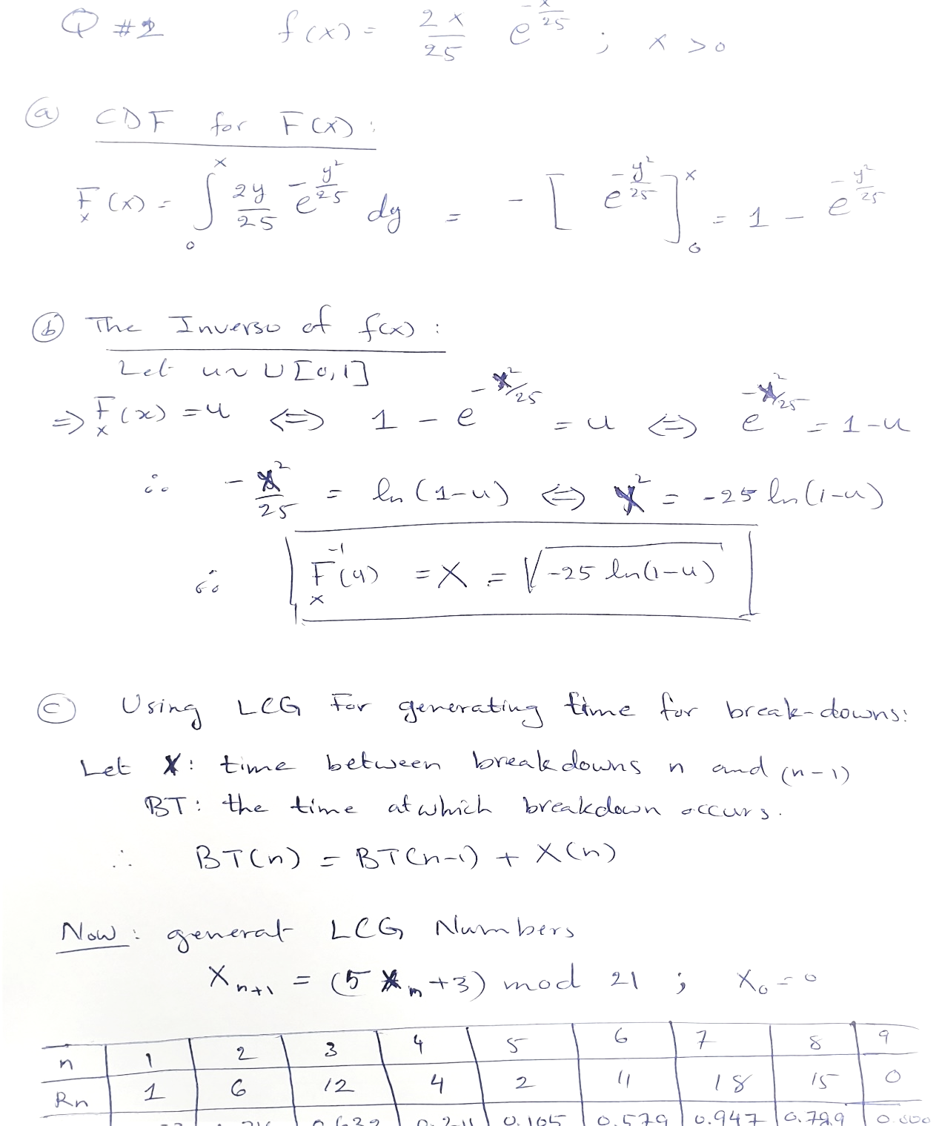
Solution:

Question #3 :
Suppose that customers arrive to a pharmacy with time between arrivals follows Integer Uniform distribution between 3 minutes and 8 minutes. Customer can decide to enter the store instead or use the drive through lane. The service time is assumed random in each way. Assume a 75% chance that the arriving customer decides to enter the pharmacy and a 25% chance that use the drive through. If customers enter the pharmacy, then each customer may have 1, 2, or 3 prescriptions for medication (integer uniform). Each medication takes a random amount of time to prepare that follows integer Exponential distribution with mean time ( E[T] = 2 minutes). For example, if the customer has 2 medications and 1st needs 3 min and the 2nd needs 2 min then the service time is (3+2) minutes. Finally, when a customer take drive through he takes a fixed time for service equals 3 minutes.
- Write the steps and functions for generating the time between arrivals.
Generate Time between arrivals from IU[3,8] min
- Get u~U[0,1]
- Then T = int.[6 u]+3
- Arrival time of Cust#(n) = Arrival time of Cust#(n) + T
- Using the table and the uniform numbers below, generate the arrival times of 8 customer’s pharmacy in minutes.
Cust. # | 1 | 2 | 3 | 4 | 5 | 6 | 7 | 8
U(0,1) | 0.389 | 0.536 | 0.649 | 0.609 | 0.779 | 0.913 | 0.842 | 0.058
Time between | 5 | 6 | 6 | 6 | 7 | 8 | 8 | 3
Arrival Time | 5 | 11 | 17 | 23 | 30 | 38 | 46 | 49

- Write the steps and functions for generating the choices of each arrival (In-Pharmacy/Drive-through).
Generate the choice of In-Pharmacy/Drive-through from Ber(p=0.75)
- Get u~U[0,1]
- If u ≤ 0.75 Then customer chooses In-Pharmacy =1
- If u > 0.75 Then customer chooses Drive-through =2
- Using the table and the uniform numbers below, Generate the choice of 8 customers (Let: In-Pharmacy = 1 and Drive-through = 2).

Cust. # | 1 | 2 | 3 | 4 | 5 | 6 | 7 | 8
U(0,1) | 0.823 | 0.450 | 0.027 | 0.017 | 0.670 | 0.965 | 0.027 | 0.468
Choice | 2 | 1 | 1 | 1 | 1 | 2 | 1 | 1

- Write the steps and functions for generating the number of medication for each customer (1 or 2 or 3 ).
Generate number of medications from IU[1,3]
- Get u~U[0,1]
- Then N = int.[2 u]+1

- Using the table and the uniform numbers below, generate the choice of the number of medication for each customers

Cust. # | 1 | 2 | 3 | 4 | 5 | 6 | 7 | 8
U(0,1) | 0.285 | 0.769 | 0.308 | 0.752 | 0.929 | 0.712 | 0.281 | 0.709
No. of Medic. | 1 | 3 | 1 | 3 | 3 | 3 | 1 | 3

- Write the steps and functions for generating Service Times (in minutes).
Generate service time
- If choice = 1 in-pharmacy Then
    - Get the number of medication N
    - For all N : get u~U[0,1] and generate service time (S) for each medication from exponential E[S]=2 min
    - S = -2 ln(1-u)
    - Total service time TS = sum of S for all N
- If choice = 2 Drive through Then service time = 3 min

- Using the table and the uniform numbers below and your answers in part (d) and part (f), generate the service time of each customer.

Cust. # | 1 | 2 | 3 | 4 | 5 | 6 | 7 | 8
Choice | 2 | 1 | 1 | 1 | 1 | 2 | 1 | 1
No. of Medic. | 1 | 3 | 1 | 3 | 3 | 3 | 1 | 3
U₁(0,1) | 0.780 | 0.693 | 0.157 | 0.834 | 0.097 | 0.460 | 0.872 | 0.415
U₂(0,1) | 0.457 | 0.429 | 0.808 | 0.468 | 0.627 | 0.527 | 0.881 | 0.588
U₃(0,1) | 0.566 | 0.332 | 0.863 | 0.732 | 0.281 | 0.306 | 0.067 | 0.281
Service Time | 3.0 | 4.3 | 0.3 | 7.5 | 2.8 | 3.0 | 4.1 | 3.5
Remark: for each customer use uniform as needed
- When customer enter the pharmacy for medication there is only on server and a waiting line for service. So, customer have to wait in line when the server is busy. In the table below, write the details of all customers who enter the pharmacy only.
Cust. In#  (Sys Cust#) | Arrival time | No. of Medic. | Service time | Service start | Cust. Wait ?? | Wait Time | Departure time | Server Idle time
1 (2) | 11 | 3 | 4.3 | 11 | 0 | 0 | 15.3 | 11
2 (3) | 17 | 1 | 0.3 | 17 | 0 | 0 | 17.3 | 1.7
3 (4) | 23 | 3 | 7.5 | 23 | 0 | 0 | 30.5 | 5.7
4 (5) | 30 | 3 | 2.8 | 30 | 1 | 0.5 | 33.3 | 0.0
5 (7) | 46 | 1 | 4.1 | 46 | 0 | 0 | 50.1 | 12.7
6 (8) | 49 | 3 | 3.5 | 50.1 | 1 | 1.1 | 53.6 | 0.0
7
8

- From the table above, compute the average waiting time?
Ave.[Waiting Time] = Sum(waiting times)/6 = 1.6/6 = 0.267 min

- From the table above, compute the probability of idle server?
Pr{Idle server} = {Total Idle times } / {Total Sim. Time}
= 35.8 / 53.6 = 0.668

Question #4:
Customers arrive to a minimarket according to a random process. The arriving customers come to a single server checkout counter after they finish shopping. It is assumed that the checkout sever takes a random amount of time to finish the checkout for a customer. The following data was collected.
Cust. # | Time between arrivals | Arrival time  (min) | Service time  (min) | Service Start Time  (min) | Cust.  Wait? | Wait Time  (min) | EXIT time  (min) | Cashier Idle Time  (min)
1 | 8.00 | 8.00 | 9.00 | 8.00 | 0 | 0 | 17.00 | 8.00
2 | 7.00 | 15.00 | 5.00 | 17.00 | 1 | 2.00 | 22.00 | 0.00
3 | 2.00 | 17.00 | 3.00 | 22.00 | 1 | 5.00 | 25.00 | 0.00
4 | 17.00 | 34.00 | 5.00 | 34.00 | 0 | 0.00 | 39.00 | 9.00
5 | 5.00 | 39.00 | 1.00 | 39.00 | 0 | 0.00 | 40.00 | 0.00
6 | 3.00 | 42.00 | 14.00 | 42.00 | 0 | 0.00 | 56.00 | 2.00
7 | 8.00 | 50.00 | 4.00 | 56.00 | 1 | 6.00 | 60.00 | 0.00
8 | 13.00 | 63.00 | 2.00 | 63.00 | 0 | 0.00 | 65.00 | 3.00
9 | 9.00 | 72.00 | 11.00 | 72.00 | 0 | 0.00 | 83.00 | 7.00
10 | 2.00 | 74.00 | 2.00 | 83.00 | 1 | 9.00 | 85.00 | 0.00
- From the simulation run, what is the percentage of customers who wait in line?
percentage of customers who wait in line = Total customers wait/ Total arrivals = 4/10 = 40%.

- Let Y be a random variable of the customer (Wait or No Wait), use the data above to write the algorithm to generate only the variable Y?
- Get u~U[0,1]
- If u ≤ 0.4 Then customer wait Y = 1
- If u > 0.4 Then customer will not wait Y= 0

- What is the probability that the cashier is IDLE during the simulation time?
Pr{Idle server} = {Total Idle times } / {Total Sim. Time} = 29 / 85 = 0.3412

- If you want to simulate only (the cashier is idle or not), use the data above to write the algorithm to generate only this variable?
- Get u~U[0,1]
- If u ≤ 0.3412 Then cashier is idle X = 1
- If u > 0.3412 Then cashier is busy X= 0

- What is the average number of arrivals in one hour from simulation?
E[ Time between arrivals] = (Sum interarrival times) / (number of arrivals)= 74/10 = 7.4 min
Average arrivals per min = 1/7.4 = 0.135 cust./min
Average arrivals per hour = 60/7.4 = 8.12 cust./hr

- If you want to model the service time as Erlang distribution with parameters α and β cust../min what are the parameters for the service time.
model the service time as Erlang distribution Using moment matching:
ST : service time is Erlang (α,β)
E[ST] = α/β and Var[ST] = α/β² with α must be integer
From data we have:
Average service time = 5.6 = α/β and Variance of service time = 18.71 = α/β²

Var/Ave = (5.6/18.71) = β β^ = 0.3
Then
α/β = 5.6 α/β^ = 5.6 α = 5.6 β^ = 5.6(0.3) = 1.68
We know that α must be integer then α^ = 2

- If you want to model the arrival process as Poisson distribution, using Moment Matching Method, write the algorithm and the parameters used in the model.
Using moment matching:
T : time between arrivals is Exponential E[T] = 1/λ
From data: Average time between arrivals = (74–0)/10 = 7.4
Then 1/λ = 7.4 λ^ = 1/7.4 = 0.135 arrival/min.
Then f(t) = (0.236) e^{-0.236 t}

- Using the output data for the first 6 customers only, compute the probability that there are 1,2,3 in the system?
from | to | change | N(t) | inter. |  | N | P(N)
0 | 8 | 0 | 0 | 8 |  | 0 | 0.349
8 | 15 | 1 | 1 | 7 |  | 1 | 0.395
15 | 17 | 1 | 2 | 2 |  | 2 | 0.256
17 | 17 | 1 | 3 | 0 |  | 3 | 0
17 | 22 | -1 | 2 | 5 |  | 4 | 0
22 | 25 | -1 | 1 | 3
25 | 34 | -1 | 0 | 9
34 | 39 | 1 | 1 | 5
39 | 39 | 1 | 2 | 0
39 | 40 | -1 | 1 | 1
40 | 42 | -1 | 0 | 2
42 | 50 | 1 | 1 | 8
50 | 56 | 1 | 2 | 6
56 | 60 | -1 | 1 | 4
60 | 63 | -1 | 0 | 3
63 | 65 | 1 | 1 | 2
65 | 72 | -1 | 0 | 7
72 | 74 | 1 | 1 | 2
74 | 83 | 1 | 2 | 9
83 | 85 | -1 | 1 | 2
85 | 86 | -1 | 0 | 1

- Given that the customer wait in line, what is the average waiting time and the standard deviation?
Average waiting time if customer waits = (Total waiting times) / (num. waiting customers) = 22/4 = 5.5 min

- From (9), if you want to do simulation this system to get the average waiting time with confidence interval of half-width E less than 1, we should run the simulation for how many customers to get this accuracy with α = 0.05 and Z_{α/2} = 1.96.
Average waiting time = (Total waiting times) / (num. customers) = 22/10 = 2.2 min
St.Dev waiting time = 3.29 min and E = 0.1
n >= (1.96(3.29)/0.1)² n >= 4,158.2 run

Question #5:
A student takes a rout to the university that takes an integer uniform time between 20 min and 30 min if there is nothing stopes him in his way to the university. However, there are two traffic lights and an intersection that may be congested as shown in the graph.
Home
KSU

In his way to the university:
- If the student stops at the 1st traffic light (with probability 0.6),
then he will spend a random time that follows the distribution function.
- If the intersection is congested (with probability 0.4) then he will spend a random time that follows an exponential distribution with mean 10 min.
- If the student stops at the 2nd traffic light (with probability 0.3), then he will spend a random time that follows the Erlang distribution with parameters α= 2 and β = 0.25.
- Write the steps of the simulation for this student.
- Make a simulation for 5 days for this students to give the data for:
- Time to the university
- Waiting time at the 1st traffic light, if the student stops.
- Delay at the intersection if there is congestion.
- Waiting time at the 2nd traffic light, if the student stops.
- Use your output to model the distribution function of the travel time as binomial distribution.
Day 1 | Day 2 | Day 3 | Day 4 | Day 5
0.909 | 0.635 | 0.077 | 0.309 | 0.114
0.228 | 0.809 | 0.456 | 0.590 | 0.767
0.787 | 0.724 | 0.458 | 0.254 | 0.127
0.140 | 0.135 | 0.153 | 0.536 | 0.126
0.277 | 0.887 | 0.698 | 0.394 | 0.823
0.063 | 0.099 | 0.116 | 0.270 | 0.882
0.272 | 0.707 | 0.013 | 0.611 | 0.577
0.271 | 0.362 | 0.179 | 0.934 | 0.316

- The steps of the simulation for this student.
- Generate Time to the university from IU[20,30] min
- Generate possibility to stop at 1st traffic light from Bernulli(p=0.6)
    - If Stop at 1st T.L. then generate waiting time from the given function
      - Get new u~U[0,1]
      - If 0 ≤ u ≤ 0.2 then waiting time at 1st is TLW1 = 1
      - If 0.2 < u ≤ 0.5 then waiting time at 1st is TLW1 = 2
      - If 0.5 < u ≤ 1.0 then waiting time at 1st is TLW1 = 4
    - Else, waiting time TLW1= 0
- Generate possibility to stop at intersection from Bernulli(p=0.4)
    - If Stop at intersection, then generate waiting time from Exp(λ = 1/10).
      - Get u~ U[0,1]
      - IWT = (–10)ln(1– u)
    - Else, waiting time IWT= 0
- Generate possibility to stop at 2nd traffic light from Bernulli(p=0.3)
    - If Stop at 2nd T.L. then generate waiting time from Erlang (α =2, β=1/4).
      - Get u₁, u₂ ~ U[0,1]
      - WTL2 = (–4)*(ln(1– u₁) + ln(1– u₂))
    - Else, waiting time ETL2 = 0
- The Home-University total travel time is HUT= WTL1 + IWT + WTL2

- Simulation for 5 days for this students to give the data for:
 | Day 1 | Day 2 | Day 3 | Day 4 | Day 5
U[0,1] | 0.909 | 0.635 | 0.077 | 0.309 | 0.114
Travel Time | 29 | 26 | 20 | 23 | 21
U[0,1] | 0.228 | 0.809 | 0.456 | 0.59 | 0.767
Stop 1st TL ?? | 1 | 0 | 1 | 1 | 0
U[0,1] | 0.787 | 0.724 | 0.458 | 0.254 | 0.127
Waite 1st TL | 4 | 0.0 | 2 | 2 | 0.0
U[0,1] | 0.14 | 0.135 | 0.153 | 0.536 | 0.126
Stop Intersec.?? | 1 | 1 | 1 | 0 | 1
U[0,1] | 0.277 | 0.887 | 0.698 | 0.394 | 0.823
Wait Intersec. | 3.2 | 21.8 | 12.0 | 0.0 | 17.3
U[0,1] | 0.063 | 0.099 | 0.116 | 0.27 | 0.882
Stop 2nd TL | 1 | 1 | 1 | 1 | 0
U[0,1] | 0.272 | 0.707 | 0.013 | 0.611 | 0.577
U[0,1] | 0.271 | 0.362 | 0.179 | 0.934 | 0.316
Wait 2nd TL | 2.5 | 3.6 | 1.6 | 21.7 | 0.0
Total time | 38.8 | 51.4 | 35.5 | 46.7 | 38.3
3. Use your output to model the distribution function of the travel time as binomial distribution.
Binomial(n,p) has E[X] = np and Var[X] = np(1–p)
From Simulation:
Sample mean = 42.14 and Sample Variance = 44.133

So, np = 42.14 and np(1–p) = 44.133
Var/Ave = 1.0473 1–p = 1.0473 p^ = – 0.0472
Since p^ < 0 then the binomial is not a good choice for this process.

Question #6:
Females
# Slices | Prob.
1 | 0.25
2 | 0.35
3 | 0.40
Customers arrive to a sweet-shop. Number of slices purchased from Chees-Cake depends on the gender of the customer (Male or Female). The distribution of number of slices purchased by Male is Binomial (n=3,p=0.35) and number of slices Female purchased by is given as follows:
Solution:
- Past data the manager estimates that 40% of the customers are Male and 60% of the customers are Female Write the steps and functions for simulation of this system.
- Generate a uniform (0,1) = U
- Test U : If U ≤ 0.40 → Gender = M
  - Get Number of pieces for M
  - Generate new Uniform = V ~ U[0,1]
# Slices | 0 | 1 | 2 | 3
Pr {N} | 0.275 | 0.444 | 0.239 | 0.043
CDF | 0.275 | 0.718 | 0.957 | 1.000
  - Test V : If 0 ≤ V ≤ 0.275 → Number of pieces = 0
If 0.275<V ≤ 0.718 → Number of pieces = 1
If 0.718<V ≤ 0.957 → Number of pieces = 2
Else → Number of pieces = 3
- ELSE: If U > 0.40 → Gender = F
  - Get Number of pieces for F
  - Generate new Uniform = V ~ U[0,1]
  - Test V : If V ≤ 0.25 → Number of pieces = 1
If V ≤ 0.60 → Number of pieces = 2
Else → Number of pieces = 3
- Using the table and the uniform numbers below, do simulation for 8 customers
Cust. # | 1 | 2 | 3 | 4 | 5 | 6 | 7 | 8
U(0,1) | 0.389 | 0.536 | 0.649 | 0.609 | 0.779 | 0.913 | 0.842 | 0.058
Gender | Male | Female | Female | Female | Female | Female | Female | Male
U(0,1) | 0.823 | 0.450 | 0.027 | 0.017 | 0.670 | 0.965 | 0.027 | 0.468
Number of Slices | 2 | 2 | 1 | 1 | 3 | 3 | 1 | 1
- The percentage of male customers depends on number of male arrived before. If total number of male customers arrived is (M), then the probability of next arrival (number N) to be male is max{0.3,M/N}. For example if you want to generate for customer number 5 and there are 3 male customers arrived before him, then customer 5 will be male with probability max{0.3, 3/5}. Write the steps and functions for simulation of this system.
- Generate a uniform (0,1) = U
- Let M : number of male customers arrived up to N.
- Let p = max {0.3, M/N}
- Test U : If U ≤ p → Gender = M
- Using the table and the uniform numbers below, do simulation for 8 customers
Cust. # | 1 | 2 | 3 | 4 | 5 | 6 | 7 | 8
U(0,1) | 0.389 | 0.136 | 0.249 | 0.609 | 0.779 | 0.913 | 0.842 | 0.058
Prob. Male | Max{.3,0}  0.3 | Max{.3,0}  0.3 | Max{.3,.5}  0.5 | Max{.3,.66}  0.66 | Max{.3,.75}  0.75 | Max{.3,.6}  0.6 | Max{.3,.5}  0.5 | Max{.3,.43}  0.43
Gender | Female | Male | Male | Male | Female | Female | Female | Male
U(0,1) | 0.823 | 0.450 | 0.027 | 0.017 | 0.670 | 0.965 | 0.027 | 0.468
Number of Slices | 3 | 1 | 0 | 0 | 3 | 0 | 1 | 1

