Njood Abdullah Alghamdi

437202704

493 Mic

Urine bench
Samples:
-MSU: mid-stream urine
-catheter
Media
-Cystine Lactose Electrolyte Deficient (CLED) Agar
-Blood Agar
-MacConkey Agar
Sorting the samples
*UA
-log in , print the barcode
-pour the sample in the tube
-put the tube on the rack
-put in IRIS Machine

* Urine culture
-log in , print the barcode
-inoculate on CLED agar by using 10 µL loop

*UA & Urine culture
put in IRIS Machine then culture on CLED agar

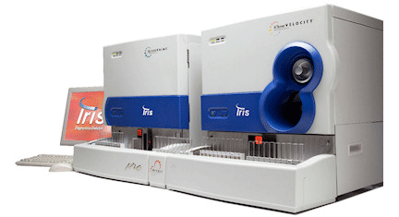
Double barcode*
Print 2 barcode for UA and Urine culture

IRIS Machine

*chemistry test
Depend on Strip color for PH – blood-nitrate-ketone
*microscopic
Observe WBC , RBC’s , bacteria , yeast , crystals ( high salts ) , casts ( high protein ) , squamous cells

If there is high WBC >10, or nitrate, or bacteria, or yeast *
Culture on:
Blood agar – MacConkey agar – CLED agar
And SAB agar for yeast

Reading

Gram –

CLED agar
LF
Escherichia coli: Large, elevated, yellow
Klebsiella: mucoid colonies, yellow
NLF
Proteus: translucent blue colonies
Pseudomonas: green colonies with typical matte surface and rough periphery

Gram +

Staphylococcus aureus
Streptococcus agalactiae Group B
Enterococcus

*we do microscan if we have
1 type ≥ 10 colony
microscan
2 type ≥ 10 colony

3 type ≥ 10 colony
Rejected

Mix skin flora or mix gram negative

Cystine Lactose Electrolyte Deficient (CLED) Agar

CLED Agar is a differential medium used for isolation and enumeration of bacteria from urine. The medium supports the growth of all urinary potential pathogens and provides distinct colony morphology. It supports the growth of urinary pathogens and contaminants and gives good colonial differentiation without the spread of Proteus species due to its lack of electrolytes.
Organisms capable of fermenting lactose will lower the pH and change the color of the medium from green to yellow. The color change is indicated by the presence of pH indicator Bromthymol Blue.

