.
COLLEGE OF SCIENCES CHEMISTRY DEPARTMENT

CHEM 101 LABORATORY OF GENERAL
CHEMISTRY (1)

Dr. Ahmad Al-Owais & Professor Taieb Aouak
1441 - 2020

TABLE OF CONTENTS
CONTENT | PAGE | DATE
INTRODUCTION | C - D | -
EXPERIMENT (0):  Basic Principles Of Laboratories: Safety Rules And Housekeeping Rules . | 1 -11 | -
EXPERIMENT (1):  Evaluation Of Error, Accuracy And Precision . | 12 -13 | 1/6/1441 H
EXPERIMENT (2):  Determination Of The Density Using Different Methods . | 14 - 19 | 8/6/1441 H
EXPERIMENT (3):  Reaction Stoichiometry: Determination Of The Limiting Reactant And Yield Percentage . | 20 - 23 | 15/6/1441 H
EXPERIMENT (4):  Determination Of The Transfered Thermal Energy: Endothermic And Exothermic | 24- 26 | 22/6/1441 H
EXPERIMENT (5):  Graham’s Law Of Gas Diffusion | 27 - 28 | 29/6/1441 H
First Exam |  | 6/7/1441 H
EXPERIMENT (6):  Enthalpy Of Reaction: Hess’s Law | 29 - 31 | 13/7/1441H
EXPERIMENT (7):  Determination The Molar Mass Of Volatile Liquid | 32 - 34 | 20/7/1441 H
EXPERIMENT (8):  Preparation Of A Solid/Liquid Solution | 35 - 37 | 27/7/1441 H
EXPERIMENT (9):  Preparing Solutions By Serial Dilution | 38 - 39 | 5/8/1441 H
EXPERIMENT (10):  Determination The Molar Mass Of Unknown Substance By Freezing Point Depression | 40 - 41 | 12/8/1441 H
Second Exam |  | 19/8/1441 H

INTRODUCTION

Our aims in this course are:
- Recognizing the importance of safe lab practices.
- Knowing all safety rules required to perform experiments in a safe environment.
- Identifying basic equipment and glassware used in any chemistry laboratory.
- Using equipment, glassware and chemicals in the safe and the proper way.
- Realizing that chemical changes and its scientific phenomenon are present in our daily life at homes, streets everywhere and every time. Thus, every materialized things, changes and behaviors can scientifically be explained and understood.

To achieve these aims, we must recognize the following:
- Because chemistry has developed largely through experiments, the study of chemistry is increased by laboratory experiences side beside with the principles of chemistry discussed in the classrooms.
- The laboratory environment and its lifestyle differ considerably from the outside world and is much more structured than our lifestyle at homes, or even in the classrooms.
- Using chemicals, glassware and equipment doesn’t follow our personal styles, emotions or wishes but it solely follows conventional rules that must be followed and obeyed.
- Chemistry is the science of our life (food, transportation, buildings, medicines, clothes, batteries …etc.)

This laboratory course is designed in such a way to be executed as if we have never encounter a chemistry laboratory and never had any preliminary experiences with chemicals, laboratory tools and equipment.

This course will develop an appreciation and respect to “Chemistry Laboratories” and will uncover the proper and conventional regulations and protocols.

Safety of persons inside and nearby laboratory is the primary concern that shouldn’t be neglected or underestimated at any time and at any circumstances.

Any chemical laboratory cannot be named so without its personals, contents and materials. Therefore, housekeeping is a crucial subject. We must exercise how to keep our laboratory safe, clean and tidy.

Chemical experiments can be carried out successfully only if we obey laboratory’s rules and follow its steps one by one. Chemical experiments do not follow our own personal styles in standing, holding, pouring or any other personal mode. When we are told, for example, to hold a test tube this way, we are not allowed to hold it except this way regardless weather it suits our personality or it does not.

This laboratory course also will help us to understand the theoretical bases of the experiments and how they verify and explain theoretical findings.

We should keep in mind that “NO report is presented NO experiment is done”. This simply means that any chemical experiment has to be reported in writing. The report of an experiment is a presentation of the idea of doing the experiment, how it has been done, what materials and equipment are used, which properties are measured and what are the values of these measurements, how calculations, if any, are carried out, and finally what is the final findings of the experiment.

Our efforts and work can be evaluated easily. We can score the highest possible value as long as we work with attention and care and we follow rules and regulation.

All of the experimental works we will encounter here are and approved by the Chemistry Department at King Saud University as they are consistent, with the B SC program of the this department. They were all carried out successfully in one of the general chemistry laboratories in this department.

These experiments are written here exactly as they were tested and carried out.

We, greatly, thank the head of the Chemistry Department at King Saud University Prof. Zeid Alothman, the general chemistry course coordinator.

Our great appreciation must be delivered to teacher assistants and chemistry technicians: Sultan Saad Almadhhi, Nabil Mohammed Alsahli, Mishary, Khaled Aldaghash, Mohammed Abdullah Alkhathran, Abdullah A. Adam, Suliaman Mohammed Alhmoud and Rajeh Theeb Alotaibi whose their concerted and mutually supportive efforts made the best in testing the validity of all experiments. What we see here could have not been seen as it is without their sincere efforts.

Ahmad Alowais and Taieb Aouak
20 RABI’II 1439 – 07 JANUARY 2018

EXPERIMENT (0):
BASIC PRINCIPLES OF LABORATORIES: SAFETY RULES AND HOUSEKEEPING RULES
- Safety rules
Work in a laboratory should be a safe experience. It will be safe, however, only if you follow the following safety rules with no exception.

  - Do not violate safety rules. Never violate safety rules given here or safety instructions given by your laboratory instructor.

  - Locate the safety equipment. Find the eye wash fountains, safety showers, fire extinguishers, fire blankets, first aid kit, and all of what exits to be used in case of emergency.

  - Protect your eyes. Wear goggles at all times. Prescription eyeglasses, if you need them, must be worn under goggles. You should not wear contact lenses unless allowed by your laboratory instructor.

  - Tie long hair back. Tie your hair if it is long. This precaution will keep your hair out of burner flames and harmful liquids.

  - Wear shoes that cover all of your feet. Broken glass on the laboratory floor is all too common. Your feet will need more protection than that afforded by open- toed shoes or sandals.

  - Wear clothes that cover most of your body. Good clothing can be protected with a laboratory coat. Remember lab coat is required in the chemistry labs. You may not be allowed to work in the lab without a lab coat.

  - Do not eat or drink in the laboratory. Foods and drinks are susceptible to contamination by chemicals that could cause a serious harm to your health. Therefore, food and drinks are not allowed in chemistry labs.

  - Do not taste any chemical. (TASTING CHEMICALS IS STRICTLY FORBIDDEN AND PROHIBITED). Some chemicals are very harmful and some are deadly substances. Never think or try to taste any chemical in chemistry labs.

  - Do not smell chemicals directly. Do not get your nose clause to chemicals. Use your hand to waft the odor to your nose.

  - Do not pipet by mouth. Use a rubber suction bulb or special pipette filler.

  - Do not put flammable substances near flame. A lot of chemicals are flammable and cause a sudden fire break out. Never have flammable substances near flame.

  - Do not engage in games in the laboratory. Laboratory is a place for chemistry work, it is not a playing space. Avoid playing any games inside your lab.

  - Do not do or watch unauthorized experiments. When in a lab, you are to perform a specified task. Do not do any experiment other than specified.

  - Do not work in the laboratory in the absence of your laboratory instructor or his/her authorized representative. Your instructor is the top responsible person in the lab. If the instructor is absent you are not allowed to stay in the lab.

  - Use a fume hood when required. Some chemicals are volatile and the lab is equipped with fume hood. Use it when instructed so.

  - Handle glass tubing with care. When tubing (including glass thermometers) is to be inserted through a rubber stopper, the tubing must be lubricated with water or glycerol. Hold the tubing with a cloth or a paper towel near the end that will be inserted, and use a twisting motion during insertion.

  - Be aware of your neighbors. Are they obeying the safety rules? A neighbor’s accident may not hurt him/her, but it may hurt you badly. Report any unsafe behavior of your neighbor to the lab instructor.

  - Wash your hands before leaving the laboratory. Always put in your mind that chemical may have contaminate your hands. Therefore, wash your hands before exiting the lab.

  - Tell your instructor about any accident or a spill immediately no matter how minor it is. Never ignore spills or accidents. Even if you think they are minor, report themto your instructor promptly.

  - AGAIN: Do not violate safety rules. Never violate safety rules given here or safety instructions given by your laboratory instructor.

I have read, I understand, and I will follow the above safety rules.

Student name:

Student number:

Signature:

Date

- Housekeeping rules
Good housekeeping in the laboratory will lead to pleasant surroundings. In addition, it will provide a safe work site in which you may be assured that chemicals are not contaminated.
  - Clean up broken glass immediately with a broom and a dustpan. Do not use your hands. Special containers are available for disposal.

  - Clean up solid and liquid spills immediately, but only after checking with your laboratory instructor about possible safety hazards.

  - Do not pour any chemical into a sink without authorization. Often, disposal bottles will be provided.

  - Take containers to the stock of chemicals. Never bring stock chemicals to your stand.

  - Read the label on a bottle carefully. Is it the correct chemical?

  - Do not insert a pipette or medicine dropper into a stock bottle. Avoid contamination by pouring the liquid into one of your glassware before taking a sample.

  - Use special care with stoppers or tops of stock bottles. Do not allow them to pick up contamination. Your laboratory instructor may provide additional instructions for handling the stoppers or tops found in your laboratory.

  - Take no more of a chemical than the experiment requires.

  - Never return an unused chemical to a stock bottle. You must assume that the chemical is contaminated. It must be discarded.

  - Set up your glassware and apparatus away from the edge of the laboratory bench.

  - Follow any other housekeeping rules given by your laboratory instructor.

I have read, I understand, and I will follow the above safety rules.

Student name:

Student number:

Signature:

Date:
The following is a presentation of glassware and equipment available in any chemistry laboratory.

First: Common glassware

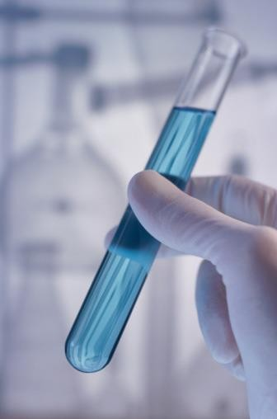
1-Test tubes
It has usually the shape of a finger with an open upper flat end and a closed lower rounded end.
- It is available in a variety of lengths and diameter, but the most common is the 10 cm × 1 cm.
- It is used for a lots of purposes (reactions, heating, transferring, smelling… etc.).

How to use?
- Hold the test tube exactly the way you are instructed to.
- Look at it; inspect it and read everything written on it.
- Apply instructions given to you by your instructor.

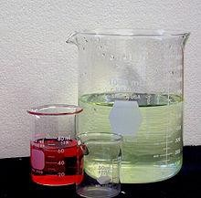
Beakers

- It has usually the shape of a cub without a handle.
- It is available in a variety sizes , the volume written on its outside walls .
- Mostly manufactured from glass and plastic .
- It is used for many purposes (reactions, heating, transferring, etc.).

How to use?
- Hold the beaker exactly the way you are instructed to.
- Look at it; inspect it and read everything written on it.
- Apply instructions given to you by your instruct.

Conical flask

- The “Erlenmeyer” or “conical flask” is used for titrations and many other purposes where we have to handle liquids.
- It is not suitable for measuring accurate volumes.
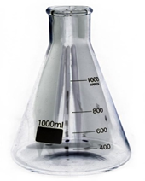

Graduated cylinders
- A graduated cylinder is used to measure an approximate volume of a liquid but is more accurate than some other glassware such as beaker or Erlenmeyer flask, which will be explained later.
- Graduated cylinders come in many sizes, 10 mL, 50 mL, and 100-mL are often found in general chemistry laboratories.
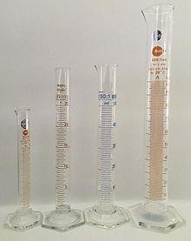

How to use?
- Hold the graduated cylinder exactly the way you are instructed to.
- Look at it; inspect it and read everything written on it.
- When water or an aqueous solution is added, the upper surface of the liquid in the graduated cylinder will be concave.
- This concave surface is called a meniscus.
- The bottom of the meniscus is used for all measurements.
- To avoid error which is called “parallax error”, your eye should always be level with the meniscus when you are measuring the volume.
- Apply instructions given to you by your instructor.
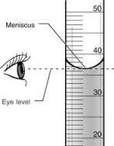

Pipettes

- There are two types of pipette.
- Mohr pipette is graduated so that it can deliver different volumes from tenth of a milliliter up to its maximum volume. ( 0.1 ml to max volume )

2- A transfer pipette is calibrated to deliver only one volume.
It comes in many sizes, 5-mL, 10-mL, and 20-mL pipettes.

- The correct use of a pipette requires manual dexterity which comes with practice.
- Use pipette pump to deliver harmful and corrosive liquids .
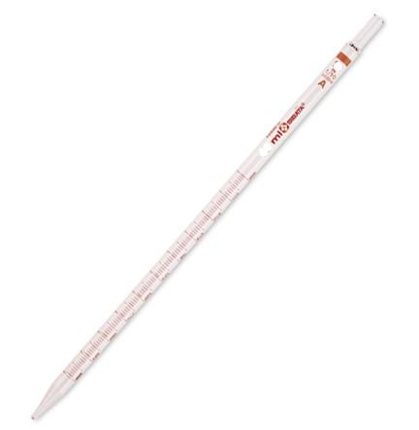

Volumetric pipette
Graduated pipette

How to use?
- Hold the graduated cylinder exactly the way you are instructed to.
- Look at it; inspect it and read everything written on it.
- Practice drawing water in it up to the indicated sign.
- Always use the tip if your index finger not your thumb to press its upper aperture.
- Practice draining water from it into a conical flask.
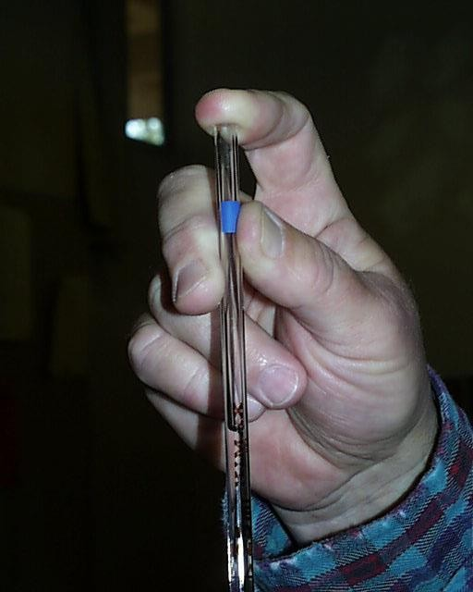
- While draining never blow liquid by your mouth.

Burettes
- The principal use of the burette is for titrations.
- A good burettes is the burettes that drains freely, are very clean, and do not leak around the stopcock.
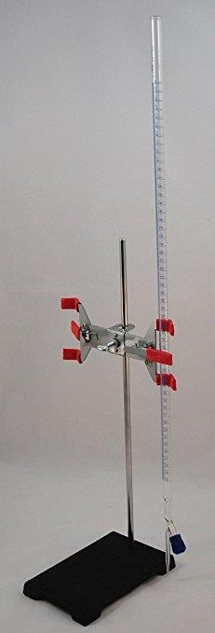
- The following three steps will help you to have a burette that operates correctly:
    - The capillary tip of the burette should be clean and free of foreign objects.

(A thin wire can sometimes be used successfully to dislodge grease or dirt that impairs or prevents draining.)
    - If water droplets are left on the inner walls of the burette after draining, the burette needs a thorough cleaning. It should be cleaned with warm water, detergent, and a burette brush; then it should be rinsed with tap water. Finally, it should be rinsed with distilled water.
    - Some maintenance is required if the stopcock or valve leaks while the burette is draining or if drops form on the capillary tip when the stopcock is turned off. Teflon stopcocks or valves do not require lubrication. Leaking can usually be prevented by tightening the tension nut, which seats the stopcock more firmly.

How to use?
- Burette must be placed properly in a clamp attached to a stand.
- Before using, the burette should be rinsed couple of times with the solution that will eventually be in it.
- To rinse the burette apply the following steps:
  - Place a funnel in the top of the burette.
  - Pour about 3 to 5 mL of the solution through the funnel into the burette.
  - Remove the funnel and take the burette from the clamp.
  - Carefully tip the burette on its side while holding it with your hand.
  - Do not allow the solution to spill, but tip the burette until the solution comes in contact with almost the entire length.
  - Rotate the burette in your hand so that the inner walls are rinsed completely with the solution.
  - Drain the burette through the stopcock; discard this portion of the solution.
  - Repeat the entire rinsing steps two more times.
- The lines that span the entire circumference occur for each milliliter, starting with zero at the top and reaching the maximum volume at the bottom of the burette.
- As a consequence, the burette will show the volume of a liquid that has been delivered rather than the volume that remains.
- When using the burette, use both hands: one to open or close the stopcock or valve, and the other to swirl the flask.
- The smaller lines indicate each tenth of a milliliter.
- These lines allow you to estimate the volume to the nearest 0.01 mL.
- Readings such as 9.34 mL and 17.60 mL are acceptable.
- Readings such as 9.3 mL and 17.6 mL are not acceptable.
- Fill the burette to above the zero mark with the stopcock closed.
- Open the stopcock fully so that the liquid drains rapidly to flush out air bubbles in the tip of the burette.
- Drain the burette until the meniscus rests between the zero and l-mL marks.
- Do not waste time trying to align the bottom of the meniscus with the zero mark.
- Read the burette with your eye on the same level as the meniscus.

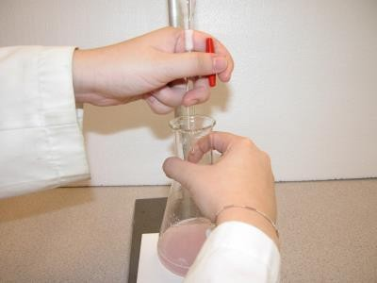

The correct way of handling a burette

- To obtain the volume of the liquid that you used, subtract this reading from the final reading.
- With a bit of practice, you will be able to adjust the stopcock or valve so that as little as half a drop will form on the capillary tip.

Volumetric flasks
- Volumetric flasks are used to make solutions of an accurately known volume and accurate concentrations.
- They are 10 mL, 50 mL, 100 mL, 250 mL, 500 mL, and 1 L flasks.
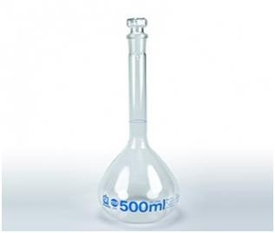

How to use?
Burette must be placed properly in a clamp attached to
- Quantitatively, transfer a certain mass of a solid chemical to the flask.
- Carefully, fill the flask exactly to the mark with distilled water.
- Stopper the flask then invert it a number of times until all solid is dissolved and the solution has been mixed well.
- The concentration of the solution can then be calculated in other experiments.
- Using a pipette, transfer a certain amount of a solution of known concentration to the flask.
- Fill the flask to the mark, stopper and invert to mix.
- The Molarity of the solution in the flask can then be calculated from the dilution equation (M_{cnc}V_{conc} = M_{dil}V_{dil}).
- The accuracy of the volume depends on the size of the flask. Typically for a 250 mL volumetric flask the accuracy of the volume is ±0.1%.

Other commonly glassware and equipment

The glass funnel

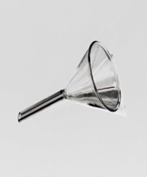
The glass funnel is used mainly to fill burettes.
Larger funnels together with folded or fluted filter paper are used to filter impurities or product from solutions.

How to use?
- Clean your funnel with distilled water then with the solution you will use.
- Place the funnel on the top of the burette.
- Pour your solution carefully inside the burette through the funnel.
- Notice that a spill may occur if solution is poured quickly .

Second: Balances
- A balance is used to measure masses.
- The modern electronic balances used in our laboratories can have sensitivities of 0.1000 mg (± 0.0001 mg), 1.000 mg (± 0.001 mg), or 1.00 mg (± 0.01 mg).
- Your laboratory instructor will provide details about the operation of the balances in your laboratory.
- You should be able to achieve the maximum precision offered by your balance almost immediately.
- Practice weighing different kind of samples as instructed.

How to use?
- Make sure that the balance is located in its proper place away from air flow, heat, chemicals and sun rays.
- Make sure that the balance top is clean.
- Balance should be always turned off and plugged off the electric socket.
- When you are ready to use, turn on the balance.

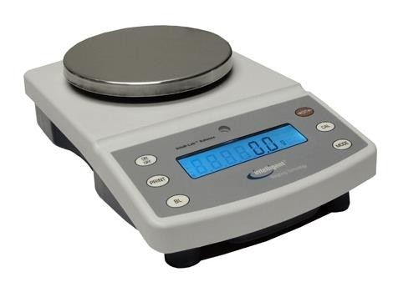
- Place the object you need to weigh on the balance.
- Look at the reading, when its last digit starts settling at certain number record the value as the mass of your object.
- Turn off the balance.
- Remove your object from the top of the balance and make sure its clean.
EXPERIMENT (1):

EVALUATION OF ERROR, ACCURACY AND PRECISION
- Experimental error (∆x) is defined as the absolute value of the difference between the experimental value of the measured quantity (x) and the its actual value (x₀).

Experimental error = Experimental value − Actual value
∆x = |x− x_{𝟎}|
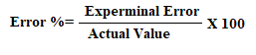
- The percent error is the ratio of the experimental error (∆x) to the actual value (x) multiplied by 100.
$$Error(\%)=\frac{Δx}{x_{օ}}X100$$
- The precision of a measurement is a measure of the reproducibility of a set of measurements, and is recorded as:

Precision = measured value ± ∆x

- The significant figures displayed on an instrument are an indication of its precision.

Part one: Evaluation of percent error
In This part, a substance will be weighed and the percent error will be calculated.

Equipment and reagents
- Balance
- Beaker
- Known weight Object .

Procedure
- Zero the balance.
- Weigh the object. Record this mass as m.
- Record the balance precision as ± ∆x.
- Calculate the percent error for the mass of the salt.
- Record the salt mass with precision m ± ∆x.

Results and calculation
- Calculate the experimental error, error percentage and precision.

Part two: Determination of accuracy and precision
In this part, the average mass the experimental error in mass (∆m), the percent error of the measured mass (m %), and the accuracy of mass measurement will be determined as follows:

Determining of

$$\overline{m}=\frac{m_{1}+m_{2}+m_{3}+…+m_{n}}{n}$$
n is the number of measurements.

Determining of ∆m:
∆m = m_{max} mmin

Determining of m%:
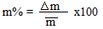

Determining the accuracy of measurement:
Accuracy in m value = $\overline{m}$ ± ∆m

Equipment and reagents
- Balance. 3. 50-ml flask with a stopper
- 50-mL graduated cylinder 4. 25 mL graduated burette

Procedure

1.Weight an empty beaker and record the mass as m_{empty beaker}
- Into the dry beaker, add 25 mL of distilled water measured carefully by a dry 50- mL graduated cylinder.
- Empty the water from the beaker and repeat the above steps two more times.
- Weight the beaker with the added water and record the mass you get as m_{beaker and water}
- Repeat all of the above steps using a dry 50 mL- graduated burette.

Results and Calculation

m_{empty beaker}= m= m_{beaker and water}-m_{empty beaker}

- Tabulate the results.
 | m₁ | m₂ | m₃
graduated cylinder
burette
Calculate the average, the experimental error (∆m), the percent error (m%), and the the. Accuracy of the mass value ($\overline{m}$ ± ∆m) .

- State which is more accurate the graduated cylinder or the graduated burette?
EXPERIMENT (2):

DETERMINATION OF THE DENSITY USING DIFFERENT METHODS

Objectives
- Determination of volume by two different methods.
- Using measured volumes and masses to calculate densities.
- Using the relationship between mass, volume, and density to find desired unknown quantities.
- Evaluating results using error analysis.

Theoretical information
- The density is defined as the ratio of mass, m, to volume, V:

Density = ^{𝐦}
𝐕

- Usually, densities units are g/ml or g/cm³ (1 ml = 1 cm³).
- Masses are measured on electronic balances.
- Volume is measured in many ways.
- In this experiment, you will measure masses and volumes to determine density.

Materials and equipment
A specimen (massive cylinder) Ruler
100 mL-graduated cylinder A massive cylinder Graduated burette
Balance

First method

Determination of density directly by calculation of volume and weighing mass
of a geometric specimen .

Theoretical information
- Example: Specimen (massive cylinder)

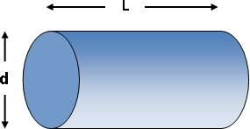
D

- The mass, m, in grams, is obtained directly by weighting the specimen (massive cylinder) using the balance.
- The degree of precision is calculated from the ∆m taken from the balance (precision) and from the measurement tool for volume (precision) using the following relation:

Procedure

- Using a proper an accurate ruler, measure the length (L) and the diameter of the specimen (massive cylinder) (D).
- Weigh the mass (m) of your specimen (massive cylinder).

Results and calculations
- Report your measurements as follows:

L (cm) | D (cm) | m

- Calculate the volume of your specimen (massive cylinder).

$Volume=\frac{πD^{2}L}{4}$ =

- Calculate the density of your specimen (massive cylinder).

$Density=\frac{m}{V}$ =

4-Tabulate your errors of measurements:

∆m (g) | ∆L (cm) | ∆D (cm)

∆m is the error occurred during the weighing on the balance. The figure below shows how you find the value of ∆m is taken as follows

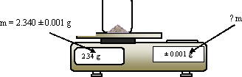

∆L and ∆D are the errors occurred during the measurement of the length and the diameter of the cylinder using a ruler.
The figure below shows how you find the value of ∆L and ∆D
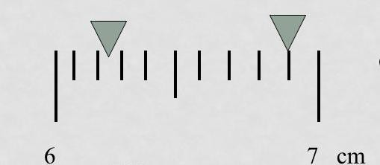
The above figure shows two measurements.
The correct reading of the first is 6.2 cm ± 0.1 cm The correct reading of the second is 6.8 cm ± 0.1 cm

- Calculate the error in the density (Δdensity), and its accuracy:

$ΔDensity=±density[\frac{ΔD}{D}+\frac{ΔL}{L}+\frac{Δm}{m}]$

The accurate density = density ± ∆density

Second method

Determination of density by displacement of water

Theoretical information
When volume of an object cannot be calculated by a mathematical equation, or if it is desired to determine the volume without using the mathematical equation, it can be determined by water displacement.

Procedure

(Here you will determine the volume of the same object used in the first method)
- Pour water into the graduated cylinder. Record the exact volume as V₁.
- Place your specimen (massive cylinder) which you used in the first part inside the graduated cylinder. Record the new volume as V₂.

(Because you object is the same object used in the first method, do not weigh it, but use the mass you obtained in the first method)

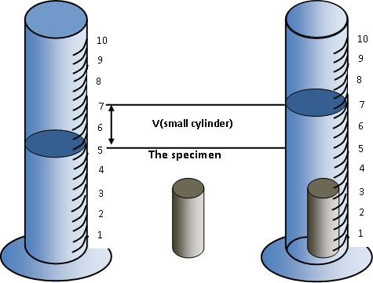

Results, calculations and comparison
- Report your measurements as follows:

V₁ (cm³) | V₂ (cm³) | m

- Calculate the volume of your specimen (massive cylinder):

V = V₂ – V₁

- Calculate the density of specimen (massive cylinder):

$Density=\frac{m}{V}$

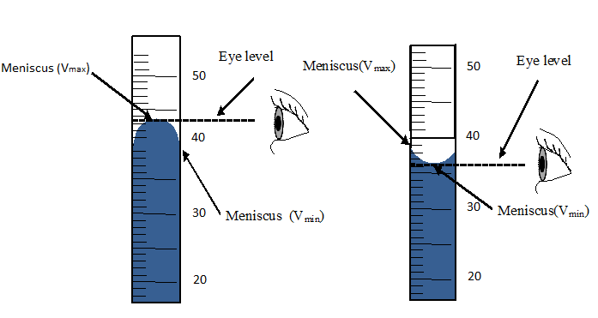
Evaluate the values of ∆m ∆V₁ and ∆V₂ as follows:
∆m is evaluated exactly as described in the first method of this experiment.

∆V₁ and ∆V₂ are evaluated as follows :

∆V₁=∆V₂=∆V_{graduated} _{cylinder}

∆V_{graduated} _{cylinder} is written on the top of the cylinder.

If not written it can be evaluated By using the following equation:

$${ΔV}_{graduated cylinder}=\frac{V_{max}-V_{min}}{2}$$

As is described in the scheme.

- Tabulate the values of experimental errors:

∆V₁ | ∆V₂ | ∆m

- Calculate the error in the density (Δdensity), and its accuracy:

$ΔDensity=±density[\frac{ΔV1}{V1}+\frac{ΔV2}{V2}+\frac{Δm}{m}]$

The accurate of density = density ± ∆density

- Calculate the absolute difference between the density determined by this method and that determined by the first method as follows:

Δdensity = |𝐝𝐞𝐧𝐬𝐢𝐭𝐲_{𝐟𝐢𝐫𝐬𝐭} _{𝐦𝐞𝐭𝐡𝐨𝐝} − 𝐝𝐞𝐧𝐬𝐢𝐭𝐲_{𝐬𝐜𝐨𝐧𝐝} _{𝐦𝐞𝐭𝐡𝐨𝐝}|

Third method

Determination of the density by adjusting the density of a fluid
Theoretical information
(Volume of an object can be obtained not only by mathematical equation or by water displacement but also can be determined by this method.)
- The idea of this method is based on the fact that when an object (that does not swell or dissolve in the fluid) is in a fluid it takes one of the three following situations:
Fist: if the body is heavier than the fluid it will sink down.
Second: if the body is lighter than the fluid it will float up.
Third: if the body and the fluid are of the same heaviness, the body will suspend in the middle of the fluid.
Procedure
- Weight a wide 100 mL-graduate cylinder. Record its mass ($m_{gc1})$.
- Pour 50 mL of water inside the cylinder.
- Immerse a cylindrical specimen in the water inside the cylinder.
- Fill a separation funnel with a saturated solution of the salt.
- Slowly and carefully and gradually, pour the salt solution into the graduated cylinder. Use a glass stirrer to insure that the added solution is completely mixed with the water.
- Continue doing the previous step until you see the cylindrical specimen is positioned in the midpoint of the cylinder.
- Get the cylindrical specimen back.
- Read the total volume of the solution remained in the cylinder. Record this volume as final volume ($V_{soluion}$)
- Weight the wide 100 mL-graduate cylinder with the remaining solution. Record its mass ($m_{gc2})$.
Results and calculations
- Report your measurements as follows:

$m_{gc1}$ (g) | $m_{gc2}$ (g) | $V_{soluion}$ (cm³)

- Calculate the mass of the solution ($m_{solution}$):

$m_{solution}$ = $m_{gc2}$ − $m_{gc1}$

- Calculate the density of the solution which is at the same time equals that of the cylindrical specimen.

Density of the cylindrical specimen = Density of the solution = $\frac{m_{solution}}{V_{soluion}}$

EXPERIMENT (3):

REACTION STOICHIOMETRY: DETERMINATION OF THE LIMITING REACTANT AND YIELD PERCENTAGE

Objectives
The objectives of this experiment are the determination of:
- The limiting reactant.
- The percentage of the yield.

Theoretical information

Na₂CO₃(s) + 2HCl (aq) → 2NaCl (aq) + CO₂ (g) + H₂O (l)

The balancing coefficients indicate that there is a 1:2 mole ratio between Na₂CO₃ and HCl. This means that for every one mole of sodium carbonate that reacts, two moles of HCl should react and two moles of NaCl should be produced.

Safety
- Be careful when handling the hydrochloric acid, it can cause chemical burns to the skin.
- If any acid spills on you, rinse immediately under running water for 15 minutes and report the accident to your instructor.
- Acid spills may also can be neutralized using sodium bicarbonate solution on the sinks.
- Be sure to exercise appropriate caution when using the Bunsen burner and handling hot equipment.

Materials and equipment
- Sodium carbonate (Na₂CO₃),
- Hydrochloric acid Solution HCl ( 1 M )
- Balance.
- Evaporating dish.
- Watch glass (to fit as a cover for the evaporating dish),
- Stand and ring clamp and wire gauze.
- 10 mL-pipette
- small beaker
- Bunsen burner or hot plate

Procedure
- Measure and record the mass of your clean dry evaporating dish with watch glass. Record this mass as 𝐦_{𝐈𝐍𝐈𝐓𝐈𝐀𝐋}.
- Carefully weigh 0.3 – 0.4 g of Na₂CO₃ to the evaporating dish. Record the exact mass as m(𝐫𝐞𝐚𝐜𝐭𝐚𝐧𝐭).
- Using your dropper pipette, obtain exactly 10.0 mL of the 1.0 molar HCl (aq). Record the exact volume as 𝐕_{𝐇𝐂𝐥}.
- Add hydrochloric acid drop by drop to the sodium bicarbonate in the evaporating dish.

(The reaction will be evident by the bubbling that takes place.)
- Carefully mix the reactants after every 4-5 drops of HCl.
- Continue adding HCl to its last drop.

(The reaction is complete once no more bubbling is noticed.)
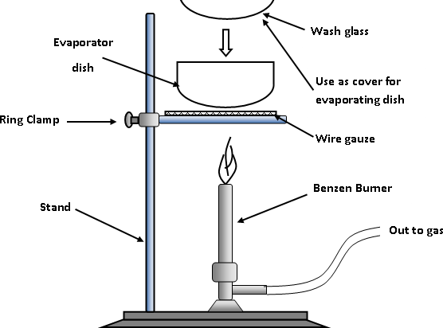
- As shown in the figure below, assemble the stand, ring clamp and wire gauze apparatus for heating.

- Cover the evaporating dish with the watch glass and place it on the wire gauze.
- Carefully heat the solution in the covered evaporating dish with a Bunsen burner flame in order to remove the water generated in the reaction (as well as any excess HCl present).

(The flame should be adjusted to a lower temperature and wafted under the evaporating dish constantly.)
- Continue heating until the contents are completely dry. Note that the watch glass cover should also be dry!
- Allow the evaporating dish to cool to room temperature.
- Measure the mass of the evaporating dish + watch glass + residue (NaCl). Record the exact mass as (𝐩𝐫𝐨𝐝𝐮𝐜𝐭).
Results and calculations
Tabulate your experimental results:

mNa2CO3 ( g ) | VHCl ( L ) | M HCl ( mol/L ) | m INITIAL ( g ) | m TOTAL product( g )

(Molar masses /g mol^{–1}: H = 1.008, C = 12.01, O = 16, Na = 22.99, Cl = 35.45)

  - The limiting reactant
- To determine which of the reactants is the limiting reactant, number of moles used in the experiment (n_{Na}2CO3 ) and (n_{HCl}) must be known , then divided by the coefficient of each reactants in equation.

$n_{Na2CO3}=\frac{m_{Na2CO3}}{{Mw}_{Na2CO3}}$ ${Mw}_{Na2CO3}=\left(23x2\right)+12+(16x3)=106 g/mol$

$$n_{Na2CO3}=$$

$$\frac{n_{Na2CO3}}{1}=$$

n_{HCl} = M _{HCl}× V_{HCl}

n_{HCl} =

$$\frac{n_{HCl}}{2}=$$

- The reactant which gives the lowest quotient is the limiting reactant.

So the limiting reactant is .

  - The yield percentage

- Calculate the mass of NaCl prodused (m_{NaCl}):

mNaCl,actual = mTOTAL(product) – mINITIAL

- The consumed amount of the limiting reactant will be used stoichiometrically to calculate the amount of NaCl that should be produced theoretically .

1 mole of Na₂CO₃ 2 mole of NaCl

….. mole of Na₂CO₃ X mole of NaCl

X mole of NaCl (n _{NaCl, theorical}) =

Determined (m_{NaCl, theorical}) using the following equation:

m_{NaCl, theorical} = n _{NaCl, theorical} x ${Mw}_{NaCl}$ ${Mw}_{NaCl}=23+35.5=58.5 g/mol$

m_{NaCl, theorical} =

- The yield percentage of NaCl can be calculated by the following equation:

NaCl yield% = mNaCl, actual × 100
mNaCl, theoretical

EXPERIMENT (4):

DETERMINATION OF THE TRANSFERED THERMAL ENERGY:ENDOTHERMIC AND EXOTHEMIC

Objectives
Measurement of the amount of Heat (Q) change because of mixing of two substances.

Theoretical information
- In this experiment, you will measure the amount of heat involved two mixtures (solid-liquid and liquid-liquid).using the following relationship:

Q = m × ρ × (_{Tfinal} - _{Tinitial})
Where:
m is the mass, in grams, of the solid or the liquid substance.
ρ is the specific heat (ºC/J.g).
T_{final} and T_{initial} are the temperature at the before and after the mixing respectively.
- When two substances having different temperatures were mixed together in an adiabatic container, the substance that has the lower temperature gains the energy and its sign will be positive (q_{Endothermic}) and that having the higher temperature loses the same energy and its sign will be negative (Q_{Exothermic}).
qEndo = m1 × ρ 1× (Tfinal – Tinitial)
qExo = m2 × ρ 2× (Tfinal – Tinitial)
qEndo = – qExo

Materials and equipment
Water Glass rod
Stir stick
250 –mL beaker Balance
Thermometers (0 - 100ºC) two large styro-foam cups 100-mL graduated cylinder Bunsen burner or hot plate

Procedure:

Part one

(NOTE: Considering the density of water is 1.0 g/cm³,)
- Weigh out 50 g of water and put it in a 250 -ml beaker. Record its mass as
𝐦𝐰𝐚𝐭𝐞𝐫.
- Record the initial temperature as T_{initial water} .
- Weigh a glass or metal rod and record its mass as 𝐦_{𝐫𝐨𝐝}.
- Put the glass rod in the heated water.
- After waiting for one minute. Record its temperature as T_{initial,rod}.
- Take the glass rod at T_{initial,rod} outside and insert it immediately in the previous styro-foam cup which contains water at T_{initial,water}.
- After waiting for one minute, record the new temperature as T_{final}.

Results and calculations

- Tabulate your results as follows:

mwater | Tinitial,water | mrod. | Tinitial,rod | Tfinal

ρ_{water} = 4.184 J/g ºC, ρ_{glass} = 0.836 J/g ºC , ρ_{iron} = 0.45 J/g ºC

2. Calculate the heat quantity changes, in the units of Joule, as follows:
  - First: Heat gained by water:

q_{water} = m_{water} × ρ_{water} × (T_{final} - T_{initial,water})

  - Second: Heat lost by the rod:

q_{rod} = m_{rod} × ρ_{rod} × (T_{final} - T_{initial,rod})

Part two

- In 250-ml beaker, put 50 g of water is heated to its boiling temperature. record the temperature T_{initial,Hot water}
- In a separate beaker, add 50 g of water at ambient temperature. Record this temperature as T_{initial,water}.
- Add an amount of the water at T_{ambient} to the hot water. Record your temperature as T_{final}.

Results and calculations
- Tabulate your results as follows:

mwater | m_{hot water} | Tinitial water | Tinitial,hot water | Tfinal

ρ_{water} = ρ_{hot water} = 4.184 J/g ºC

2. Calculate the heat quantity changes as follows:
  - First: Heat gained by water in the units of Joule:

qwater = mwater × ρ_{water} × (Tfinal − Tinitial,water)

  - Second: Heat lost by hot water in the units of Joule:

qhot water = mhot water × ρhot water × (Tfinal − Tinitial, hot water)

- Depending on the previous calculation , calculate the mass of water (m_{water}) you need to add to your tea in order to make the temperature of the tea low enough to be drinkable: (Consider tea as hot water, Drinkable temperature is 55 º C) .

qwater = − qtea
mwater ×ρ_{water} × (Tfinal − Tinitial,water) = − m hot water × ρ_{hot water} × (Tfinal − Tinitial, hot water)

m = − mhot water × (Tfinal – Tinitial, hot water)
water
(Tfinal − Tinitial water)

EXPERIMENT (5):
Graham’s Law of Gas Diffusion
Graham’s law states that a gas will effuse at a rate inversely proportional to the square root of it’s molecular mass under same conditions of temperature and pressure .

$$\frac{L_{1}}{L_{2}}=\frac{\sqrt{M_{w2}}}{\sqrt{M_{w1}}}=\frac{\sqrt{d_{2}}}{\sqrt{d_{1}}}$$
L _{NH3}
L _{HCl}

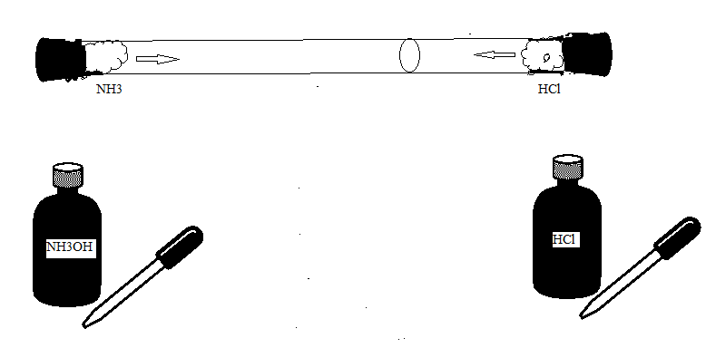

NH₄Cl

NH3
HCl

Reaction Equation :

Ghraham Law for this reaction is:
$$\frac{L_{NH3}}{L_{HCl}}=\frac{\sqrt{{Mw}_{HCl}}}{\sqrt{{Mw}_{NH3}}}=\frac{\sqrt{d_{HCl}}}{\sqrt{d_{NH3}}}$$
Materials and equipment
Glass tube (40 cm x 1 cm) Two stoppers
HCl and NH3 solutions. Cotton

Procedure:
- Put the glass tube in horizontal position as in diagram
- Insert the cotton in the ends of glass tube.
- At the same time, inject equal amount of each solution in the cotton (one in each side) and close them quickly by stoppers.
- Observe the formation of white smoke inside the glass tube and mark it with pen.
- Measure the distance moved by each gas (from center of the cotton to the white smoke).

Results:
- Distance moved by HCl gas ( L_{HCl}) = cm.
- Distance moved by NH3 gas ( L_{NH3}) = cm.

Molar masses (g/mol ): H =1 , N =14 , C =12 , Cl =35.5

Calculation :
- The theoretical ratio between the molar masses of the two gases (Y) :

- The measured ratio between the molar masses of the two gases (X) :

- Error percentage :

$$Error \%=\left|\frac{Y-X}{Y}\right| X100$$

Question;
Unknown gas faster two times than methane (CH4), calculate its molar mass?

EXPERIMENT (6):
ENTHALPY OF REACTION: HESS’S LAW

Theoretical information

Hess’s law states that the enthalpy of any change (physical or chemical) in any system depends on the state of the system before and after the change, and it never depends on what path the system went through to accomplish this change.
- In this experiment, you will measure and compare the change of Enthalpy involved in the following three reactions:
REACTION 1:
NaOH(s) + HCl(aq) → NaCl(aq) + H₂O(l) ∆H₁

REACTION 2:
NaOH(s) + H₂O(l) → NaOH(aq) ∆H₂

REACTION 3:
NaOH(aq) + HCl(aq) → NaCl(aq) + H₂O(l) ∆H₃

- It is clear that because reaction 1 is the sum of the reactions 2 and 3,
(∆H₁) = (∆H₂ + ∆H₃)

Objectives
- Measuring the reactions’ enthalpy and verifying Hess's Law.

Materials
Solid Sodium hydroxide (NaOH) .
0.50 mol/L sodium hydroxide solution
0.50 mol/L Hydrochloric acid solution
0.25 mol/L Hydrochloric acid solution Balance
Thermometer
styro-foam cup calorimeter.
100-mL graduated cylinder
2 Small beakers
50-mL automatic burette 50-ml graduated burette

Safety
- Avoid direct contact with hydrochloric acid and sodium hydroxide (BOTH ARE CORROSIVE).
- If any touches your skin, wash it off immediately.
- Solid sodium hydroxide is especially dangerous because it absorbs moisture rapidly from the air, forming an extremely corrosive liquid.
- If solid sodium hydroxide spills, clean it up immediately.
- Always keep the bottles of solid sodium hydroxide securely closed.

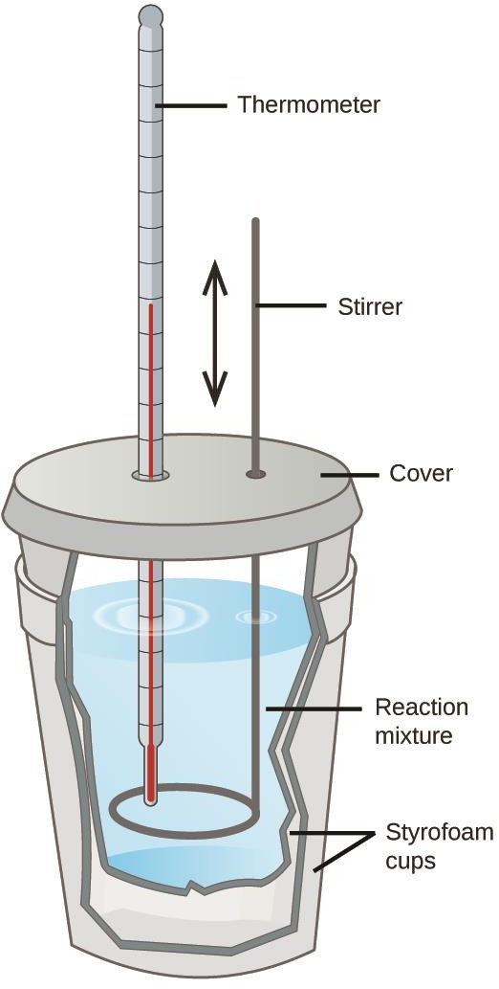
Procedure
- Assemble your styro-foam calorimeter cup as in the figure .

- Weigh the glass tube and record its mass as 𝐦_{𝐠𝐥𝐚𝐬𝐬}.

REACTION 1:
- Pour 50 mL of the 0.25 mol/L hydrochloric acid into your styro-foam cup calorimeter. Stir carefully until a constant temperature is reached. Measure and record this temperature as T₁.
- Accurately find and record the mass of about 0.5 g (2-3 granules) of solid sodium hydroxide. Record the exact mass as m_{1,𝐍𝐚𝐎𝐇}
- Place the solid sodium hydroxide into the hydrochloric acid solution in your styro-foam cup calorimeter. Stir gently to insure that the solid is completely dissolved. Record the highest temperature reached as T₂.
- Discard the solution safely and rinse the cup thoroughly with water.

REACTION 2:
- Pour 50 mL of cool distilled water into your styro-foam cup calorimeter. Stir carefully until a constant temperature is reached. Measure and record this temperature as T₁.
- Accurately weigh a mass of about 0.5 grams (2-3 granules) of solid sodium hydroxide, Record the exact mass as m_{2,NaOH} .
- Immediately put it into the water in the cups. Stir gently to insure that the solid is completely dissolved. and record the highest temperature reached as T₂.
- Discard the solution safely and rinse the cup thoroughly with water.

REACTION 3:
- Accurately measure a 25 mL of the 0.50 mol/L hydrochloric acid solution into your calorimeter. Record the temperature of both solutions as T₁ .
- Accurately measure a 25 mL of 0.50 M sodium hydroxide into a 250 mL beaker.
- Pour the sodium hydroxide solution to the acid solution in the styro-foam cup.
- Stir the mixture and record the highest temperature reached. Record this temperature as T₂ .
- Discard the solution as directed by your teacher.

Results and calculations:

m_{calorimeter} | m_{solution} | m_{1,N𝐚𝐎𝐇} | m_{2,N𝐚𝐎𝐇} | ρ_{water} J/g ºC | ρ_{glass} J/g ºC
 |  |  |  | 4.18 | 0.836
. Tabulate your results as follows:
 | Reaction 1 | Reaction 2 | Reaction 3
t_{1 ( ℃ )}

t_{2 ( ℃ )}

ΔT = t₂ - t_{1 ( ℃ )}

q _{Solution} ( J )

q₁ = m_{solution} x ρ_{water} x ΔT

q _{calorimeter} ( J )

q₂₌ m_{calorimeter} x ρ_{glass} x ΔT

Q=q₁+q₂ ( J )
nNaOH ( mole)

$ΔH=\frac{-Q}{n}$ (kJ.mol⁻¹ )

. Proof the Hess’s law.
(∆H₁) = (∆H₂ + ∆H₃)
EXPERIMENT (7):

DETERMINATION THE MOLAR MASS OF VOLATILE LIQUID

Objectives

Application of the gas law.
- Observation of evaporation and condensation.
- Measurements of certain physical properties of a gaseous substance.
- Determination of the molar mass of an unknown substance.
Theoretical information
- If the substance in question is a gas or the vapor of a volatile liquid, a common method to determine its molar mass is to use the ideal gas law.
- Volatile substances are usually composed of nonpolar molecules, which easily vaporize to the gaseous state.
- If volume, pressure, and temperature of the gas are measured, the numbers of moles (n) can be calculated using the ideal gas law:
n = P × V
R × T

Molar mass (M) can be evaluated using the following equation:

$$Mw=\frac{m}{n}$$

Materials and equipment

Unknown volatile Liquid (Acetone) 13 cm × 1 cm-test tube
Test tube holder A needle
Two 400 ml beakers (or larger) Ice bath
Balance
Water bath Aluminum foil
A conventional barometer

Procedure
- Trim a piece of aluminum foil , that it just covers the top of a test tube
- Use a needle to make a small hole in the center of the foil.
- Measure and record the mass of the test tube and the foil. Record this mass as 𝐦_{𝟏}
- Prepare a hot-water bath by warming about 300 mL of tap water in a 400 mL beaker.
- Place the test tube in the hot water bath.
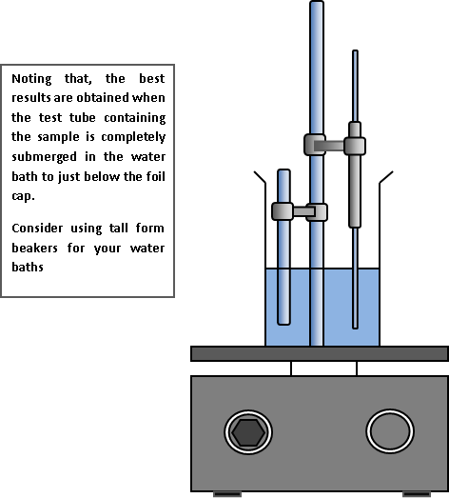
(Notice: You can replace test tube with 25 ml conical flask)
- Submerge your test tube as far as possible without making contact with the bottom (see figure).
- Immerse the thermometer in the hot-water bath (see figure). (Do not allow the tip of the thermometer to touch the beaker.)

Heat the hot-water bath to boiling and maintain it boiling as your sample of liquid vaporizes.
(Note that some of your sample will escape the test tube through the needle hole in the foil. This process also serves to flush the air out of the test tube.)

- After all of the liquid in the test tube has vaporized, keep the test tube in the boiling-water bath for at least three minutes.
- Watch the temperature readings and record the temperature of the boiling water bath, which will be used in the ideal gas law calculations. Record this temperature in Kelvin unit as T.
- Using a test-tube holder, transfer quickly the test tube to the ice water bath.
- Leave the test tube to cool for about one minute, then remove it and dry it completely.
- Measure and record the mass of the test tube and the aluminum foil.
Record this mass as 𝐦_{𝟐}.
- Record the room’s barometric pressure. Record this pressure as P. 15.Rinse out the test tube and fill it to the top with tap water.
16. Measure the volume of water by pouring it into suitable graduated cylinder and record the volume of the test tube ( V ) .

Results and calculations
Report your measurements as follows:

𝐦_{𝟏} ( g ) | 𝐦_{𝟐} ( g ) | V ( ml ) | T ( K ) | P ( atm )

Calculate the mass of the unknown gas (it equals the mass of the condensed vapor), 𝐦_{𝐠𝐚𝐬}, as follows:
mgas = m2 – m₁ =

Calculate the molar mass of the unknown substance, $Mw$, as follows

$Mw=\frac{m_{gas}.R.T}{P.V}$

EXPERIMENT 8:
PREPARATION OF A SOLID/LIQUID SOLUTION

Part one: Dissolving a solid solute in a solvent

Theoretical information
- The amount of solute that is dissolved in a given quantity of solvent is expressed as the concentration of the solution.
- A diluted solution contains only a small amount of solute in a given amount of solution, unlike concentrated solution contains a large amount of solute .
- Chemists mostly use molarity as concentration unit.
- The molarity, M, of a solution is the number of moles of solute in one liter of solution and is calculated as follows:

Molarity = 𝐧𝐬𝐨𝐥𝐮𝐭𝐞
𝐕𝐬𝐨𝐥𝐮𝐭𝐢𝐨𝐧 (𝐋)
where n is number of moles of solute and S_{olution} _{(L)} is the volume of solution in liter (1 L = dm³).
- If n_{solute} is not known, it can be calculated from its mass “m_{solute}” and its molar
mass “Mw_{solute}” as follow :
$n_{solute}=\frac{m_{solute}}{{Mw}_{solute}}$

Equipment and Reagents
Balance
A small beaker
100-mL volumetric flask A funnel
Wash bottle Burette Distillated water Sodium chloride

Procedure

- In a small beaker, use the balance to weigh a mass of 3.00 g of NaCl.
(RECORD THIS MASS as 𝐦_{𝐍𝐚𝐂𝐥})
- Transfer this mass to a 100-mL volumetric flask.
- Rinse beaker and funnel with a small amount of distillated water into the flask.
- Repeat the previous step two more times.
- Cap the flask and invert it several times to dissolve the solid.
- Add water until the liquid is just below the etched line on the neck of the flask.
- Bring the water to the line by adding the last few drops of water drop-by-drop using a wash bottle, Cap and invert the flask several times to ensure proper mixing.
- The final solution volume is 100 mL and contains a mass of NaCl equals to mNacl.

The figure below is merely an example that shows the preparing of 100 ml
Of an aqueous solution containing 3 g of NaCl (not 𝐦_{𝐍𝐚𝐂𝐥}).

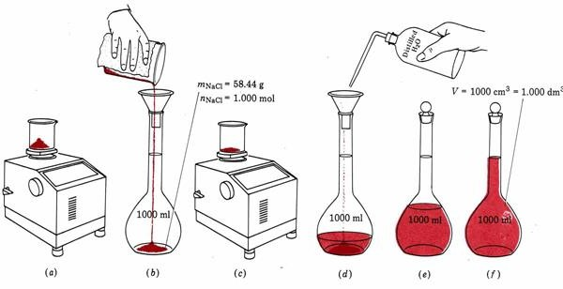
Results and calculations
mNacl = 3 g

- Tabulate your results

mNaCl/g | Vsolution/L

- Calculate the molarity of your solution.

Part two: Preparing a solution from another solution by dilution

Theoretical information
- Laboratory stock solutions are usually concentrated.
- Experiments often require a solution that is more dilute than the stock solution.

Equipment and Reagents
Balance Graduated burette A small beaker
100-mL volumetric flask
Wash bottle Burette
Distillated water
A 0.60 mol/L sodium chloride solution

Procedure
- Using a graduated burette transferred 35.0 mL of the 0.60 mol/L NaCl into a 100- mL volumetric flask.
- Add water up to etched line on the neck of the 100-mL volumetric flask.
- Mix thoroughly.

The figure below, which shows the preparing of a diluted solution from a concentrated solution.
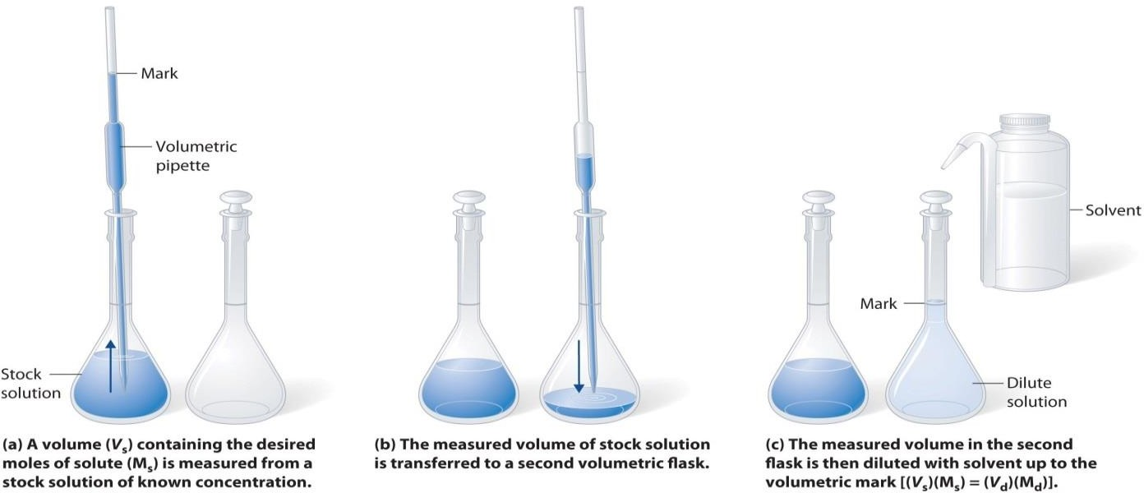
Results and calculations
- Tabulate your results as follows:

Molarity_{conc} mol L⁻¹ | Vconc ml | Molarity_{dil} mol L⁻¹ | V_{dil} ml

- Calculate the molarity of your diluted solution

Molarity_{conc} × V_{conc} = Molarity_{dil} × V_{dil}

EXPERIMENT 9:

PREPARING SOLUTIONS BY SERIAL DILUTION
Theoretical information
- Serial dilution is a series of dilutions are conducted with constant dilution factor.
- The source of dilution material for each step comes from the diluted material of the previous step.
- Dilution continues until the desired concentration is reached.
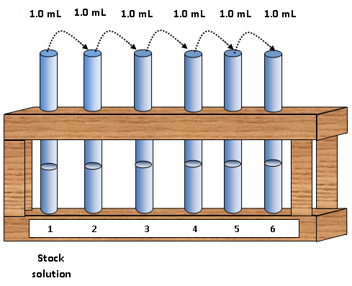
- Usually a stock solution is prepared with a known molarity, written as M_{o} .

- To calculate the concentration of the diluted solution in the successive dilution process (M_{dil}),

M_{dil} = $\frac{M_{conc}× V_{conc }}{V_{dil}}$

Equipment and Reagents

10.0-mL pipette
25 ml-Graduated cylinder.
Three test tubes in a rack.
A stock solution (0.1 mol/L sucrose solution colored with a few drops of methyl orange as a dye )

Procedure

- Place 3 clean and dry test tubes in a test tube rack and number them.
- Into a 25-mL graduated cylinder, using 10 mL-volumetric pipette transfer precisely 1.0 mL of sucrose solution 0.1 M .
- Add water until reach line of the 10 mL in the graduated cylinder.
- Pour this solution into the test tube number 1.
- Rinse the graduated cylinder with distillated water.
- Rinse the volumetric pipette with water, then with the solution in test tube number 1.
- From the solution in test tube number number 1, transfer 1.0 mL into the graduated cylinder.
- Add water until reach line of the 10 mLin the graduated cylinder.
- Transfer this solution to the test tube number 2.
- Repeat the steps from 5 to 8 to prepare the remaining solutions labeled as test tube number 3.

Results and calculations
- Using the dilution equation, calculate the molarity of the three solutions.
- Tabulate the results of your experiment and calculations:

$M_{0}$ / mol L⁻¹ | $V_{0}$ / mL
0.1 | 1

Test tube number | Initial volume  ($V_{conc}$) / mL | Initial molarity  ($M_{conc}$) / mol L⁻¹ | Final volume  ($V_{dil}$) / mL | Final molarity  ($M_{dil}$) / mol L⁻¹
0 | 1 | 0.1
1 | 1 |  | 10
2 | 1 |  | 10
3 | 1 |  | 10

EXPERIMENT (10):

DETERMINATION THE MOLAR MASS OF AN UNKNOWN SUBSTANCE BY FREEZING POINT DEPRESSION

Objectives
Using the Raoult’s relationship between freezing point depression and the molality of the solution to determine :
- The K_{f,solvent}
- The molar mass of an unknown compound .

Theoretical information
- The freezing point depression is one of four important colligative properties of ideal solutions (freezing point depression, boiling point elevation, vapor pressure lowering, and osmotic pressure increase).
- The depression in the freezing point, ΔT_{f}, is:
ΔTf = Tf,solvent − Tf,solution
- Where:
T_{f,solvent} = the freezing temperature of solvent (water). T_{f,soution} = the freezing temperature of solution

Note that ΔT_{f} is positive because the freezing temperature of the solution is lower than that of the pure solvent, and the word “depression” implies the negative sign.

- The molality is given by the following equation:

$$Molality=\frac{n_{solute(mole)}}{m_{solvent(kg)}}=\frac{m_{solute}(g)x1000}{M_{W (solute)}\left(\frac{g}{mol}\right)xm_{solvent}(g)}$$
- The magnitude of ΔT_{f} is proportional to the molality of the dissolved solute:

ΔT_{f} = K_{f} × molality

$$ΔT_{f}=K_{f}x\frac{m_{solute}x1000}{M_{W (solute)}\left(\frac{g}{mol}\right)xm_{solvent}(g)}$$

Where K_{f} is the proportionality constant, and is called the molal freezing point constant, which depends on the nature of solvent.

Materials and equipment

500 ml Beaker Balance

A wide test tube Ice

A suitable thermometer Deionized water

Glucose Unkown substance

Procedure
  - Add exactly 25 g (25 mL) of deionized water in the test tube. Record this mass as mSolvent.
  - Weigh a 5 g of Solute. Record your precise mass as m_{Solute}.Add this mass to the test tube. (Make sure that all of the solute is completely dissolved )
  - Put test tube in the ice bath and stir the solution with stirrer until you see the ice formation occur .
  - Determine freezing point of the solution. Record this temperature as Tf,solution .

Results and calculation
. Present the results of your experiment in the following tables:

 | mSolvent(g) | mSolute (g) | Tf,solvent  (°C) | Tf,solution  (°C) | ΔT_{f}= Tf,solvent − Tf,solution
Glucose
Unknown

A : Determination the K_{f,water} in Glucose solutions (M_{W (glucose)} = 180.16 g/mol)

${ K}_{f}=\frac{ΔT_{f}xM_{W (solute)} xm_{solvent}}{m_{solute}x1000}$

B : Determination of the molar mass of the Unknown substance(K_{f} = 1.86 ℃.molal⁻¹ )

$M_{W (solute)}=\frac{{K_{f} x m}_{solute}x1000}{{ΔT}_{f} x m_{solvent}}$

