Were the babies switched?

Two couples had babies on the same day in the same hospital. Ahmad and Sara had a girl, Hend. Khalid and Nadia had twins, a boy, Fahad, and a girl, Yara. Nadia was convinced that there had been a mix-up and she had the wrong baby girl, since Yara had light skin, while Fahad and Hend looked more like twins since they both had dark skin.

Nadia insisted on blood type tests for both families to check whether there had been a mix-up.

Results – Complete the following table:

 | Reacts with anti-A antibody | Reacts with anti-B antibody | Blood type  (A, B, AB, O) | Possible genotypes
Khalid
(Father of twins)
Nadia
(Mother of twins)
Ahmad
(Father of daughter)
Sara
(Mother of daughter)
Fahad
(Boy twin)
Yara
(Girl twin, according to hospital)
Hend
(Daughter of Ahmed and Sara, according to hospital)

Discussion

Now you can use the results of your blood tests to evaluate whether Khalid and Nadia's baby girlwas switched withAhmed and Sara's baby girl.

a.Draw Punnett squares that show the possible genotypes for Khalid and Nadia and their children. Write in the blood type for each genotype to show the possible blood types for Khalid and Nadia’s children.

1ST possibility 2ND possibility
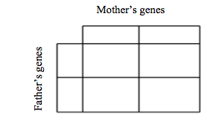

b. Draw Punnett squares that show the possible genotypes for Ahmed and Sara and their children. Write in the blood type for each genotype to show the possible blood types for Ahmed and Sara’s children.

1ST possibility 2ND possibility

c.Were the babies switched? Who are the parents of each baby girl?

