434202181 امل الشعلان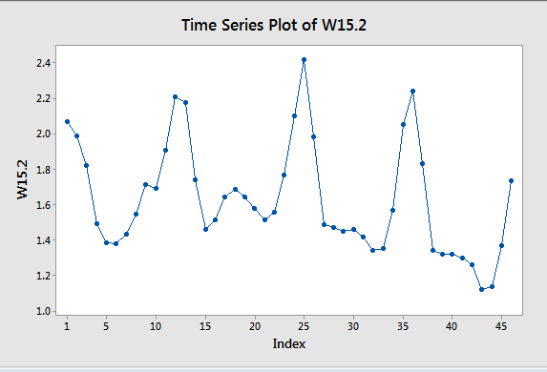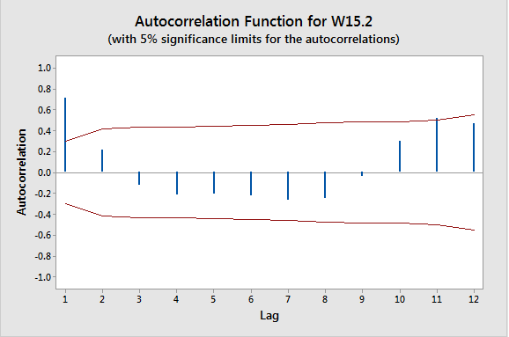
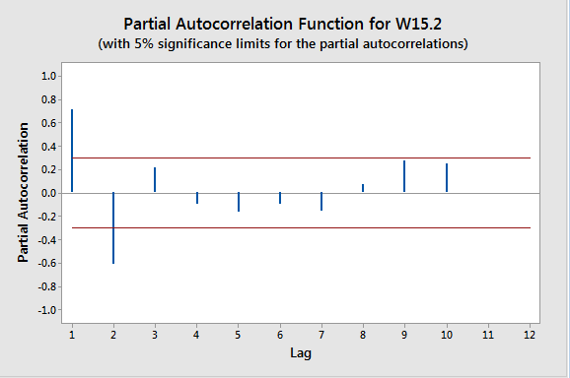
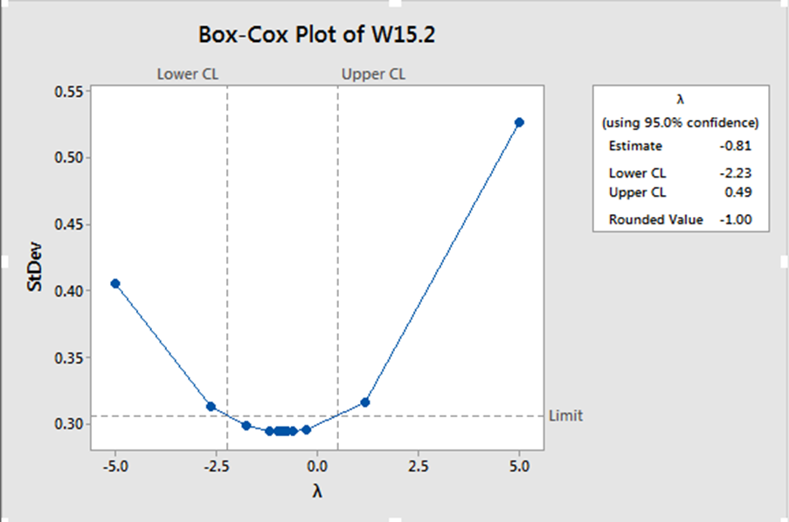

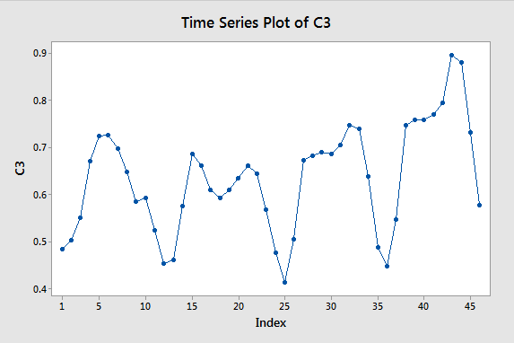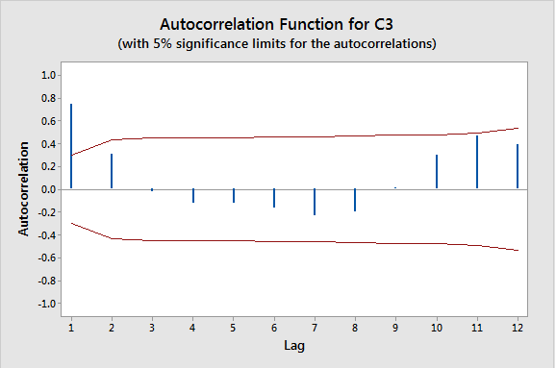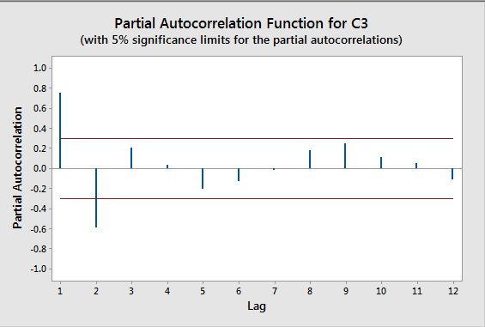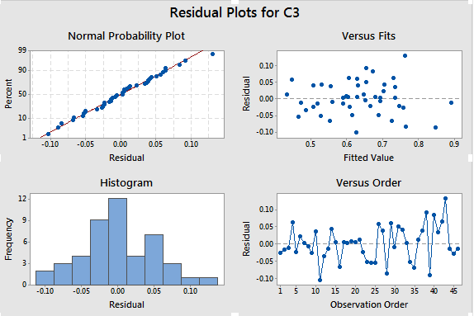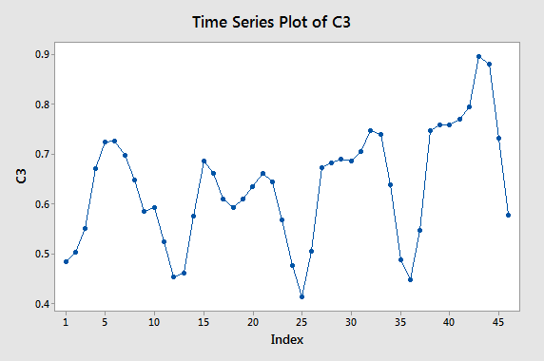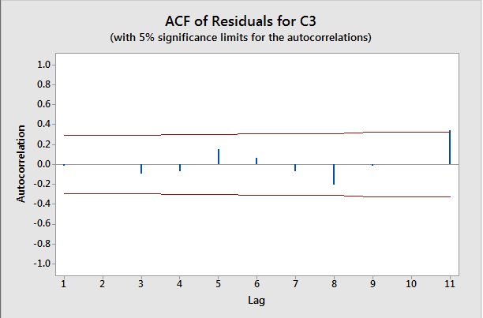

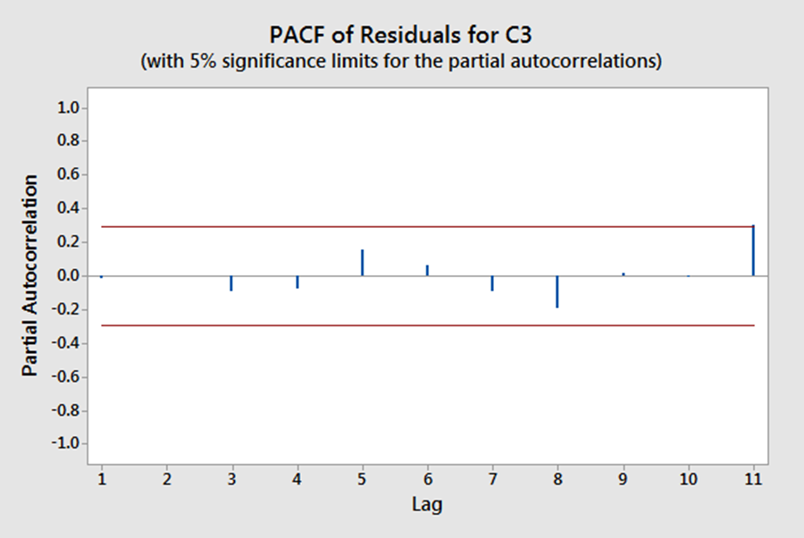
ARIMA (2,0,1)

ARIMA Model: C3

Estimates at each iteration

Iteration SSE Parameters
0 0.927850 0.100 0.100 0.100 0.588
1 0.721053 0.250 -0.005 0.085 0.548
2 0.620485 0.400 -0.075 0.144 0.486
3 0.591445 0.284 -0.065 -0.006 0.561
4 0.532618 0.208 -0.076 -0.156 0.621
5 0.349058 0.358 -0.200 -0.290 0.591
6 0.267551 0.508 -0.279 -0.303 0.535
7 0.202559 0.658 -0.359 -0.327 0.478
8 0.148695 0.757 -0.410 -0.477 0.435
9 0.128020 0.907 -0.472 -0.445 0.370
10 0.115910 1.047 -0.488 -0.457 0.280
11 0.115438 1.055 -0.506 -0.468 0.284
12 0.114952 1.102 -0.526 -0.441 0.267
13 0.114893 1.108 -0.534 -0.435 0.268
14 0.114873 1.105 -0.546 -0.434 0.277
15 0.114778 1.124 -0.551 -0.423 0.269
16 0.114724 1.141 -0.571 -0.410 0.270

Unable to reduce sum of squares any further

Final Estimates of Parameters

Type Coef SE Coef T P
AR 1 1.1413 0.1715 6.65 0.000
AR 2 -0.5707 0.1629 -3.50 0.001
MA 1 -0.4105 0.1840 -2.23 0.031
Constant 0.26974 0.01073 25.13 0.000
Mean 0.62818 0.02500

Number of observations: 46
Residuals: SS = 0.111593 (backforecasts excluded)
MS = 0.002657 DF = 42

Modified Box-Pierce (Ljung-Box) Chi-Square statistic

Lag 12 24 36 48
Chi-Square 13.7 28.1 40.5 *
DF 8 20 32 *
P-Value 0.091 0.107 0.143 *

Time Series Plot for C3

ACF of Residuals for C3

PACF of Residuals for C3
Residual Plots for C3

