205NET
2nd semester 1439 /1440
Assignment # 4

Q1) if a signal s(t) has the following specification
s(t) = 13 sin (2000πt + π) for binary 1
s(t) = 5 sin (2000πt + π) for binary 0

What kind of modulation is applied? Why?

Q2) Draw the modulated signal for the following digital signal if we apply a phase shift keying using the following carrier
s(t) = sin (6πt + π) for binary 1
s(t) = sin (6πt + π/2) for binary 0

Q3) For a signal that has a frequency shift keying using the two frequencies: 300, 700 Hz.
If the signal spectrum is shown below, draw the spectrum of the modulated signal
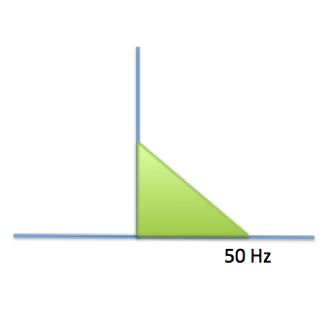

Q4) If an audio signal has a bandwidth equal to 30 KHz, what will be the bandwidth of the AM modulated signal?

