205NET
Assignment # 7
2nd semester 1439 /1440

Q1) What is the required bandwidth to multiplex 10 voice channels (for 3 channels each occupies a bandwidth of 3K and the rest each occupies 4 kHz) with guard bands of 500 Hz using FDM.

Q2) Assume we have two channels: one occupies a bandwidth of 40 Hz and the other occupies a bandwidth of 20 Hz. We need to combine these two channels into a link with a bandwidth of 70 Hz, from 20 to 90Hz. Show the configuration of each channel, assuming there are guard bands each with 5 Hz bandwidth.

Q3) What is the output stream for the following synchronous TDM multiplexer.
Each frame is only 10 bits long (3 bits taken from each input plus 1 ynchronization bit). The bits arrive at the multiplexer as shown by the arrows
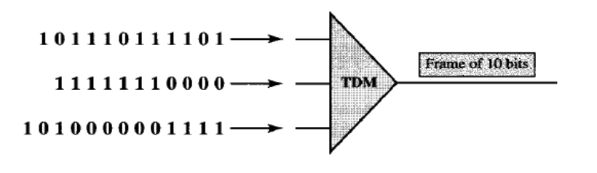
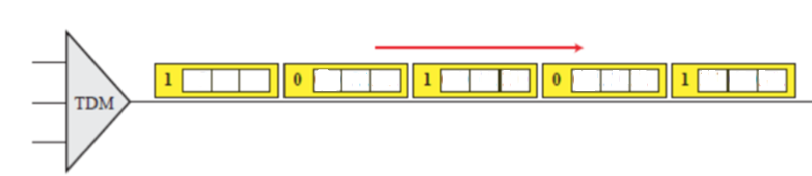

Q4) If we use synchronous TDM and combine 20 digital sources, each of 100 Kbps. Each output slot carries 1 bit from each digital source, but one extra bit is added to each frame for synchronization. What is the size of an output frame in bits?

