GC311 – Database Concepts
Assignment #2

Q1: what is cardinality and degree of the following Relation?

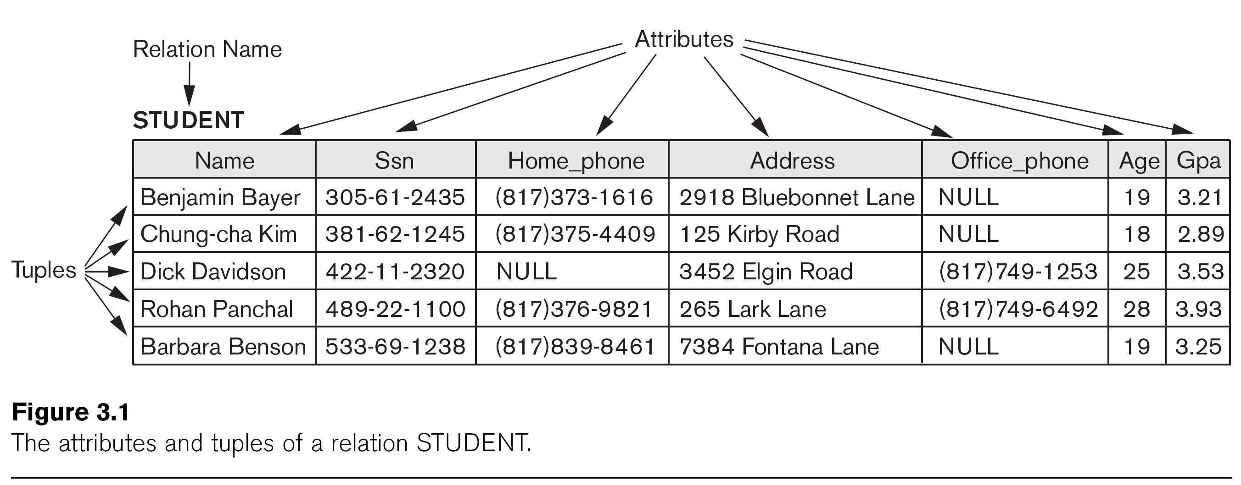
Q2: Map the following ERD to relational schema.

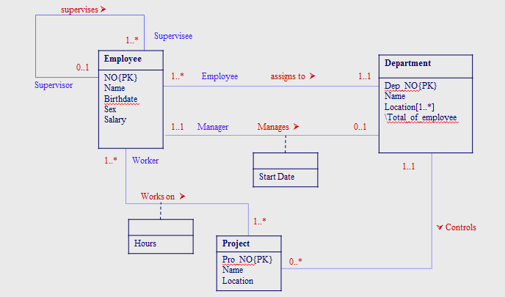
Q3: Derive relation schema for the following conceptual data model:

