[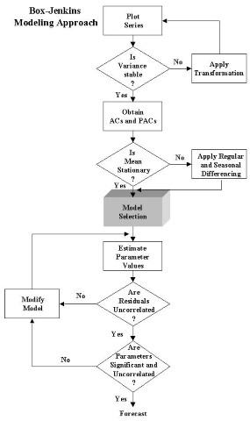](http://faculty.ksu.edu.sa/Adnan_Barry/Pictures%20Library/Box%20Jenkins%20ARIMA%20Approach.jpg)