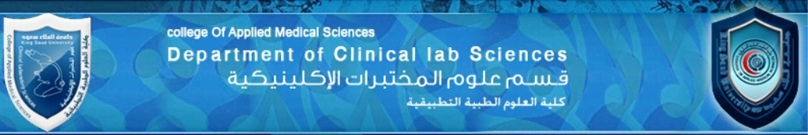
Practical course specifications
Program title : Clinical Laboratory Science
Course title : Descriptive Histology
Course code number: CLS-222
Credit hours : 1+2
Contact hours : 3 hours
Level : 6

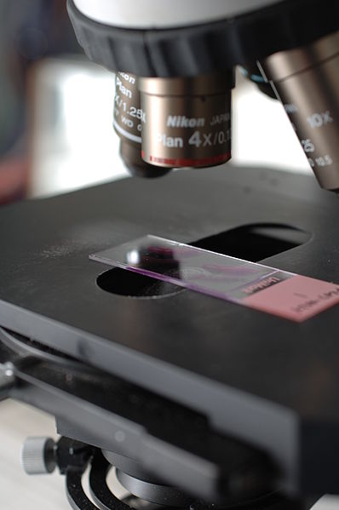

Department of Clinical Laboratory Science
College of Applied Medical Sciences
King Saud University
Course: 222-DESCRIPTIVE HISTOLOGY
Course Description:
The overall objective of this course is to prepare the students for the advanced course in CLS and enable the students to identify microscopically the normal tissue and organs of the human body.
SYLLABUS:
WEEK /LABSUBJECT
PRACTICAL 1 INTRODUCTION:
- USE OF MICROSCOPE
- SELECTION OF MICROSCOPIC SLIDE
PRACTICAL 2 EPITHELIAL TISSUE
PRACTICAL 3 CONNECTIVE TISSUE
PRACTICAL 4 CARTILAGE
PRACTICAL 5 BONE
PRACTICAL 6 MUSCULAR TISSUE
PRACTICAL 7 NERVOUS SYSTEM ---------(QUIZ)
PRACTICAL 8 BLOOD VASCULAR SYSTEM
PRACTICAL 9 LYMPHATIC SYSTEM
PRACTICAL 10 RESPIRATORY SYSTEM
PRACTICAL 11 1stHALF OF DIGESTIVE SYSTEM
PRACTICAL 12 2ndHALF OF DIGESTIVE SYSTEM
PRACTICAL 13 URINARY SYSTEM & REVISION
PRACTICAL 14 FINAL PRACTICAL EXAMINATION

FINAL MARKS:
SKETCHBOOK------------------------ 5 MARKS
QUIZ ----------------------------------- 5 MARKS
FINAL PRACTICAL EXAM ---------- 10 MARKS
TOTAL --------------------------------- 20%

