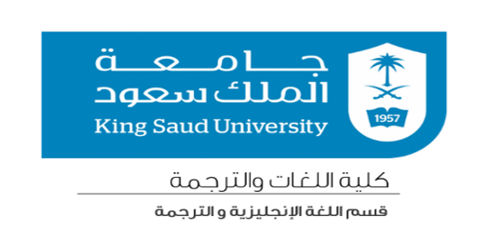
Course Syllabus
Consecutive and Bilateral Interpreting 1 Syllabus – Second Semester
Of the Academic Year 1442H.
Course information
Course Code |  |  | 328 TRAJ | Credit Hours | 2
Course Instructor |  |  | Dr. Reem Alsalem
Course Coordinator |  |  | Dr. Sara Alshubaili
Course Details
Prerequisite |  |  | 318 TRAJ
Course Goals |  |  | The main goal of the course is to train students to Interpret consecutively and bilaterally between English and Arabic by helping them acquire the skills and knowledge of strategies necessary for consecutive and bilateral interpreting.
Assessment |  |  | 1 mid-term + 1 quiz + 5 assignments + participation
Textbook |  |  | NA
Instruction Methods |  |  | Training online
Useful Resources |  |  | Ted talks – Youtube – News channels –  Interpreter Training Resources http://interpreters.free.fr/consec.htm  Acebo https://acebo.myshopify.com/
Contact information
Office location |  | 4F20
Email |  | ralsalem@ksu.edu.sa
Office Hours |  | Monday/Tuesday (8-10)  Take appointment via email ralsalem@ksu.edu.sa
How to succeed in this course |  | - Development of skills to pass exams  - Submission of homework  - Participation during session time
Class Policies |  | - Food and drinks are not allowed in the lab  - Students should arrive in time
Tentative weekly schedule
Week | Lesson
1 | General guidelines and tips
2 | Students practice interpreting selected speeches, talks or interviews
3
4
5
6
7
8
9
10
11
12
13
14
15

