Definition of fish: a limbless cold-blooded vertebrate animal with gills and fins living wholly in water

Illustration of Fish
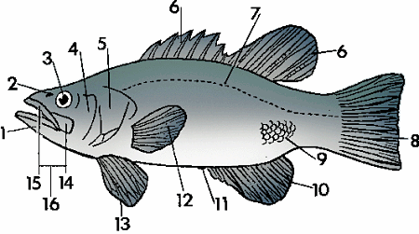
Noun
fish 1b mandible, 2 nasal opening, 3 eye, 4 cheek, 5 operculum, 6 dorsal fins, 7lateral line, 8 caudal fin, 9 scales, 10 anal fin, 11 anus, 12 pectoral fin, 13 pelvic fin, 14maxilla, 15 premaxilla, 16 upper jaw

Cycloid scales Cycloid (circular) scales have a smooth texture and are uniform, with a smooth outer edge or margin. They are most common on fish with soft fin rays, such as salmon and carp.
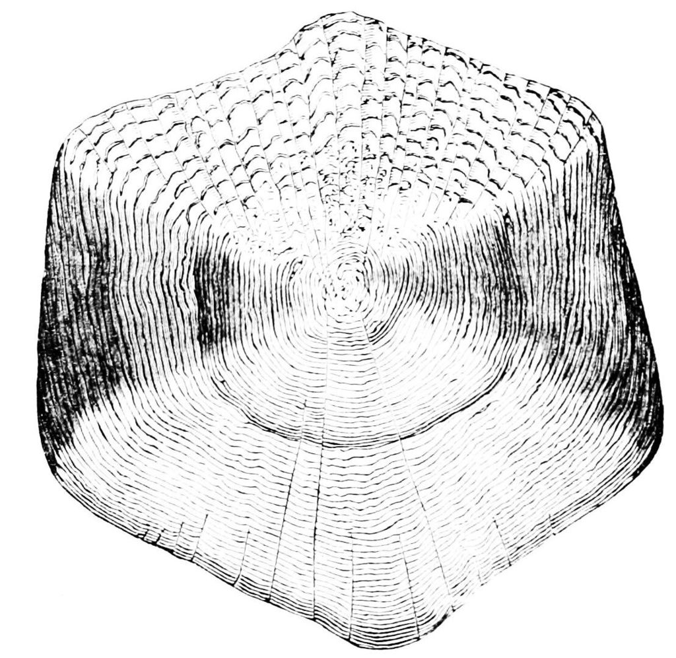
The cycloid scale of a carp has a smooth outer edge
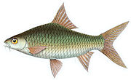
This Poropuntius huguenini is a carp-like fish with circular cycloid scales that are smooth to the touch

Ctenoid scales[edit]
Ctenoid (toothed) scales
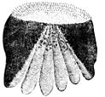
The ctenoid scale of a perch has a toothed outer edge (at top of image)
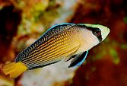
This dottyback is a perch-likefish with toothed ctenoid scales that are rough to the touch
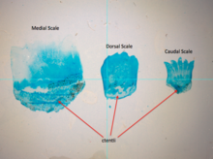
Three ctenoid scales from various locations of a perch were stained. Significant variation can be observed between the medial (middle of the fish), dorsal (top), and caudal (tail end) scales. The ctentii of each of the scales is labeled.
Ctenoid (toothed) scales are like cycloid scales, with small teeth along their outer edges. They are usually found on fishes with spiny fin rays, such as the perch-like fishes. The scales have a rough texture with a toothed outer or posterior edge featuring tiny teeth called ctenii. These scales contain almost no bone, being composed of a surface layer containing hydroxyapatite and calcium carbonate and a deeper layer composed mostly of collagen. The enamel of the other scale types is reduced to superficial ridges and ctenii.
Ctenoid scales, similar to other epidermal structures, originate from placodes and distinctive cellular differentiation makes them exclusive from other structures that arise from the integument.^{[7]} Development starts near the caudal fin, along the lateral line of the fish.^{[8]} The development process begins with an accumulation of fibroblasts between the epidermis and dermis.^{[7]} Collagen fibrils begin to organize themselves in the dermal layer, which leads to the initiation of mineralization.^{[7]} The circumference of the scales grows first, followed by thickness when overlapping layers mineralize together.^{[7]}
Ctenoid scales can be further subdivided into three types:
- Crenate scales, where the margin of the scale bears indentations and projections.
- Spinoid scales, where the scale bears spines that are continuous with the scale itself.
- True ctenoid scales, where the spines on the scale are distinct structures.
Both cycloid and ctenoid scales are overlapping, making them more flexible than cosmoid and ganoid scales. Unlike ganoid scales, they grow in size through additions to the margin. The scales of some species exhibit bands of uneven seasonal growth called annuli (singular annulus). These bands can be used to age the fish. Most ray-finned fishes have ctenoid scales. Some species of flatfishes have ctenoid scales on the eyed side and cycloid scales on the blind side, while other species have ctenoid scales in males and cycloid scales in females.

Ganoid scales[edit]
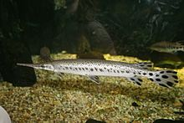
The longnose gar has diamond-shape ganoid scales
Ganoid scales are found in the sturgeons, paddlefishes, gars, bowfin, and bichirs. They are derived from cosmoid scales, with a layer of dentine in the place of cosmine, and a layer of inorganic bone salt called ganoine in place of vitrodentine. Most are diamond-shaped and connected by peg-and-socket joints. They are usually thick and have a minimal amount of overlap as compared to other scales.^{[9]} In sturgeons, the scales are greatly enlarged into armour plates along the sides and back, while in the bowfin the scales are greatly reduced in thickness to resemble cycloid scales (see above).
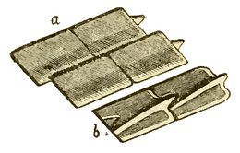 | Ganoid scales of the Carboniferous fish, Amblypterus striatus. (a) shows the outer surface of four of the scales, and (b) shows the inner surface of two of the scales. Each of the rhomboidal ganoid scales of Amblypterus has a ridge on the inner surface which is produced at one end into a projecting peg which fits into a notch in the next scale, similar to the manner in which tiles are pegged together on the roof of a house.

Cosmoid scales[edit]
Cosmoid scales are found in several ancient lobe-finned fishes, including some of the earliest lungfishes, and were probably derived from a fusion of placoid scales. They are composed of a layer of dense, lamellar bone called isopedine, above which is a layer of spongy bone supplied with blood vessels. The bone layers are covered by a complex dentine layer called cosmine and a superficial outer coating of vitrodentine. Cosmoid scales increase in size through the growth of the lamellar bone layer.
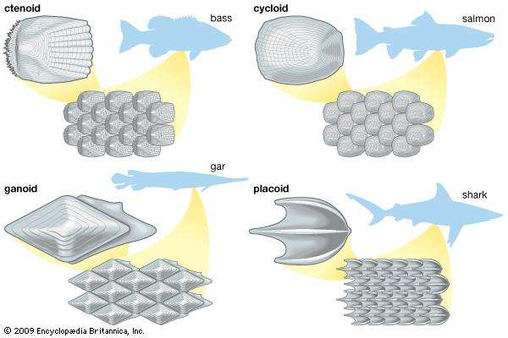

Placoid scales are found in the cartilaginous fishes: sharks, rays, and chimaeras. They are also called dermal denticles. Placoid scales are structurally homologous with vertebrate teeth ("denticle" translates to "small tooth"), having a central pulp cavitysupplied with blood vessels, surrounded by a conical layer of dentine, all of which sits on top of a rectangular basal plate that rests on the dermis. The outermost layer is composed of vitrodentine, a largely inorganic enamel-like substance. Placoid scales cannot grow in size, but rather more scales are added as the fish increases in size.
Similar scales can also be found under the head of the denticle herring. The amount of scale coverage is much less in rays and chimaeras.

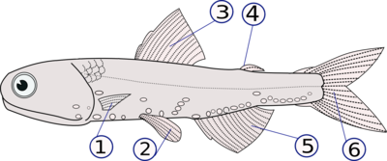
Ray fins on a teleost fish, Hector's lanternfish
(1) pectoral fins (paired), (2) pelvic fins (paired), (3) dorsal fin,
(4) adipose fin, (5) anal fin, (6) caudal (tail) fin
Fins are usually the most distinctive anatomical features of a fish. They are composed of bony spines or rays protruding from the body with skin covering them and joining them together, either in a webbed fashion, as seen in most bony fish, or similar to a flipper, as seen in sharks. Apart from the tail or caudal fin, fish fins have no direct connection with the spine and are supported only by muscles. Their principal function is to help the fish swim. Fins located in different places on the fish serve different purposes such as moving forward, turning, keeping an upright position or stopping. Most fish use fins when swimming, flying fish use pectoral fins for gliding, and frogfish use them for crawling. Fins can also be used for other purposes; male sharks and mosquitofish use a modified fin to deliver sperm, thresher sharks use their caudal fin to stun prey, reef stonefish have spines in their dorsal fins that inject venom, anglerfish use the first spine of their dorsal fin like a fishing rod to lure prey, and triggerfish avoid predators by squeezing into coral crevices and using spines in their fins to lock themselves in place.

The caudal fin is the tail fin (from the Latin cauda meaning tail), located at the end of the caudal peduncle and is used for propulsion. See body-caudal fin locomotion.
(A) - Heterocercal means the vertebrae extend into the upper lobe of the tail, making it longer (as in sharks). It is an opposite of hypocercal.
- Hypocercal means that the vertebrae extend into the lower lobe of the tail, making it longer (as in the Anaspida). It is an opposite of heterocercal.
(B) - Protocercal means the vertebrae extend to the tip of the tail and the tail is symmetrical but not expanded (as in amphioxus)
(C) - Homocercal where the fin appears superficially symmetric but in fact the vertebrae extend for a very short distance into the upper lobe of the fin
(D) - Diphycercal means the vertebrae extend to the tip of the tail and the tail is symmetrical and expanded (as in the bichir, lungfish, lamprey and coelacanth). Most Palaeozoic fishes had a diphycercal heterocercal tail.^{[9]}
Most modern fishes have a homocercal tail. These appear in a variety of shapes, and can appear:
- rounded
- truncated, ending in a more-or-less vertical edge (such as salmon)
- forked, ending in two prongs
- emarginate, ending with a slight inward curve.
- lunate or shaped like a crescent moon
