**Important bacterial genera in foods**

**Morphological characteristics :**

Cell shape

Cell size

Cells arrangement

Gram stain +ve or –ve

Flagella ,Capsule or Spores formation.

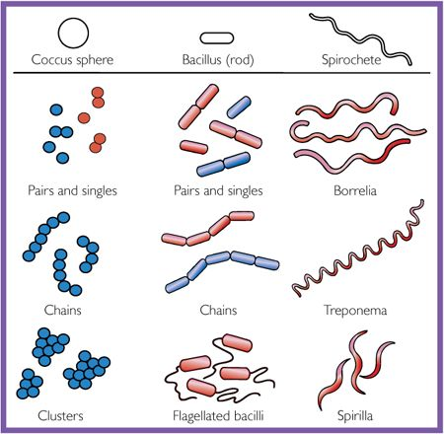

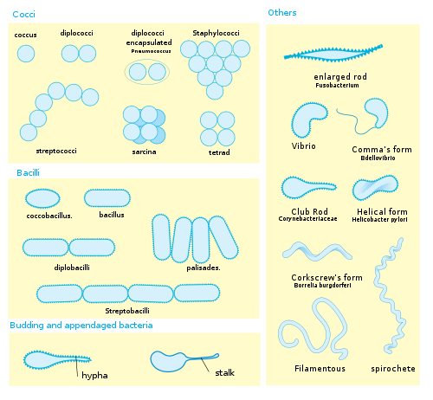

Cultural characteristics

|  |  |  |
| --- | --- | --- |
| **No.** | **Colony characteristics** | **Observations** |
| **1** | **Size** | **Very small, Small, Medium, large, very large** |
| **2** | **Form** | **Punctiform, circular, filamentous, irregular,**  **rhizoid, spindle** |
| **3** | **Elevation** | **Flat, raised, convex, pulvinate, umbonate** |
| **4** | **Margin** | **Entire, undulate, lobate, erose, filamentous, curled** |
| **5** | **Color** | **White, grey, yellow, black, orange, pink, red, etc** |
| **\*6** | **Haemolysis** | **haemolysis α , β or Ɣ** |
| **7** | **Pigment production** | **Color of the pigment production** |
| **\*\*8** | **Odor** | **Fruity, freshly cut apple, fishy, fecal or putrid, bleach, pungent** |
| **9** | **Opacity** | **Transparent, Opaque, Translucent** |
| **10** | **Surface** | **Smooth, Glistening, Rough, dull** |
| **11** | **Consistency** | **Buttery, viscid, Brittle, mucoid** |









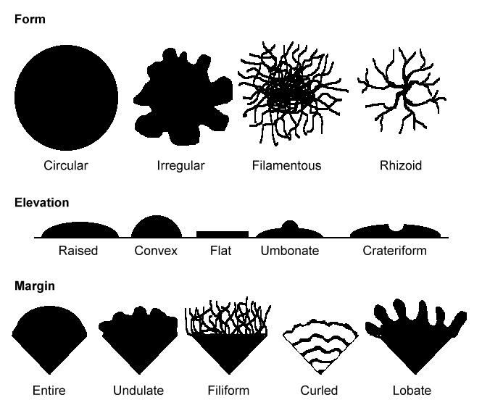

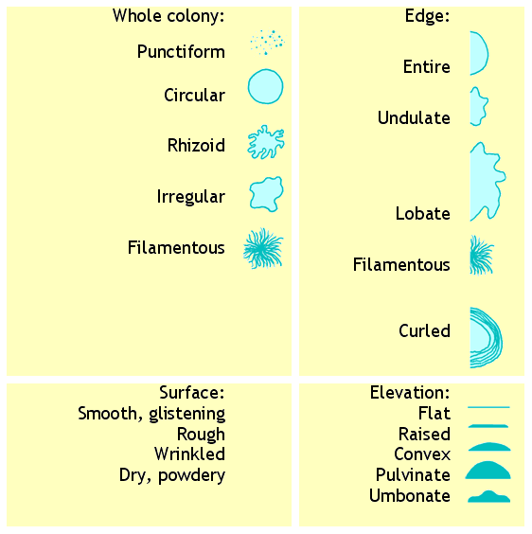

**Staining :**

* **الصبغة البسيطة Simple stain**
* **الصبغة المركبة Compound stain**
* **• OBJECTIVES**
* **Perform bacterial Gram staining.**
* **• Visualize bacteria under microscope.**
* **• Differentiate Gram‐positive and Gram‐negative bacteria**
* *Preparation of the smear :*
* 



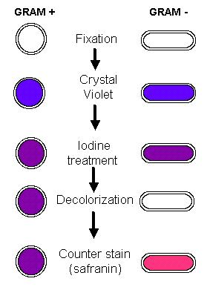

1. Prepare and heat-fix a smear of the organism to be studied. Cover the slide with **crystal violet**.

Allow one minute for this **primary stain** and then wash off (thoroughly and quickly, but gently)

with a **minimum** amount of tap water, as an excess application of water tends to decolorize.

Drain off most of the water onto a paper towel.

2. Cover the slide with **iodine** solution for one minute. The iodine acts as a **mordant** (fixer) and will form a complex with the crystal violet, fixing it into the cell. Rinse briefly with tap water, and then drain off most of the water.

3. Tilt the slide lengthwise over the sink and apply the **alcohol-acetone** solution dropwise – such that the solution washes **evenly over the entire slide** from one end to the other. Continue in this manner for about 10-15 seconds and then rinse **immediately** with tap water. If applied properly, the alcohol-acetone should **decolorize** cells with a gram-negative type of cell wall but not those with a gram-positive type of cell wall. Drain off most of the water.

4. Any decolorized, gram-negative cells need to be stained in order to be visible and differentiated from gram-positive cells. Cover the slide with **safranin** for one minute and then rinse briefly. Safranin serves as the **counterstain** in this procedure; a “counterstain” stains the decolorized cells differently than those which had retained the primary stain throughout the procedure. **Gently** (without rubbing) blot the slide dry.

5. For each smear, focus with the 10X objective, and then switch immediately to the 100X (oil- immersion) objective for the “official” observations, making sure you added a generous drop of immersion oil to the smear before moving the 100X lens into position. **Going from 10X to**

**100X (skipping the intermediate objective lens) is our standard operating procedure**. Observe the cells for morphology and gram reaction. Regarding the latter, record each culture as “gram-positive” (purple cells) or “gram-negative” (pink cells).



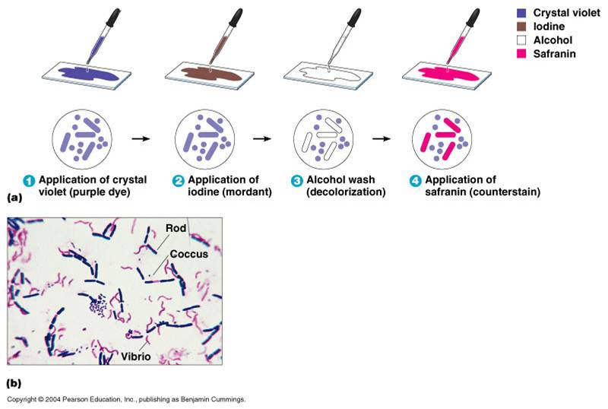

|  |  |  |  |
| --- | --- | --- | --- |
| **No.** | **Colony characteristics** | **Observation** | |
| **Colony 1** | **Colony 2** |
| **1** | **Size** |  |  |
| **2** | **Form** |  |  |
| **3** | **Elevation** |  |  |
| **4** | **Margin** |  |  |
| **5** | **Color** |  |  |
| **6** | **Haemolysis** |  |  |
| **7** | **Pigment production** |  |  |
| **8** | **Odor** |  |  |

Biochemical characteristics

characteristics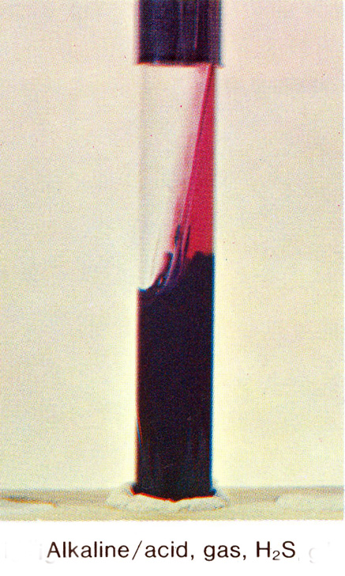o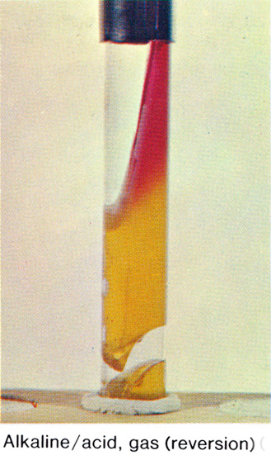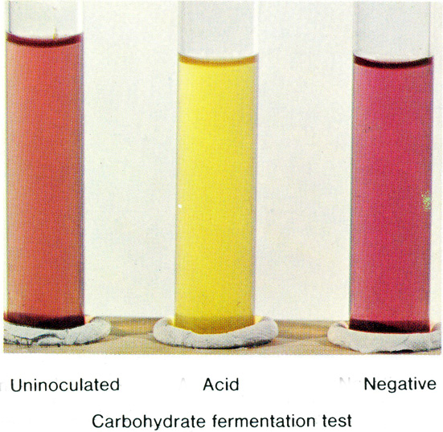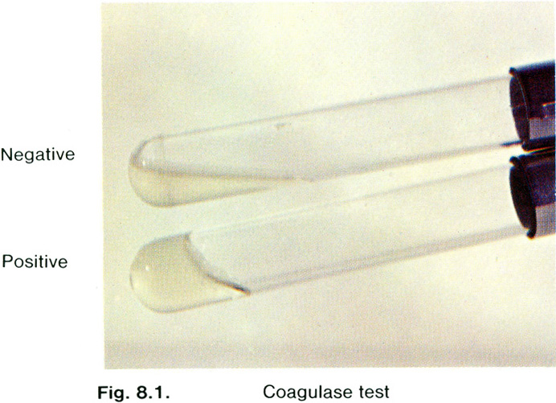chemical c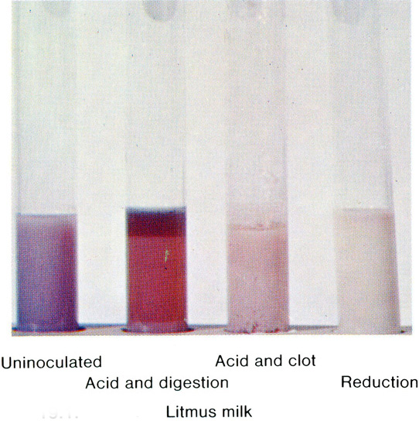

Biochemical characteristics