Evaluation report 3
Name

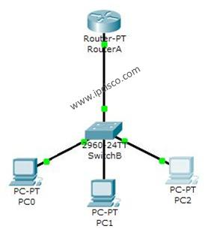

Do as shown connection.
Then open your router using Putty:
- Name the router “CEN447”
- Copy the configurations to your PC.
- Chang the name in to “KSU”
- Restore the new configurations to the router.

