**CHAPTER 4**

**LINEAR PROGRAMMING;SIMPLEX METHOD**

**(USING EXCEL)**

**SOLVER**

**Excel** includes a tool called **solver** that uses techniques from the operations research to find optimal solutions for all kind of decision problems.

**Load the Solver Add-in**

To load the solver add-in, execute the following steps.

1. On the green File tab, click Options.

2. Under Add-ins, select Solver Add-in and click on the Go button.

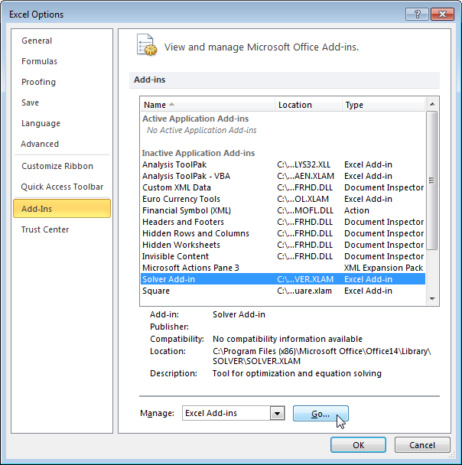

3. Check Solver Add-in and click OK.

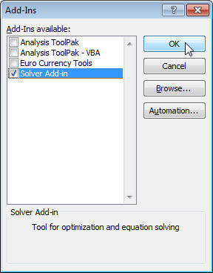

4. You can find the Solver on the Data tab.

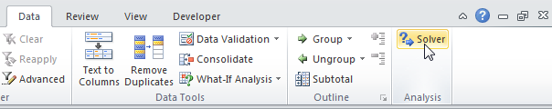

**Solving a Maximum Problem Using Excel**

Mikes’s Famous Toy Trucks specializing in making four kinds of toy trucks; a delivery truck , a dump truck , a garbage truck and a gasoline truck. Three machines –a metal casting machine, a paint spray machine, and a packaging machine are used in the production of these trucks .The maximum time available per week for each machine is given as : metal casting ,4000 hours , paint spray , 1800 hours and packaging ,1000 hours. The time, in hours ,each machine works to make each type of truck and the profit for each truck are given .

How much of each type of trucks be produced to maximize the profit ?

**SOLUTION:**

Maximize 

Subject to the constraints



**Step 1**

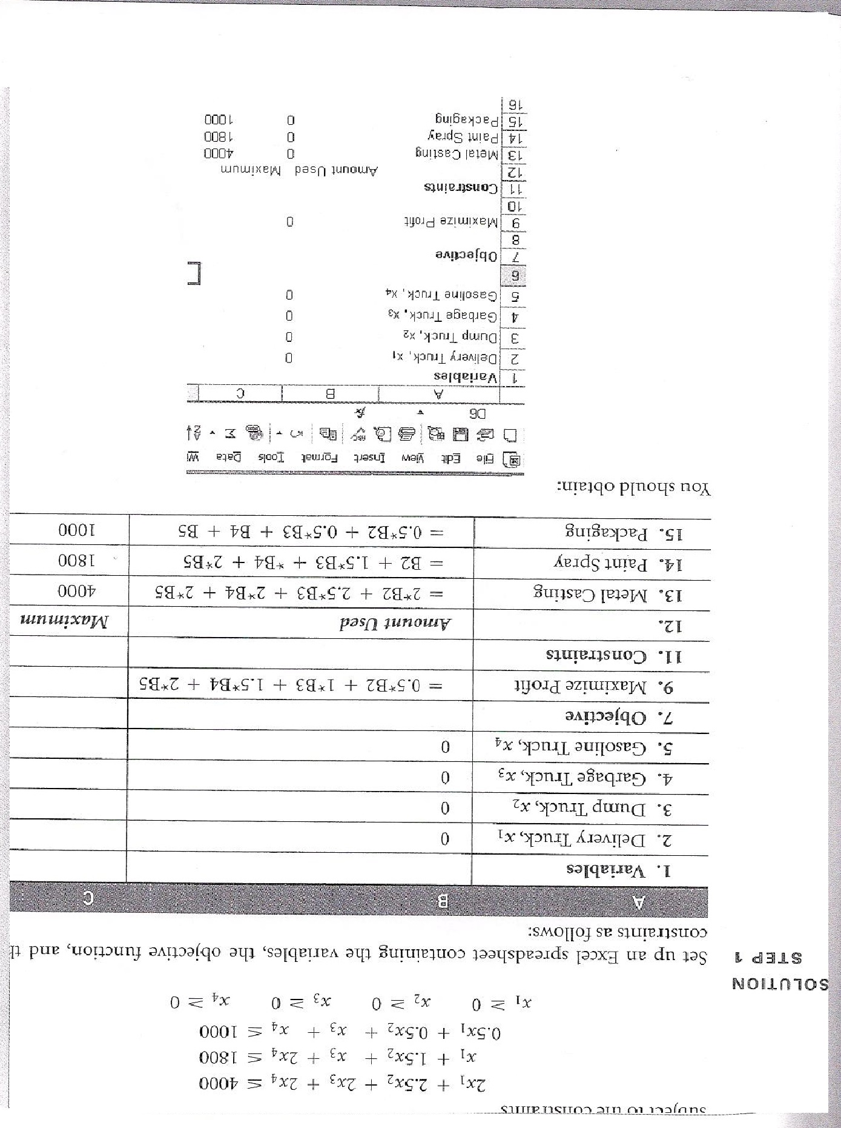

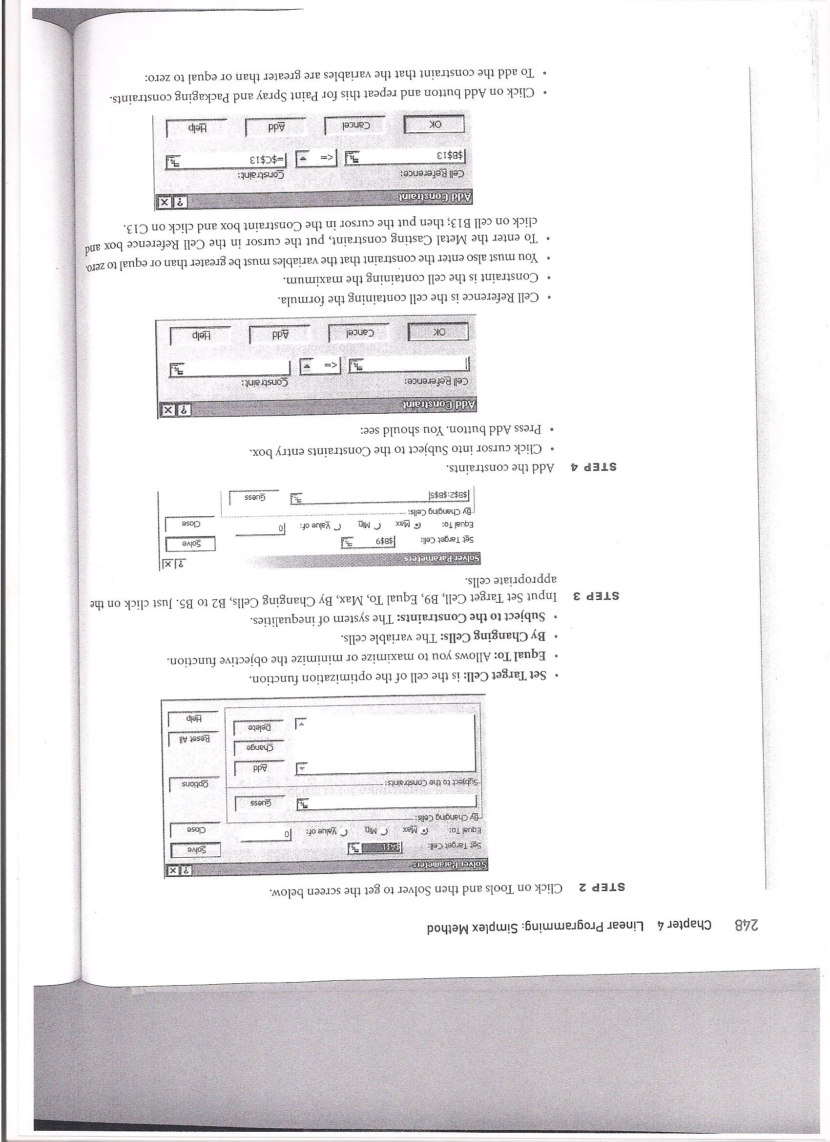

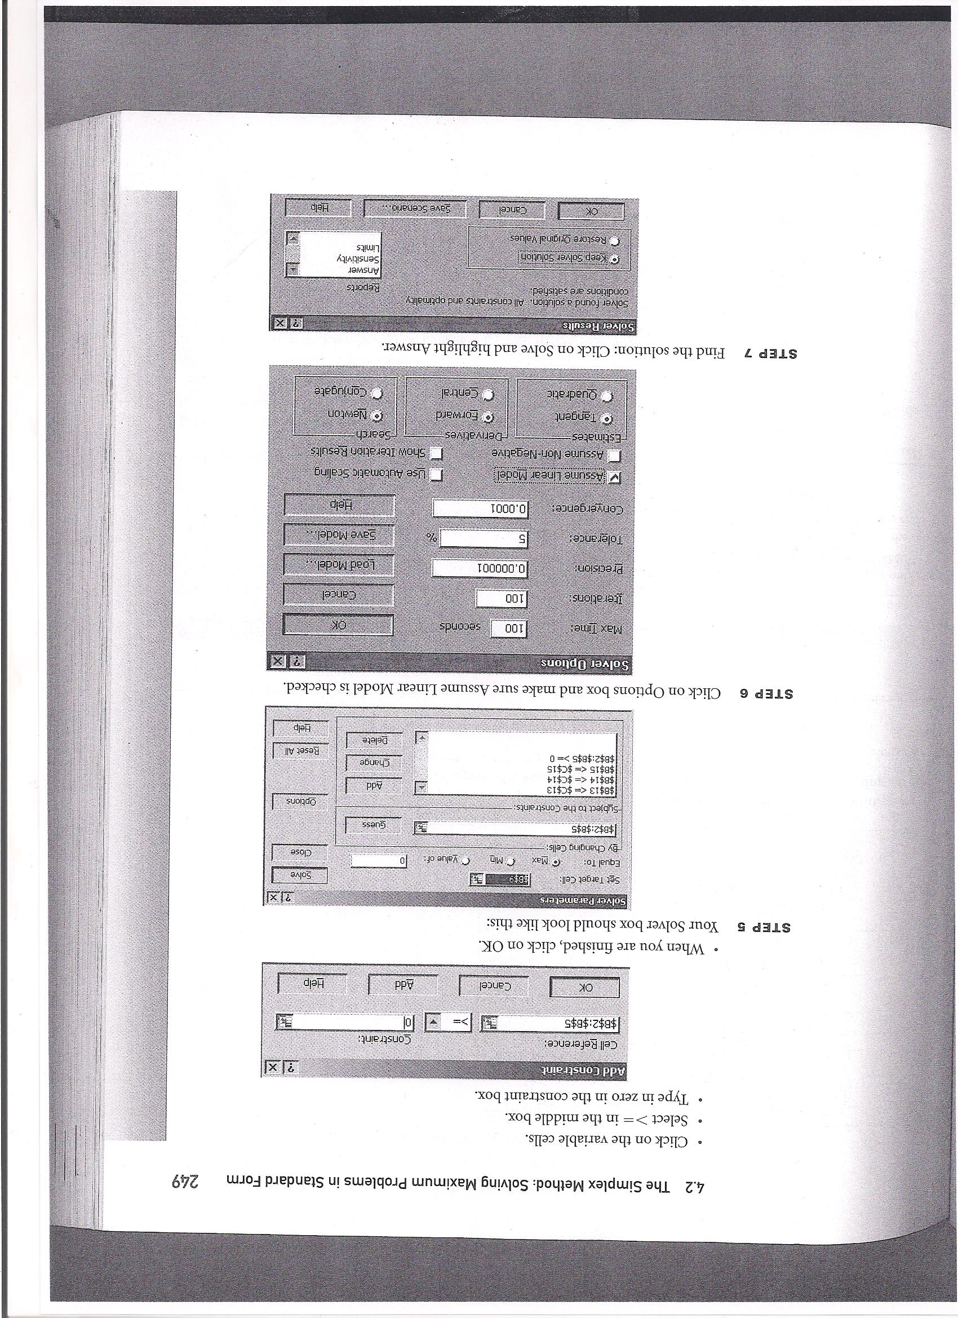

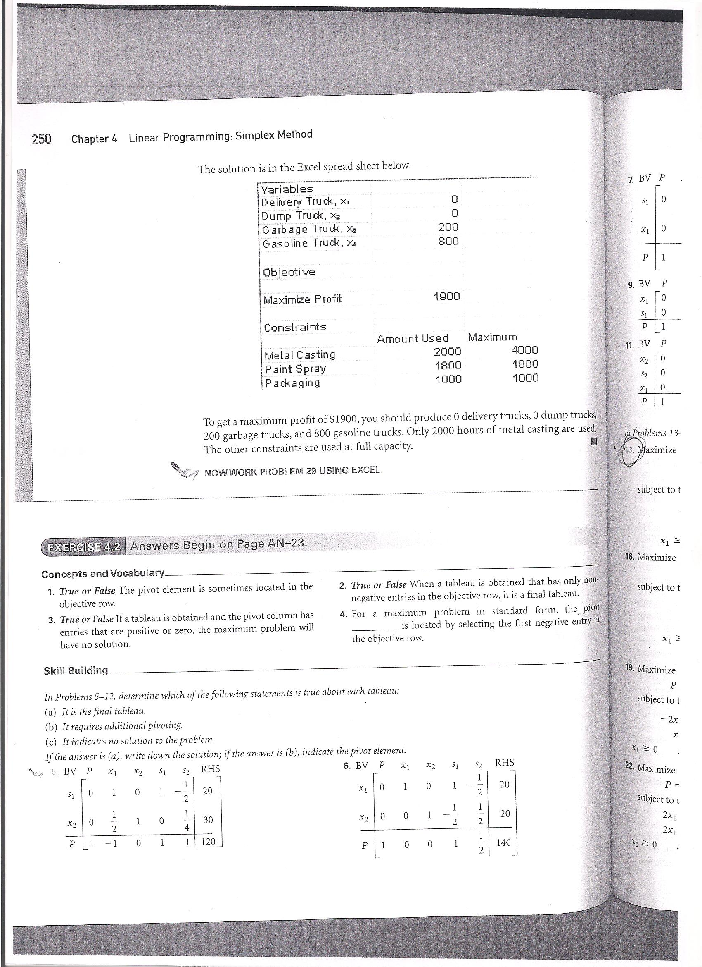

**Solving a Minimum Problem Using Excel**

**EXAMPLE 5**

Minimize 

Subject to the constraints



