NAME: NUMBER:
Question I: Choose the correct answer for the following:

- -------- is defined as the grain size of materials between 1/16 mm to 1/256 mm.
  - Gravel
  - Sand
  - Silt
  - Clay

- Consolidated gravel is known as
  - Conglomerate
  - Limestone
  - Sandstone
  - Mudstone

- Which is the most common mineral found in sandstone
  - Calcite
  - Quartz
  - Olivine
  - Mica

- Sandstone rich in mica is known as
  - Micaceous sandstone
  - Calcareous sandstone
  - Conglomeratic sand stone
  - Muddy sandstone

- Sandstone with less than 20% matrix is known as
  - Wacke
  - Arenite
  - Mudstone
  - All of the above

- The fragments that make up sedimentary rocks are known as
  - Gravel
  - Matrix
  - Sand
  - Clasts
- Long transportation results in the formation of
  - Poorly sorted sediments
  - Moderately sorted sediments
  - Very well sorted sediments
  - All of the above

- Dunham classification is uses for classifying
  - Sediment size
  - Limestone
  - Sandstone
  - Sedimentary structures

Question II: State whether True (T) or False (F):
- Sandstone having a matrix between 20-50% and rich in Quartz is known as Arkosic Wacke
- The type of limestone which does not contain mud and is clast supported is known as wackestone.
- Stratigraphy is the study of rocks to determine the order and timing of events in Earth history.
- Transgressive sequence represents a deeper water facies overlying shallow water facies.

Question III:
Sediments are commonly subdivided into three major groups. They are
1-
2-
3-

Question IV:

Draw in thick lines on Pitchers 1,2, identifying the locations of unconformities.
and what is the type of unconformities and why?

A
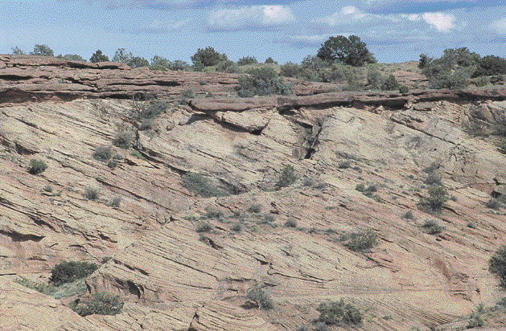

B