The Brain Stem
- The brain stem is a tube-shaped mass of nervous tissue a little over 3 inches long. It is located at the base of the brain, superior to the spinal cord and inferior to the cerebrum.
- As the brain stem ascends from the spinal cord, it widens and becomes more complex in its structures, both internally and externally.
- Three major regions make up the brain stem: medulla oblongata, pons, and midbrain.
- The medulla is the inferior-most region of the brain stem that connects the brain to the spinal cord. It is a tube very similar structurally to the spinal cord, but is wider and contains several masses of gray matter internally.
- Superior to the medulla is the pons, which is larger and structurally more complex than the medulla.
- Finally, the midbrain forms the most superior and most complex region of the brain stem.

- Broca’s Area
- An area in the frontal lobe of the left hemisphere of the brain.
- With functions linked to speech production.
- Wernicke’s Area
- An area in the posterior temporal lobe of the left hemisphere of the brain.
- It is associated with the ability to recognize and understand spoken language.

- Speaking the Heard Word
- To speak a word that is heard, information must first get to the primary auditory cortex.
- From the primary auditory cortex, information is transmitted to the Wernicke's area.
- From Wernicke's area, information travels to Broca's area.
- From the Broca’s area the information travels to the Primary Motor Cortex.

- Anatomy of Speech
- The organs of speech fall into three groupings:
- Respiratory system: Lungs generating air stream
- Phonatory system: larynx and vocal folds
- Articulatory system: vocal tract
- Framework for Respiration and Lungs
- How does airflow relate to communication?
- Air generates waves upon which sound travels.
- Air flows from lungs through larynx, between the vocal folds, through resonating cavities and out of mouth and nose.
- Airflow is essential to speech.
- Breathing
- Usually 2 to 3 sec breathing in/out
- When speaking we breath in fast and breath out slowly
- take deep breath and count slowly
- Respiratory Passage
- Respiration is exchange of gasses:
- oxygen passes into the blood vessels within the lungs,
- carbon dioxide leaves the blood vessels to be expelled from the lungs.
- Respiratory Passage
- Breathing refers to the mechanical process of moving air into and out of the lungs.
- It is also the mechanical process for generating sound into the upper aspect of the respiratory tract.
- Passage includes: nasal and oral cavities, pharynx, larynx, trachea, bronchi, lungs.

- Nasal Cavities
- The nose and nasal cavity constitute the main external opening of the respiratory system. They represent the entryway to the respiratory tract – a passage through the body which air uses for travel in order to reach the lungs.
- The cavity is lined with mucus membranes and little hairs that can filter the air before it goes into the respiratory tract. They can trap all harmful particles such as dust, mold and pollen and prevent them from reaching any of the internal components.
- At the same time, the cold outside air is warmed up and moisturized before going through the respiratory tract.
- Nasal Function
1. Filtering all that air and retaining particles as small as a pollen grain with 100% efficiency.
2. Humidifying the air that you breathe, adding moisture to the air to prevent dryness of the lining of the lungs and bronchial tubes.
3. Warming cold air to body temperature before it arrives in your lungs.
- Nasal Cavities
- Made up of 2 symmetrical chambers separated by the nasal septum.
- Nasal septum-medially placed, vertically directed plate of bone and cartilage
  - Anterior cartilaginous portion
  - Posterior bony portion
- Pharyngeal Cavity
- Musculomembranous tube running from the base of the skull to the 6th cervical vertebra.
- 12 cm in length.
- Continues down into the esophagus.
- Divided into 3 areas:
  - Nasopharynx
  - Oropharynx
  - larygopharynx
- Nasopharynx
- This portion of the pharynx begins at the back of the nasal cavity, situated behind the nose and above the soft palate.
- The Eustachian tube opening is in this area

- Oropharynx
- The oropharynx is the middle portion of the pharynx.
- Starts at the level of the soft palate and continues to the level of the hyoid bone.

- Laryngopharynx
- Bounded superiorly at the level of the hyoid and is continuous with the esophagus inferiorly.

- Trachea
  - Provides transition of air in and out of thoracic cavity.
  - Composed of 16-20 C-shaped cartilaginous rings. The rings hold the trachea open.
  - Posterior wall has trachealis muscle to fill the gap between the C-rings.
- Trachea lined inside with ciliated epithelial mucous membrane.
- Mucous glands secrete mucous to moisten incoming air and move particles out of the trachea with its sweeping cilia.
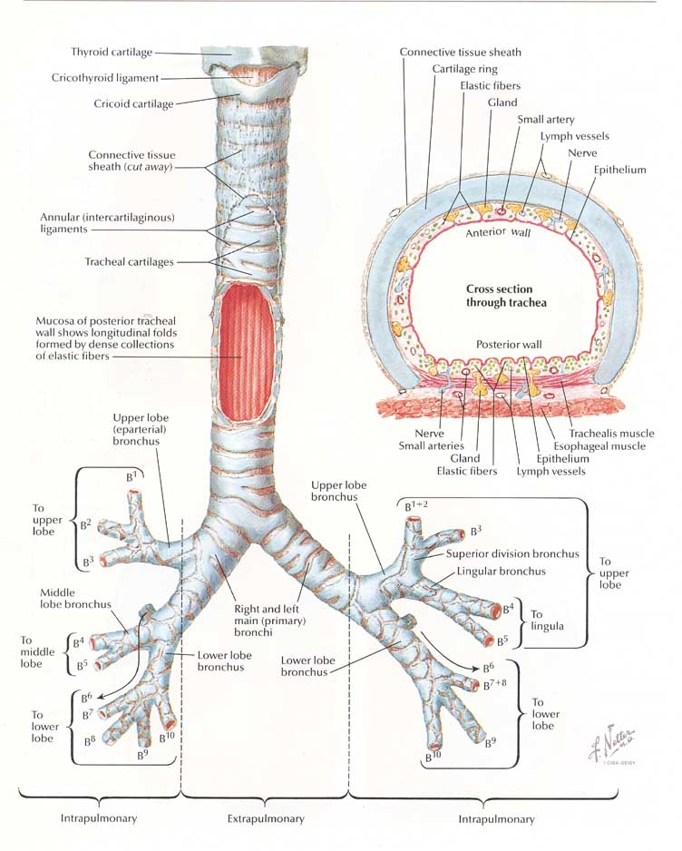

- Tracheotomy: The operation of making an incision in the trachea.
- Tracheostoma: The opening for alternate breathing.

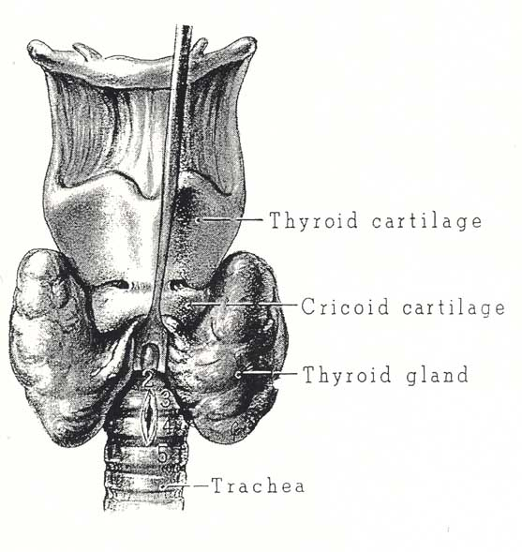

- The Bronchial Tree
  - Primary (main stem) bronchi: 2 primary divisions arise from lower end of trachea.
  - They have walls made up of a series of 16-20 incomplete rings of hyaline cartilage.
  - Terminal bronchioles: termination of bronchial tree proper.
  - Respiratory bronchioles: contain no cartilage—increase in bronchial muscle tissue

- Alveoli: pits or depressions in alveolar sacs and respiratory brochioles. Here oxygen is exchanged for carbon dioxide in a network of capillaries making up about 1000 miles of 70-90 square meters—the size of a tennis court.
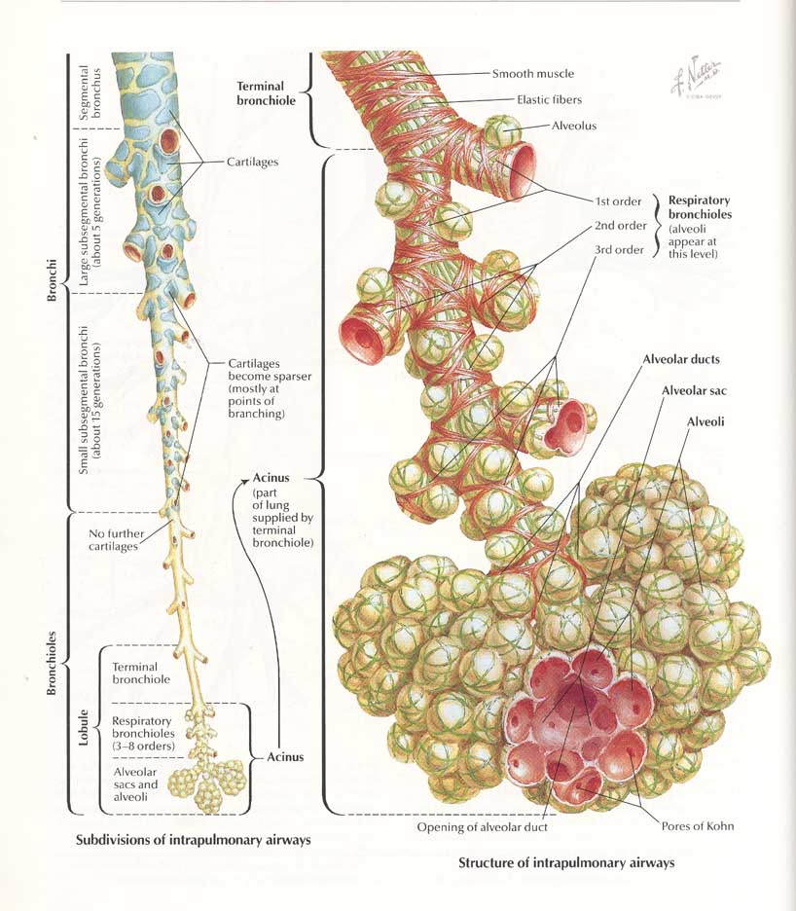
- 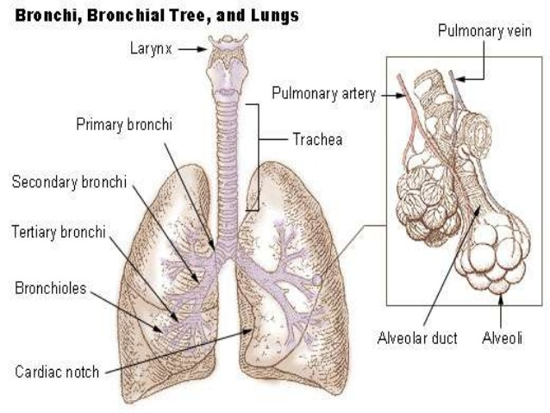

- Lungs
- Lungs - pulmones composed of tissue having a light, porous and spongy texture. They are highly elastic.
- Pleurae: coverings for lungs
- Lungs are passive, complete dependence on surrounding musculature and air pressure to “pump” the air in and out.
- Lungs
  - Color at birth is white to pinkish-white. With age they darken because of contamination from the atmosphere.
  - Apex of each lung points upward and fits into a space bounded by upper ribs, sternum, and vertebrae.
  - Base of lungs are concave and ride on the diaphragm.
  - Lungs are not identical in shape.
  - Right lung is larger than left.

- Rib Cage
- Cage encloses and protects vital organs. The lungs are within it.
- The human rib cage is made up of 12 paired rib bones; each are symmetrically paired on a right and left side.
- Of all 24 ribs, the first seven pairs are often labeled as "true." These bones are connected to the costal cartilage, while the five other "false" sets are not.
- Rib Cage
- Floor of cage is diaphragm.
- Lateral & posterior walls are ribs.
- Anterior wall is costal cartilages and sternum.
- Muscles of the rib cage
- Each rib is connected to the rib below it by both an external and internal intercostal muscle.
- Movement is important for respiration.
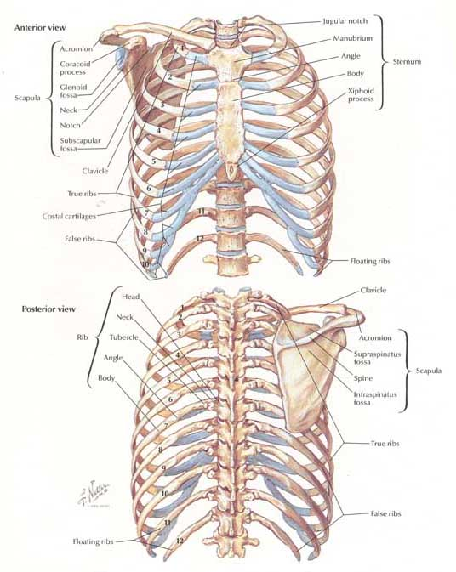

- Diaphragm
- The diaphragm is the dome-shaped sheet of muscle and tendon that serves as the main muscle of respiration and plays a vital role in the breathing process.

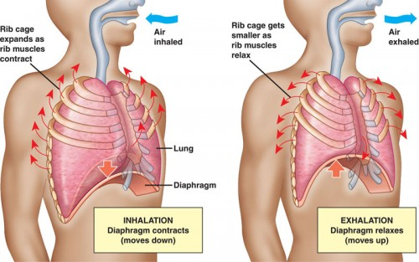
- Breathing
- Muscles in thorax contract, increasing size of thoracic cavity.
- As the rib cage expands, lungs expand too.
- Air rushes into the lungs through upper respiratory tract until pressure within lungs is same as atmospheric pressure.
- Then, expanded lungs contract, expelling the air from the lungs.
- Inhalation
- When we inhale, the diaphragm contracts and is drawn inferiorly into the abdominal cavity until it is flat.
- At the same time, the external intercostal muscles between the ribs elevate the anterior rib cage and spread the ribs.
- The thoracic cavity becomes deeper and larger, drawing in air from the atmosphere.

- Exhalation
- During exhalation, the internal intercostal muscles pull the ribs inferiorly and closer together. The rib cage then drops to its resting position.
- While the diaphragm relaxes and elevates to its dome-shaped position in the thorax.
- The compression of the ribs decreases the volume of the thoracic cavity, resulting in the forced exhalation of air from the lungs.
- Air within the lungs is forced out of the body as the size of the thoracic cavity decreases.

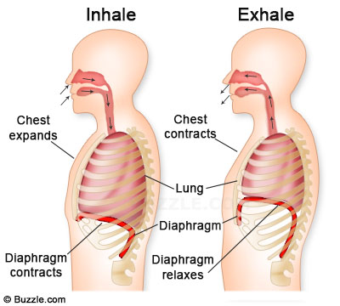

- https://www.innerbody.com/

