Microbiology (Yeast) 349 MIC (Practical)
Course Syllabus

List of Topics | No. Of Weeks
Introduction To Yeast and Biohazards, Biosafety Precaution. | 1
Isolation and Reculturing of Yeast | 2+3
Morphology & Colonial Charastristics of Yeast | 4
Cellular Characterestics of Yeast and Ascospres Formation | 5
Formation of Pseudomycelium | 6+7
Fermentation Test | 8+9
Mid-Term Exam | 10
Alcohol Utilization | 11
Osmotolernats | 12+13
Final Exam | 14

- Introduction To Yeast and Biohazards, Biosafety Precaution.

The aim of the experiment: Introduction to the yeast laboratory and reviewing the safety precaution.

What is yeast?
Yeast is a single-cell eukaryotic organism that classified as members of fungi.

In our lab we are going to use 5 genera of yeast belong to two main groups:
Ascomycetes Basidomycetes
Saccharomyces sp. Hansenula sp.
Schizosaccharomyces sp. Rhodotorula sp.
Candida sp.

Reproduction in yeast:
Asexual reproduction:
Sacchromyces sp. Is divided asexually by budding.
Schizosaccharomyces sp. Fission in the most common form of asexual reproduciton.
Sexual reproduction:
Ascomycetes Basidomycetes
Ascospres Basidospores
Ascus Basidium

Safety Precaution In The Lab:
- Always remember to wear your lab coat during your work in the laboratory. Once finished, laboratory coats should not be worn outside the laboratory.
- Never Smoking, eat or drink in the lab, nor store food in areas where microorganisms are stored. Never eat or drink in the laboratory while working with microorganisms. Keep your fingers out of your mouth, and wash your hands before and after the laboratory activity. Cover any cuts on your hands with a bandage. Gloves may be worn as extra protection.
- Always wash your hands, keep hands and other objects away from your face, nose, eyes, ears, and mouth. The application of cosmetics in the laboratory is prohibited in the laboratory.
- Label everything clearly. All cultures, chemicals, disinfectant, and media should be clearly and securely labeled with their names and dates. If they are hazardous, label them with proper warning and hazardous information.
- Sterilize equipment and materials. All materials, media, tubes, plates, loops, needles, pipettes, and other items used for culturing microorganisms should be sterilized by autoclaving. Otherwise, use commercially sterilized products. Understand the operation and safe use of all equipment and materials needed for the laboratory.
- Treat all microorganisms as potential pathogens. While the majority of microorganisms are not pathogenic to humans and have never been shown to cause illness, under unusual circumstances a few microorganisms that are not normally pathogenic can act as pathogens. Treat all microorganisms—especially unknown cultures—as if they were pathogenic. A student who has a compromised immune system or has had a recent extended illness should talk with the instructor before working in the microbiology laboratory.
- Disinfect work areas before and after use. Use a disinfectant, such as a 10% bleach or 70% ethanol solution, to wipe down benches and work areas both before and after working with cultures. Also, be aware of the possible dangers of the disinfectant, as 70% ethanol can catch fire around open flame or high heat sources. Bleach, if spilled, can ruin your clothing. Either alcohol or bleach can be dangerous if splashed in the eyes. Students should know where the nearest eyewash station and sink are located.
- Autoclave or disinfect all waste material. All items to be discarded after a class, such as culture tubes, culture plates, swabs, toothpicks, wipes, disposable transfer needles, and gloves, should be placed in a biohazard autoclave bag and autoclaved 30 to 40 minutes at 121° C at 20 pounds of pressure. If no autoclave is available and you are not working with pathogens, the materials can be covered with a 10% bleach solution and allowed to soak for at least 1 to 2 hours.
2 & 3- Isolation and Reculturing of Yeast.
Aim of the experiment: To isolate yeast and re-culture the stock culture.

Materials & Methods
Malt Extract Agar Composition
Ingredients Gms / Litre
Malt extract 30.000
Mycological peptone 5.000
Agar 15.000
Final pH ( at 25°C) 5.4±0.2
Tools:
- Microbial loops.
- Plates to cultivate our yeasts.
- Alcohol for the sterilization.
- Bunsen burner.
- 500 ml flasks with distilled water.
Media preparation & Yeast Inoculation:
- Malt Extract Agar is the general media used for yeast cultivation, weight the right amount of the powder for 5 plates.
- Suspend the powder media in distilled water, shake gently to dissolve the powder.
- Sterilize the media in the autoclave under 1- 1.5 atmosphere pressure and 121 C for 15-20 minutes.
- Once the sterilization finished, carefully open the autoclave and wait until the temperature comes down.
- Prepare the petri dishes and sterilize the area where you will work, then pour the media to the dishes and wait for the solidification.
- Each yeast inoculated to the plates and incubated.
- Zigzag streking for the yeast.

Growth condition:
Yeast: After inoculation the sample must be kept in the incubator for 4-5 days at 25 C.

4- Morphology & Colonial Charastristics of Yeast.
Aim of the experiment: To study the colonial characteristics of the yeast.

Materials & Methods
Student bring the previously cultivated culture and identify the characteristics of the yeasts.

Tools:
- Microbial loops.
- Alcohol for the sterilization.
- Bunsen burner.
Characteristics:
- Colony color: Yellow, White, Orange, Creamy, etc…
- Colony Size: less than 5 mm.
- Colony elevation: Concave, Convex, Flat, Raised, etc…
- Colony shape: Circular, Filamentous, irregular, etc…
- Colony maragin: Entire, labulate, etc…

As a result of this experiment student can identify the unique yeast cultures properties.

Yeast | Size mm | Color | Shape | Elevation | Margin
Saccharomyces | 2 | White | Circular | Concave | Entire
Schizosaccharomyces | 3 | Yellow | Circular | Concave | Entire
Hansenula | 2 | Creamy | Circular | Concave | Entire
Rhodotorula | 2 | Orange - Red | Circular | Concave | Entire

5- Cellular Characterestics of Yeast and Ascospres Formation.
Aim of the experiment: To study the cellular characteristics of yeast and ascospres formation.

Materials & Methods
Media preparation & Yeast Inoculation:
- Malt Extract Agar is the general media used for yeast cultivation, weight the right amount of the powder for 5 plates.
- Suspend the powder media in distilled water, shake gently to dissolve the powder.
- Sterilize the media in the autoclave under 1- 1.5 atmosphere pressure and 121 C for 15-20 minutes.
- Once the sterilization finished, carefully open the autoclave and wait until the temperature comes down.
- Prepare the petri dishes and sterilize the area where you will work, then pour the media to the dishes and wait for the solidification.
- Each yeast inoculated to the plates and incubated.

Tools:
- Microbial loops.
- Alcohol for the sterilization.
- Bunsen burner.
- Flasks with 250 distilled water.
- Simple Stain.
Growth condition:
- Yeast: After inoculation the sample must be kept in the incubator for 4-5 days at 25 C.
After incubation period yeasts are stained and examined under the microscope.
Dry preparation | Wet preparation
No cover slip | Cover slip
Examine under: 4X, 10X, 40X, 100X | 4X, 10X, 40X

Neutral Red 1% is used to stain volutine granule.
Yeast Cell Wall Composition:
Mannan, Beta- Glucan, Chitin.

Yeast spores Structures: رسم الطالب

Sahccgaromyces

Schizosaccharomyces

Hansenula

Rhodotorula

6 & 7 - Formation of Pseudomycelium.

Aim of the experiment: To study the ability of yeast to produce pseudomycelium.

Materials & Methods:
Media used:
Corn Meal Tween 80 Agar
Corn meal infusion 2 gm
Tween 80 7 ml
Agar 15 gm
Distilled Water 1000 ml

Media preparation & Yeast Inoculation:
- Corn meal tween 80 Agar is used for pseudohyphae detection, weight the right amount of the powder for 5 plates.
- Suspend the powder media in distilled water, shake gently to dissolve the powder.
- Sterilize the media in the autoclave under 1- 1.5 atmosphere pressure and 121 C for 15-20 minutes.
- Once the sterilization finished, carefully open the autoclave and wait until the temperature comes down.
- Prepare the petri dishes and sterilize the area where you will work, then pour the media to the dishes and wait for the solidification. Each yeast inoculated to the plates and incubated.
This media is used for the cultivation of fungi and for the inducement of chlamydospores formation.
Tools:
- Microbial loops.
- Alcohol for the sterilization.
- Bunsen burner.
- Flasks with 250 distilled water.
- Simple Stain.

After the incubation period, student can analyse the results as following:
Yeast | Pseudomycelium | Truemycelium
Sahccaromyces | Negative | Negative
Schizosaccharomyces | Negative | Negative
Hansenula | Negative | Negative
Rhodotorula | Negative | Negative
Candida | Positive | Negative

Candida albicans is the most known species to produce pseudomycelium (Dimorphic).
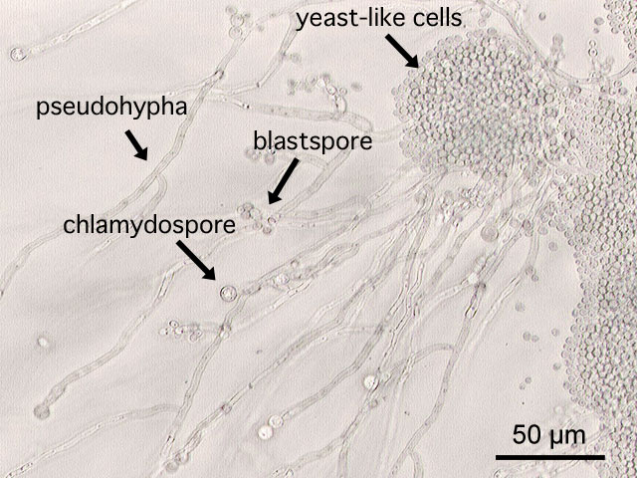

8 & 9 - Fermentation Test.
Aim of the experiment: To study the ability of yeast to ferment sugara.
C_{n}H_{2n}O_{n}
Materials & Methods
Carbohydrates 10 gm
Pepton 5 gm
Bromocresol purple 0.04 gm
Distilled Water 1000 ml

Media preparation & Yeast Inoculation:
- Carbohydrates broth media uded for fermentation test prepare the right amount of the media for 5 plates.
- Suspend the powder media in distilled water, shake gently to dissolve the powder.
- Sterilize the media in the autoclave under 1- 1.5 atmosphere pressure and 121 C for 15-20 minutes.
- Once the sterilization finished, carefully open the autoclave and wait until the temperature comes down.
- Prepare the petri dishes and sterilize the area where you will work, then pour the media to the dishes and wait for the solidification.
- Each yeast inoculated to the plates and incubated.
Tools:
- Microbial loops.
- Alcohol for the sterilization.
- Bunsen burner.
- Flasks with 250 distilled water.
- Simple Stain.
- Durhams tumes.
- 12 test tubes.
- Our fermentation indicator.

Carbohydrates are also known as CHO are divided to:
- Monosaccarides: consists of only one sugar.
Glucose and Fructose.
- Disaccarides: two sugars joined by glycoside bond.
Lactose, Maltose,
- Polysaccharides: chain of monosaccharides (polymer of glucose).
Cellulose, Starch.

Sugar Acid + CO₂
Procedures:
- A set of three sugars (mono, DI and poly) are prepared, each with four tubes.
- After sterilization, media poured into 12 test tubes.
- Insert one Durhams tubes into each of the test tubes.
- Brolmocresole purple, then mixed with the media.
- Inoculate each tube with one yeast.
After the incubation period, students check the results and analyze the data.
Yeast | Fermentation | Carbon dioxide
Sahccaromyces | Positive | Positive
Schizosaccharomyces | Positive | Positive
Hansenula | Negative | Negative
Rhodotorula | Negative | Negative

10- Mid-Term Exam.
Question Number: 1 (2 Marks)
Put true ( √ ) or false ( × )in front of each of the following sentences and correct the wrong sentences when found:
- In wet preparation of yeast we are able to examine the organism under 100 x.
- Some Yeasts are single-cell eukaryotic organism that classified as members of fungi.
- Schizosacccharomyces species are known to produce red – orange pigments.
- C. albicans is known to produce basidiospres when cultivated on Corn meal Tween 80 Agar.

Question Number: 2 (2 Marks)
Fill the following blanks with suitable words:
- .................................. and .................................. belong to Ascomycota, while .................................. and .................................. belong to Basidiomycots
- Yeast Cell wall is composed of .................................. , .................................. and ..................................
- An indicator used in fermentation test is…………………………..
- General Media used for yeast cultivation is……………………………..
Question Number: 3 (2 Marks)
Complete the missing parts in the following structure :
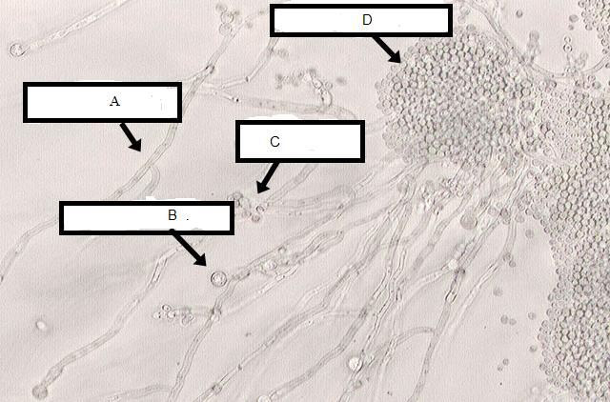

(A) .................................... (B) ....................................

(C) ................................... (D) ....................................

11- Alcohol Utilization.
Aim of the experiment: To study the ability of yeast to utilize alcohol as a source of carbon of its growth Methylotrophic Organisms.
Materials & Methods
Methanol Broth Media
Methanol 2 %
NH₄CI 0.4 %
KH₂PO₄ 0.1 %
K ₂HPO₄ 0.1 %
MgSO₄ 0.05 %
vitamin mixture each 1000 ,ug/liter
Distilled Water 7 ml

Media preparation & Yeast Inoculation:
- Prepare Methanol Broth Media to test alcohol utilization in 5 plates.
- Prepare the petri dishes and sterilize the area where you will work, then pour the media to the dishes and wait for the solidification.
- Each yeast inoculated to a tube and incubated at the room temperature.
Tools:
- Microbial loops.
- Alcohol for the sterilization.
- Bunsen burner.
- Flasks with 250 distilled water.
- 4 test tubes.
- Our fermentation indicator.
Methan Methanol
CH₄ CH₃-OH

Eukaryotic Methylotrophic
Ex, Hansenula sp.
After the incubation period, students can analyze the results as follow:
Yeast | Alcohol Utilization
Sahccaromyces | Positive
Schizosaccharomyces | Negative
Hansenula | Positive
Rhodotorula | Negative

12 & 13- Osmotolernats.
Aim of the experiment: To study the ability of yeast to grow under high osmotic pressure.

Material & Methods
Media used
Malt extract agar with 40% glucose
Glucose 400 gm
Malt Extract 12gm
Agar 15 gm
Distilled Waster 1000 ml

Media preparation & Yeast Inoculation:
- Carbohydrates agar media used as osmotic pressure media in this test, prepare the media of 5 plates.
- Suspend the powder media in distilled water, shake gently to dissolve the powder.
- Sterilize the media in the autoclave under 1- 1.5 atmosphere pressure and 121 C for 15-20 minutes.
- Once the sterilization finished, carefully open the autoclave and wait until the temperature comes down.
- Prepare the petri dishes and sterilize the area where you will work, then pour the media to the dishes and wait for the solidification.
- Each yeast inoculated to the plates and incubated.
Tools:
- Microbial loops.
- Alcohol for the sterilization.
- Bunsen burner.
- Flasks with 250 distilled water.
- Media in petri dishes.

What is the osmotic pressure?
It is the pressure resulted from the movement of water from low concentration to higher concentration through a semi-permeable membrane.
Solutions
- Hypertonic: the conc is higher than cell. Cell shrink
- Hypotonic: the conc is lower than cell. Cell explosion
- Isotonic: the conc is equal to the cell. No effect
The most known osmotolerant yeast is:
Zygosaccharomyces sp.
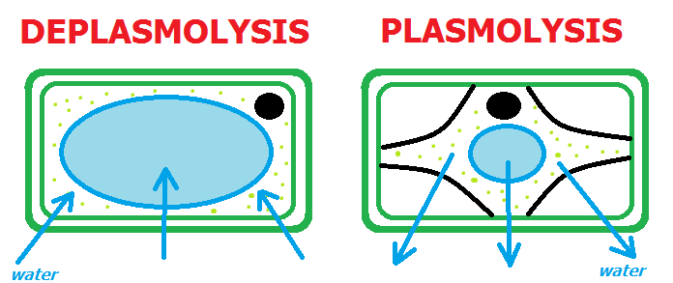

Yeast | Osmotolerants
Sahccaromyces | Positive
Schizosaccharomyces | Negative
Hansenula | Negative
Rhodotorula | Negative
After the incubation period, students can analyze the results as follow:

14- Revision

15- Final Exam

