GC311 – Database Concepts
Lab #1

Q1: The many-to-many relationship between books and authors can be modeled with 3 tables, as shown below. A books table contains data about books (such as title and price); an authors table contains data about the authors (such as name and email). A table called books_authors joins the books and authors tables and captures the many-to-many relationship between books and authors.
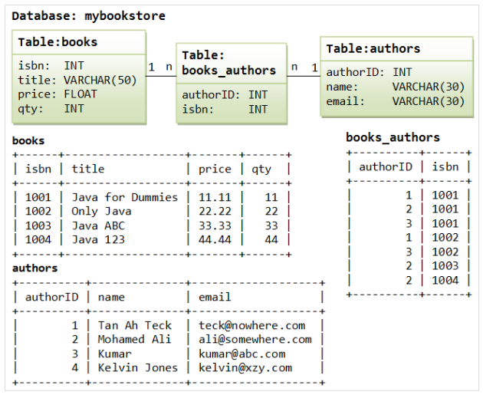

- Using Data definition language (DDL), write SQL query.
  - Create table statements for the above tables.
  - Add new column (sex) to authors table.

