Lab #1

Q1: The many-to-many relationship between books and authors can be modeled with 3 tables, as shown below. A books table contains data about books (such as title and price); an authors table contains data about the authors (such as name and email). A table called books_authors joins the books and authors tables and captures the many-to-many relationship between books and authors.
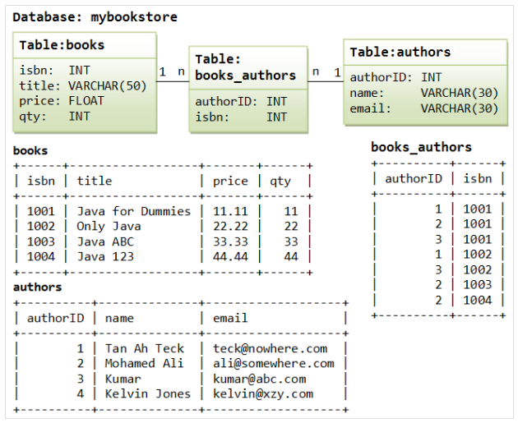

- Using Data definition language (DDL), write SQL query.
  - Create table statements for the above tables.
- Create a view named book20 that contains the isbn, title, qty for books with quantity more than or equal 20. Label the view columns as ISBN, Title, and Quantity.
For security purpose, do not allow a book to be reassigned to another quantity less than 20 through the view.
- Write SQL query to remove a book with isbn 1003 from the view.
- Write SQL query to remove the view.

