CT1501
Lab 2
Exercise

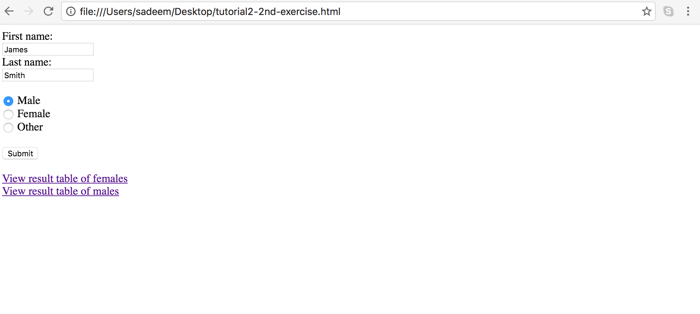
Write the HTML code that represents the following Web document
And another web page that has two tables one table for female names and another for males names as follows:

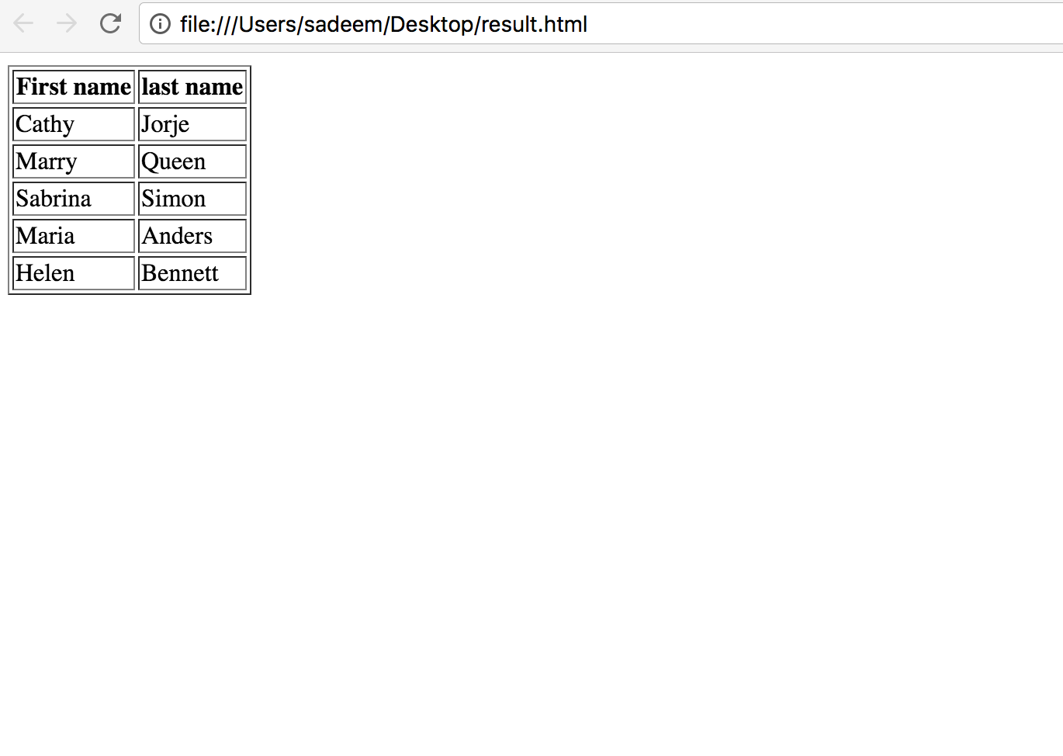

Notes:
- The default values of the form should be “James Smith”
- After clicking on submit notice what happens to the address link.
- When clicking on the “View result table of females” and “View result table of males” you should open a new tab with the corresponding tables.

