Lab #2

Q1: The many-to-many relationship between books and authors can be modeled with 3 tables, as shown below. A books table contains data about books (such as title and price); an authors table contains data about the authors (such as name and email). A table called books_authors joins the books and authors tables and captures the many-to-many relationship between books and authors.
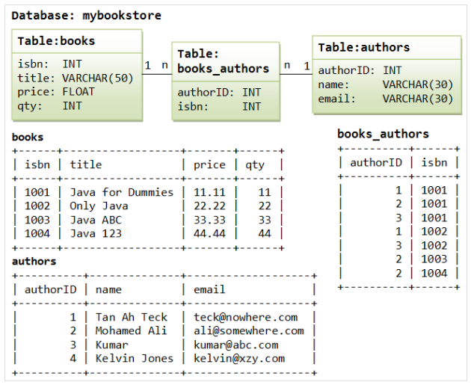

- Create a synonym for the books table to name it booklist.

- Create an index for title column in books table.

- Create an incremented sequence named seq, the sequence should start at 1 and have a maximum value of 100, the difference between each value and the next is 10?

- Write a SQL query to retrieve the next value from the sequence?

