GC311 – Database Concepts
Lab #3

Q1: The many-to-many relationship between books and authors can be modeled with 3 tables, as shown below. A books table contains data about books (such as title and price); an authors table contains data about the authors (such as name and email). A table called books_authors joins the books and authors tables and captures the many-to-many relationship between books and authors.
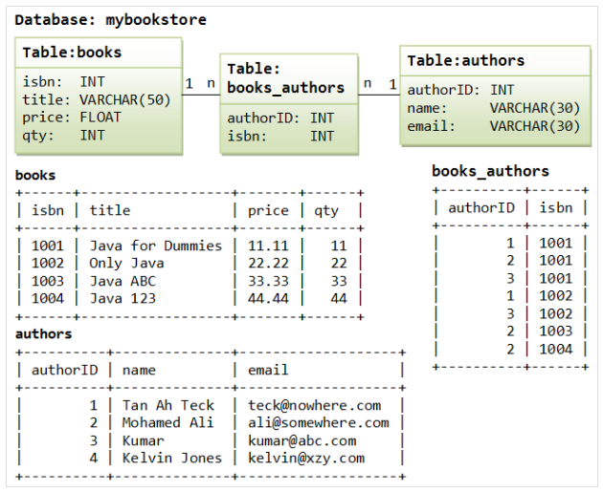

- Using Data Manipulation language (DML), write SQL query using oracle.
  - List full details of all authors with their books names arranged in descending order of author name.
  - Find author name, email and how many books for each author.
  - Find author name, email and how many books for each author that has price more than 20.
  - Find the name of author that has the maximum number of books.
  - Insert a row in authors table (5 Suzan Su@add.com)
  - Update books table by increase books price 10%.

